IB Atomic and Nuclear Mock Test

1. Photoelectric Effect
(a) A certain metal has a work function of 3.10 eV. If the ejected photo-electrons have a stopping potential of 1.45 V, calculate the wavelength of the light. (273 nm)
(b) If light with a wavelength of 180 nm illuminates the same plate, what would be the stopping potential of the photo-electrons? (3.81 V)
(c) What would be the effect of increasing the intensity of the light on the electrons ejected from the metal? What would be the effect of using light of a shorter wavelength on the electrons ejected from the metal? (more electrons/same Vs, a few more electrons/higher Vs)
(d) What was Einstein's idea for the Photoelectric effect experiment, and how did the results of Millikan’s photo-electric effect experiment support Einstein’s corpuscular theory of light? (watch video)

2. Particle Physics
(a) A high energy photon with a wavelength of 3.84 fm creates a Muon/Anti Muon pair each with 56.0 MeV of kinetic energy. Show that the rest mass of a Muon is approximately 106 MeV.
(b) Calculate the largest wavelength of photon that could create this pair. (5.87 fm)
(c) Pair production always creates a matter/anti-matter pair. Apply the concept of conservation of Energy, Muon number, and charge. (watch the video)
A partial Feynman diagram shows Muon decay:
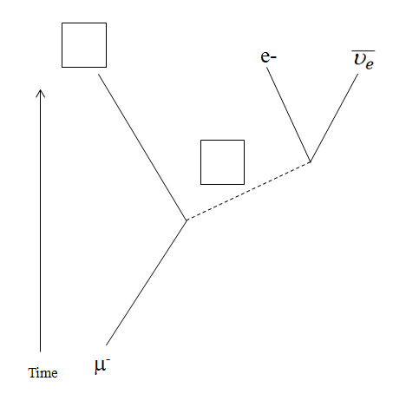
(d) Fill in the correct exchange particle, and resulting particle in the boxes. (watch video)
(e) For the four solid lines denoting the non-exchange particles, indicate with arrows their direction. (watch video)
(f) Distinguish between Mesons, Leptons, Baryons (watch video)
(g) State the quark composition of a proton and neutron (udu, udd)

3. Atomic Models
Given this energy level diagram for Hydrogen:
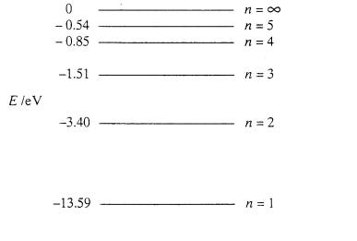
(a) What possible photon energies are there for downward transitions from n = 4? (0.66 eV, 2.55 eV, 12.74 eV)
(b) A spectral line is observed to have a wavelength of 1282 nm. State what part of the EM spectrum this is, and indicate which transition is responsible for this spectral line. (0.97 eV, so 5 to 3)
(c) Calculate the wavelength of the photon associated with a transition from n = 3 to n = 1. (103 nm)
(d) Explain the three atomic models proposed by Thomson, Rutherford, and Bohr, and the discoveries that led to each one. (watch video)
(e) The atmospheres of stars create absorption spectra. Explain how absorption or dark line spectra are created, and how scientists use them.

4. Alpha Decay
92-Uranium 229 will alpha decay into Thorium 225.
(a) Calculate the energy of this decay given this data: (6.476 MeV)
U-229: 229.033496 amu, Th-225: 225.023941 amu, Alpha: 4.002603 amu.
(b) Calculate the radius of a Thorium 225 atom. (7.30 fm)
(c) What kinetic energy in MeV must an alpha particle have to get this close to the Thorium nucleus? (35.5 MeV)
(d) If an Alpha particle can escape in 1.14x10⁻²³ seconds, what energy must it “borrow” in MeV? (29.0 MeV)
(e) Explain what is meant by tunneling in the context of an alpha decay (watch video)
(f) Explain why nuclei cannot be arbitrarily large - why there is an upper limit on the size of stable nuclei by reference of the nature of the electromagnetic and strong nuclear forces.

5. Beta Decay
53-Iodine-138 decays by Beta minus into an isotope of Xenon
(a) Write the complete equation for the decay. (watch video)
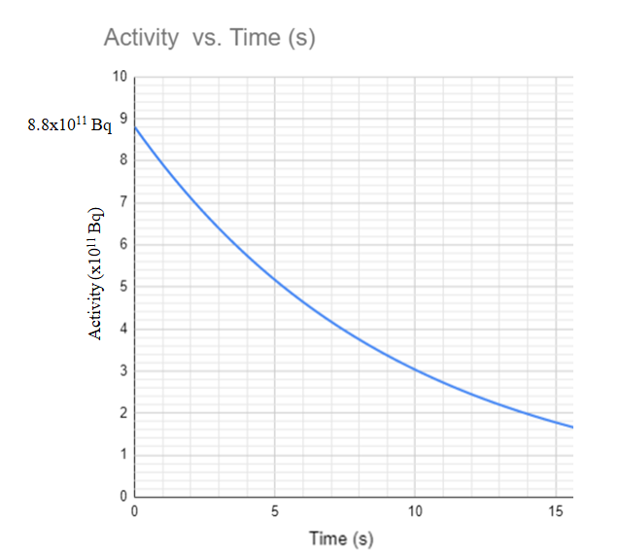
(b) The sample initially has an activity of 8.8x10¹¹ Bq. Using the graph above, determine the half life in seconds of this decay. (6.5 s)
(c) What is the mass of the sample if the molar mass of I-138 is 137.922 grams/mole? (1.89 ng)
(d) What time will it take for the activity to reach 1.1x10¹¹ Bq? (19.5 s - no calculator needed!)
(e) What will be the activity of the sample after 4 minutes? (7 Bq)

