**Noteguide for Particle Accelerators - Video 32A Name**

Basic concept - Vq = 1/2mv2

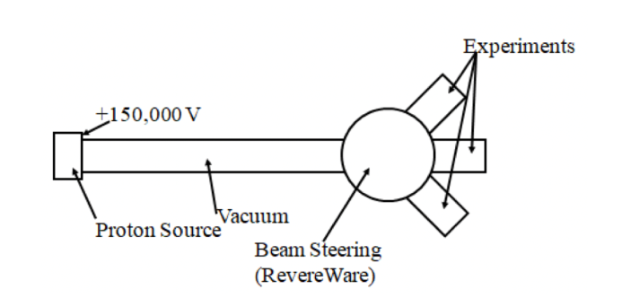 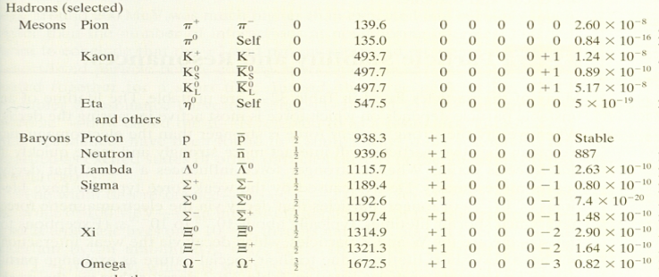

Velocity of particles?

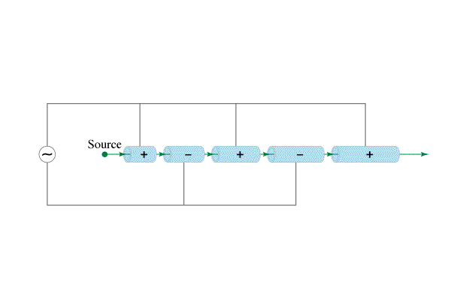(2 miles long, 50 GeV)

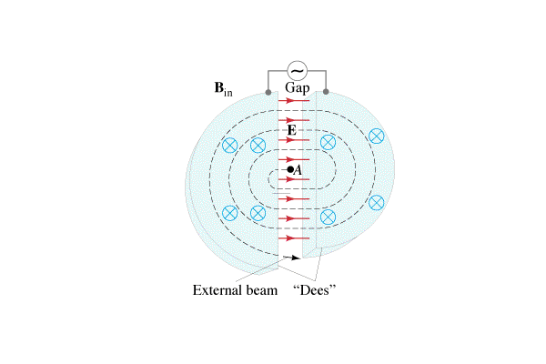

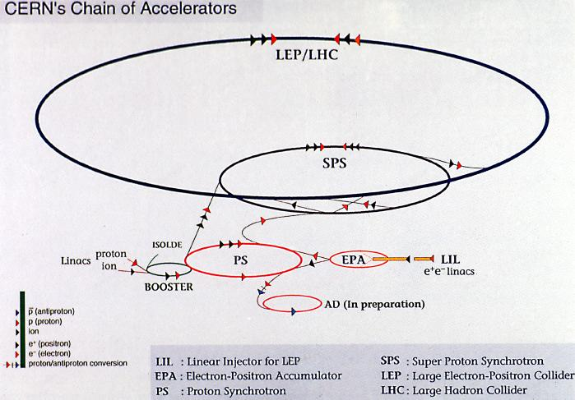 (6.5 TeV)

**Noteguide for QED and Types of Particles - Video 32B Name**

Quantum Electrodynamics (QED) – Richard Feynman

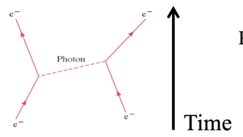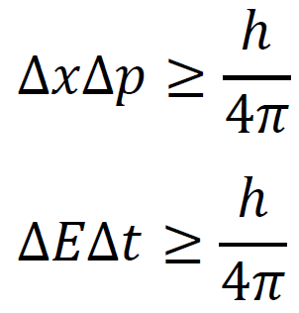Forces are mediated by virtual particles

How QED Explains:

What charge actually is

Force dropping off over distance

How accelerating a charge causes it to radiate actual photons

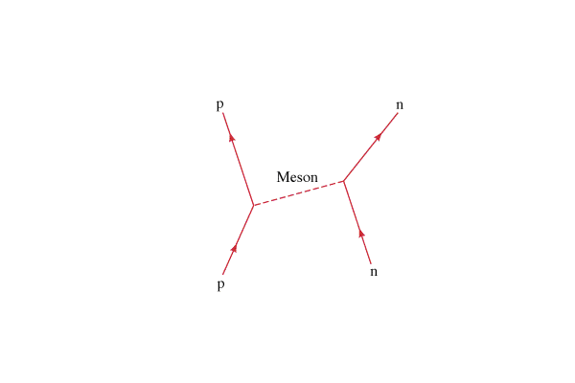

The Yukawa Particle:

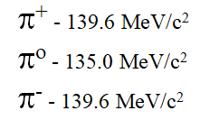

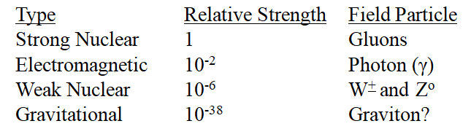 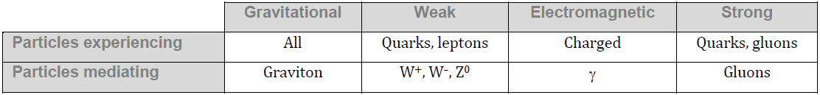

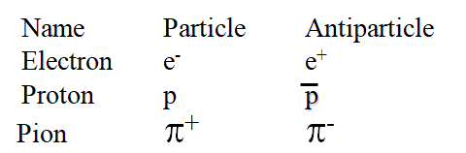

Annihilation:

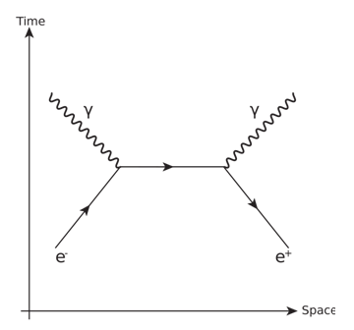

(Write down what the axes mean, and why the positron is going backwards in time)

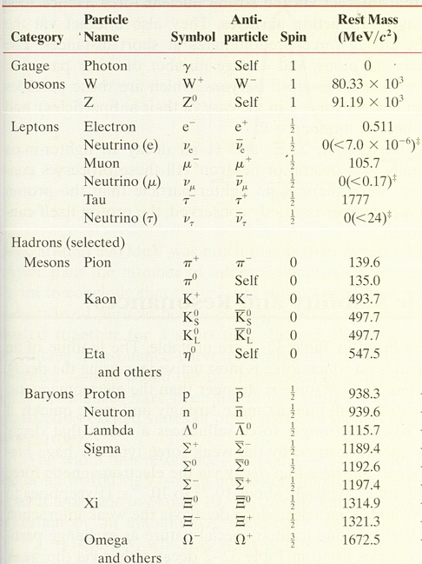

**Bosons (Integer spin)**

Gauge Bosons (Spin 1)

Scalar Boson (Spin 0)

Mesons (Even # of Spin ½)

**Fermions (Non integer Spin or Spin 1/2)**

Leptons

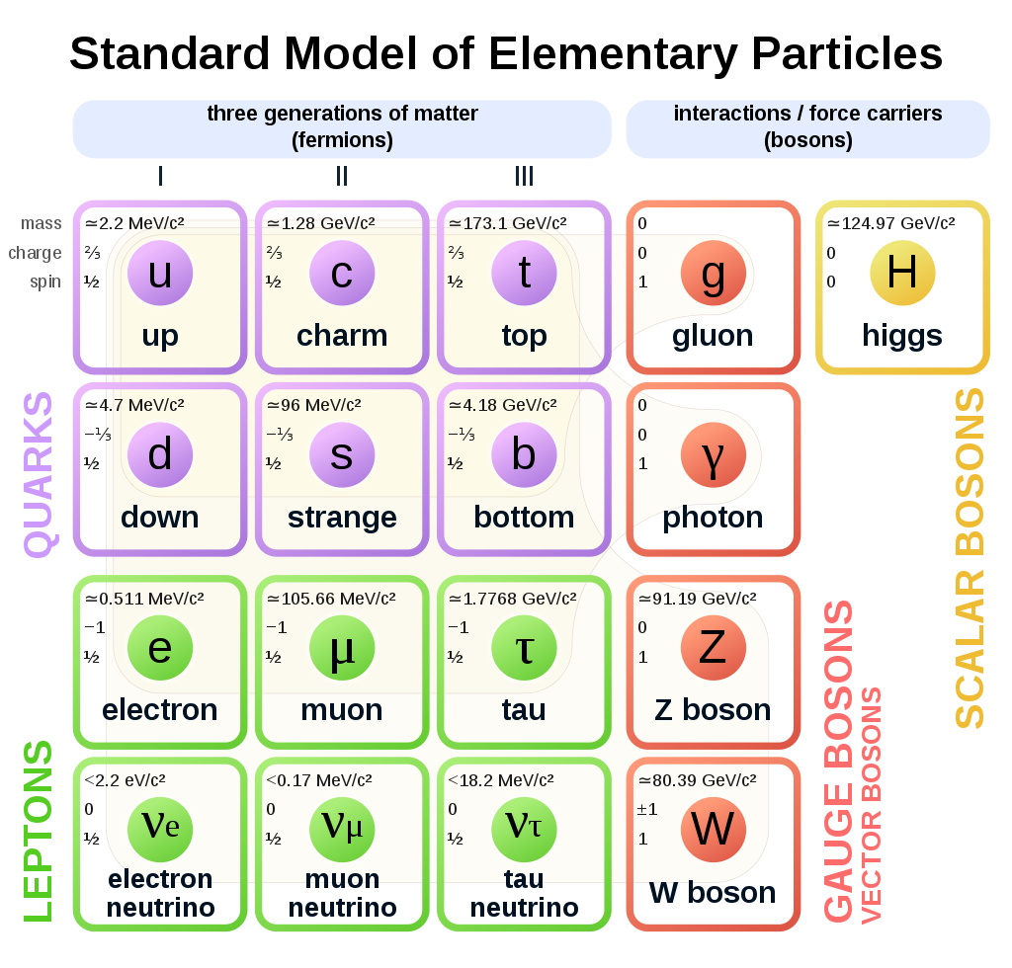

Bosons

Quarks

**Noteguide for Conservation Laws- Videos 32C Name**

**Conservation Laws:**

Charge Mass/Energy Nucleon #

**Conservation of Baryon number:** (All Baryons are B = +1, anti-Baryons are B = -1)



Example: Can the following reaction occur?

p + n → p + p + $\overline{p}$

Charge:

Mass/Energy

Baryon #

Watch all these videos, so you know you got it right:

|  |  |
| --- | --- |
| (0) | (-1) |
| (y) | (n) |
| (n) | Example |

**Example:**

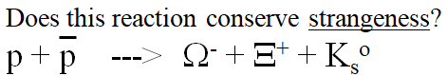

**Noteguide for Lepton Number- Videos 32D Name**

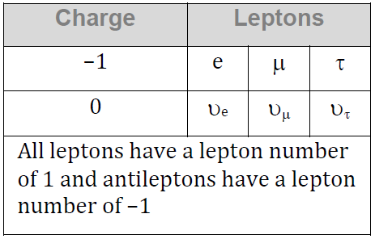**Conservation of Lepton number:** (Conserved by type Le, Lm, Lτ)



|  |  |
| --- | --- |
| Can this decay occur?  τ- → π- + πo + υτ | Find the missing decay product:  τ- → υτ + e- + ?? |

Whiteboards

|  |  |
| --- | --- |
| (no)  Why not: | (yes) |
| (yes) | (no)  Why not: |
| (no)  Why not: | In this space draw a picture of a pretty pony: |

Whiteboards:

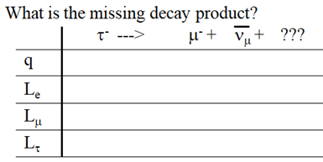 

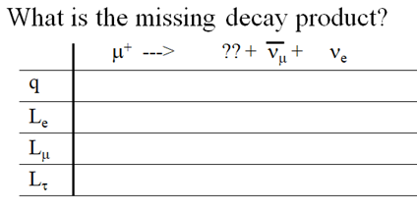 

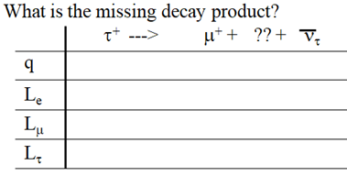 

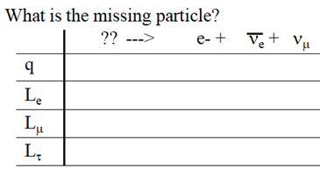 

**Noteguide for Quark Theory - Videos 32E Name**

Quark Theory:

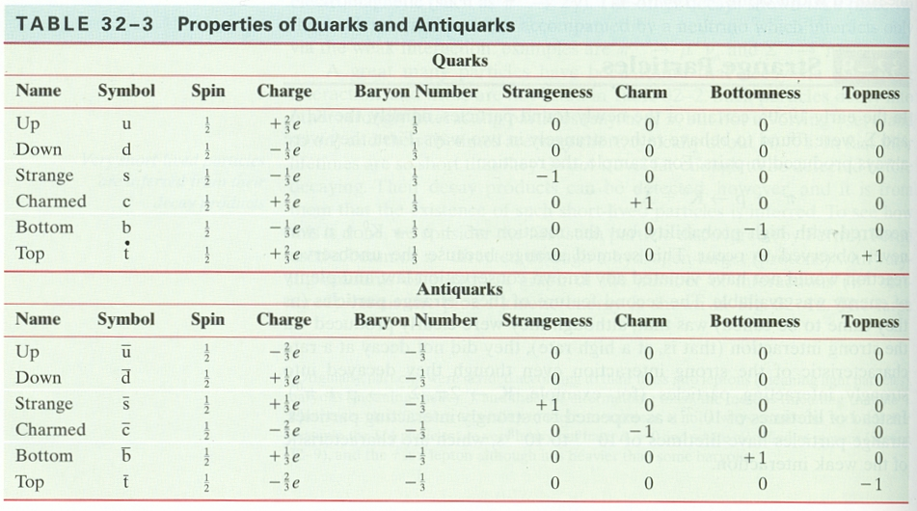

Baryons are (qqq)

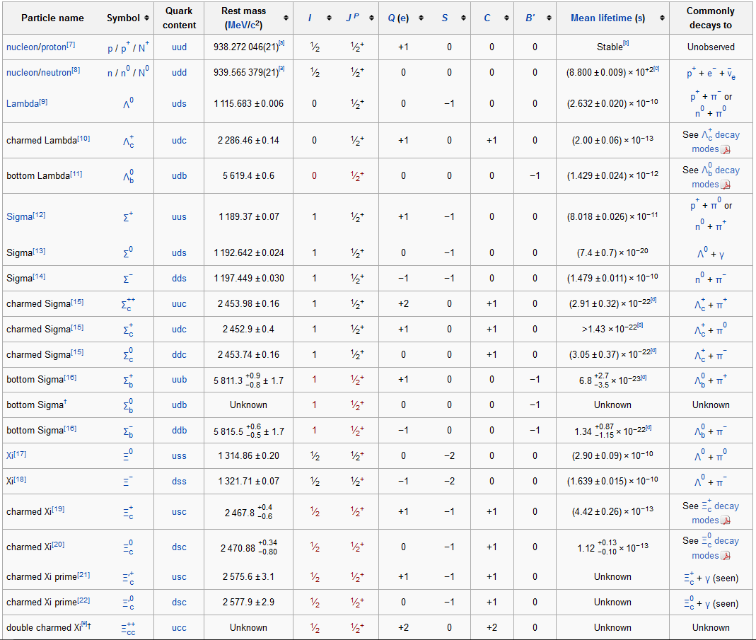 B S q

p =

n =

Λo =

Mesons are (q)

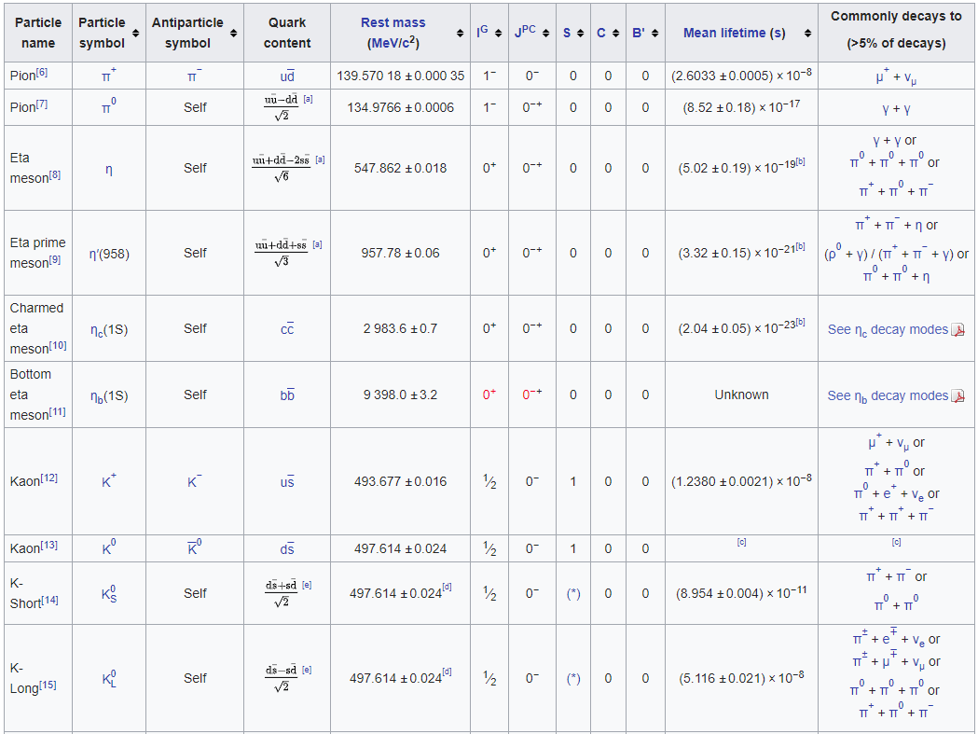 B S q

π+ =

πo (u) =

ηc =

Whiteboards:

|  |  |  |  |  |  |
| --- | --- | --- | --- | --- | --- |
|  |  | Baryon or Meson? | B = ? | S = ? | q = ? |
| 1 | usc |  |  |  |  |
| 2 | u $\overline{s}$ |  |  |  |  |
| 3 | ddc |  |  |  |  |
| 4 | d $\overline{s}$ |  |  |  |  |

**Noteguide for Feynman Diagrams - Videos 32F Name**

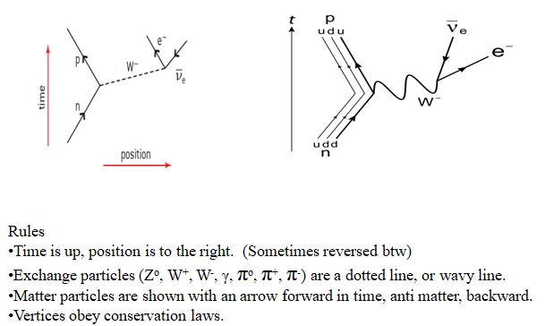

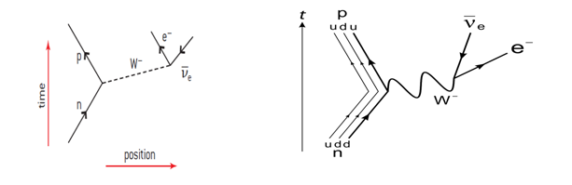

Examples:

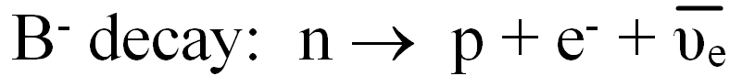















 

**Noteguide for Atomic Notation and Isotopes - Videos 30A Name**

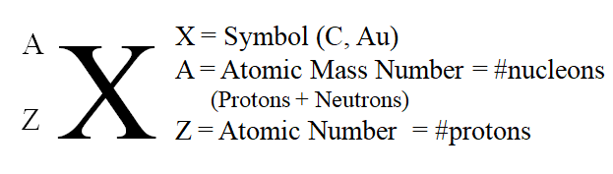 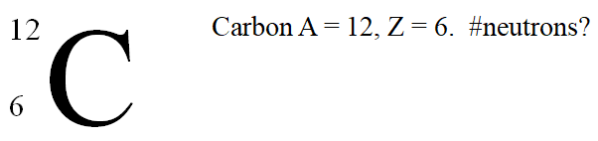

(C-12 is another notation, so the number 12 is the mass number, everyone knows Carbon is element 6)

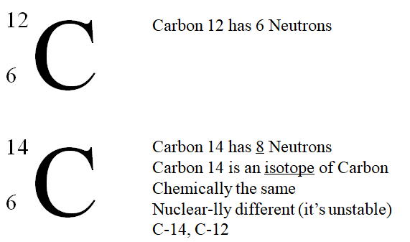

Whiteboards:

|  |  |
| --- | --- |
| What is the Atomic notation for tritium? (tritium is an isotope of Hydrogen with 2 neutrons)  (3/1 H) | 10 protons, 12 neutrons. What is its atomic notation?  (22/10 Ne) |
| How many neutrons in U 235? (235 = A)  (143) | How many neutrons in Pb 208? (208 = A)  (126) |
| How many neutrons in Kr 78?  (42) | Draw a picture of a bunny here: |

**Noteguide for Binding Energy - Videos 30B Name**

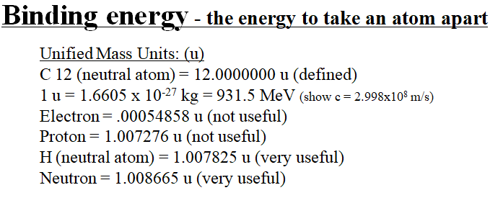

(The bigger the binding energy per nucleon, the more stable the nucleus)

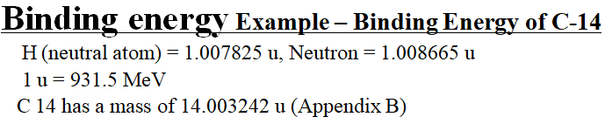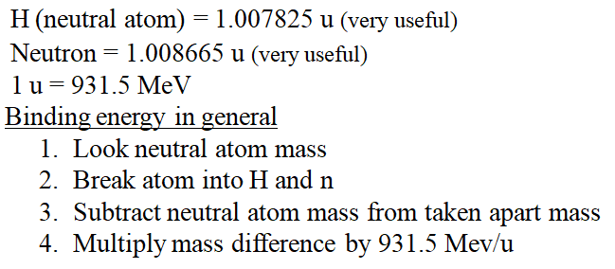

|  |  |
| --- | --- |
| What is the binding energy for Nitrogen 13?  (Z = 7) N 13 mass = 13.005739 u  H = 1.007825 u  Neutron = 1.008665 u  1 u = 931.5 MeV  (94.11 MeV) | What is the binding energy for Carbon 12?  (Z = 6) C 12 mass = 12.000000 u (duh?)  H = 1.007825 u  Neutron = 1.008665 u  1 u = 931.5 MeV  (92.16 MeV) |

**Noteguide for Balancing Nuclear Reactions- Videos 30M Name**

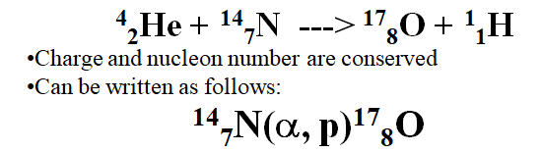

Initial Nucleus(bombarding particle, emitted particle)Final Nucleus

Common Particles you should know:

α = 42He, p = 11H, d(deuterium) = 21H, t(tritium) = 31H, 10n = neutron, **00 γ =** gamma

Exoergic means:

Endoergic means:

Example:

What is the initial nucleus:

**???  + n ---> p + 146C**

Whiteboards: - Find the missing nucleus

|  |
| --- |
| **13756Ba (n , γ) ???**  (**13856Ba**) |
| **13756Ba (n , ???) 13755Cs**  (**p** = **11H)** |
| **21H (d , ?) 42He**  (**γ** ) |
| **19779Au (α , d) ???**  (19980Hg) |
| **94Be (??? , t) 84Be**  (**21d**) |

**Noteguide for Q Value - Videos 30N Name**

Example:

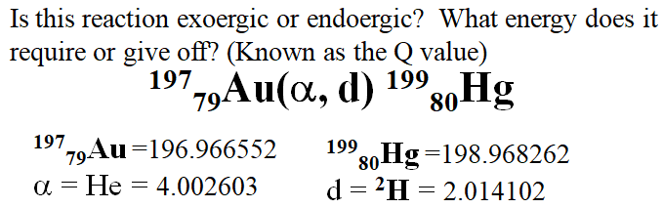

Whiteboards:

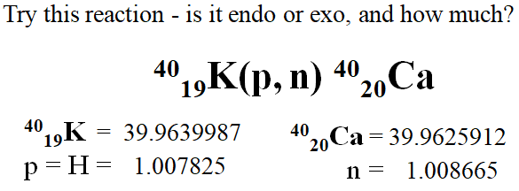 (**Q = +0.529 MeV (Exo)**)

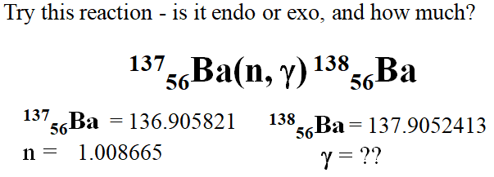(**Q = +8.611MeV (Exo)**)

**Noteguide for The Curve of Binding Energy- Videos 30O Name**

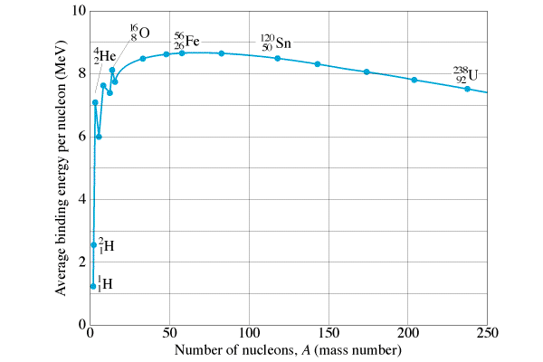The curve of binding energy:

Define:

Binding energy per nucleon -

What’s more and less stable –

Mark where fusion (joining) and fission (splitting) can release energy. Where are the most stable nuclei?

|  |  |
| --- | --- |
| Fusion powers the sun:  Energy comes primarily from the Proton-Proton cycle:  1H + 1H = 2H + e+ + ν  1H + 2H = 3He + γ  3He + 3He = 4He + 1H + 1H | Helium can also fuse:  4He + 4He = 8Be + γ  4He + 8Be = 12C + γ  Carbon can fuse as well:  12C + 12C = 24Mg + γ  16O + 16O = 28Si + 4He |

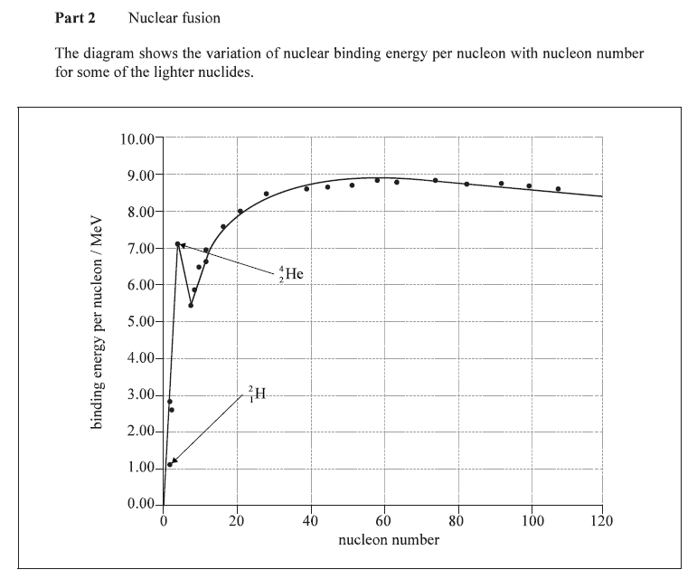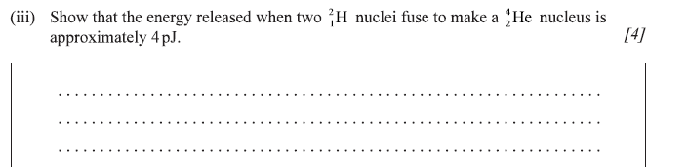

Finding Q-Value from Binding Energy per nucleon: (We did these before using mass)



K-40 has a BE of 8.538080 MeV per nucleon

Ca-40 has a BE of 8.551299 MeV per nucleon (Q = +0.529 MeV (Exo))

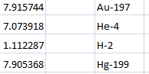 (-12.30 MeV)

**Noteguide for Radioactivity and Decay Series- Videos 30CD Name**

**Videos C:**

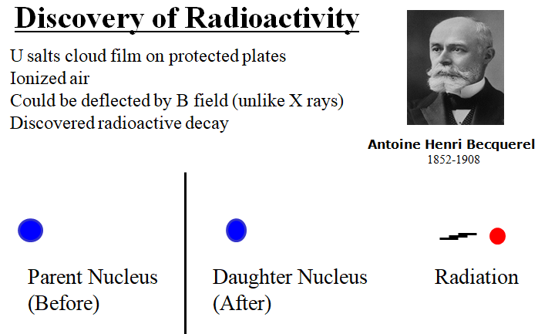 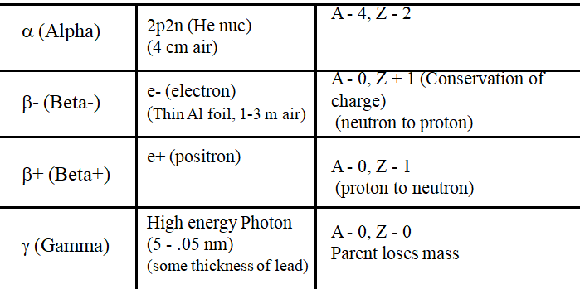

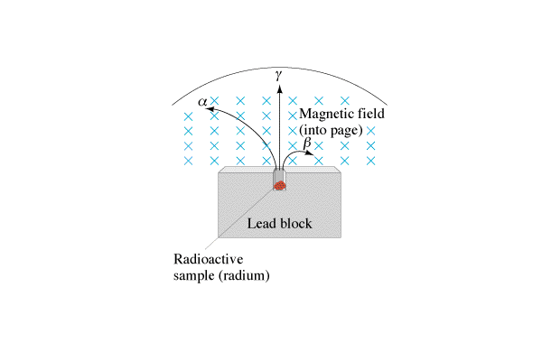

Whiteboards:

|  |  |
| --- | --- |
| 1.  () | 2.  () |
| 3.  () | 4.  () |
| 5.  () | 6.  (α) |
| 7.  () | 8.  (γ) |

**Videos D:**

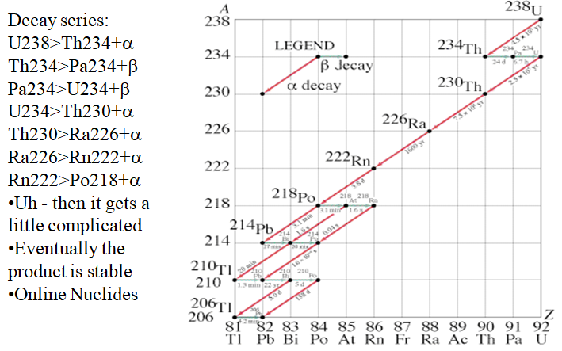

OK - So try this yourself - go to

**http://atom.kaeri.re.kr:8080/ton/nuc8.html**

and type U-238 into the box in the upper left corner that says 

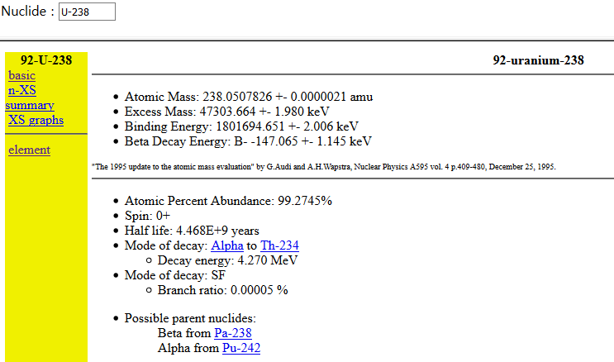 Then click on the link for Th-234.

Off you go. Keep following links after "mode of decay". Sometimes there are more than one...

Eventually, as long as you are clicking on the products of the decay, you will always end up at Pb-206

Try **Bk-247**

Look around up there near the top of the Chart of the Nuclides, and find other exciting decay series..

**Noteguide for Alpha Decay and Tunneling- Videos 30EF Name**

**Videos 30E:**

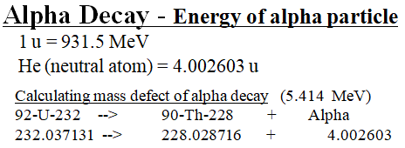

Why Alpha Decay:

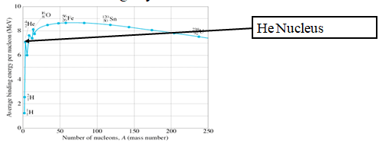

Whiteboards:

Find the energy of this Alpha Decay in MeV:

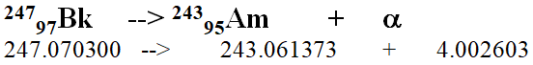

Find the energy of this Alpha decay in MeV, Joules, and calculate the velocity of the particle given the mass of an alpha particle is 6.64x10-27 kg



**Videos 30F:**

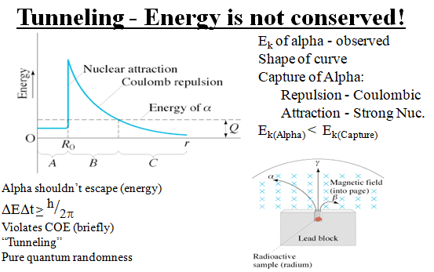

**Noteguide for Beta and Gamma Decay- Videos 30GH Name**

**Video 30G:**





Conservation of charge

Beta minus - electron

“As if” neutron -> proton + electron

Beta plus - positron

“As if” proton -> neutron + positron

Particles are “of the nucleus” (not orbital)

* - Neutrino, (anti neutrino) – fudge

Energy is continuous (i.e. neutrino gets random share)

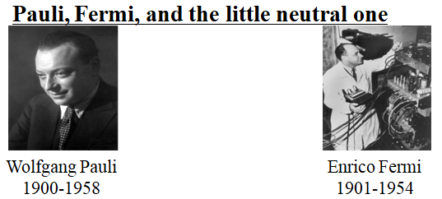

Beta decay products were missing energy

Pauli proposes a particle is carrying away energy

Fermi names it Neutrino - “Little neutral one” - It.

Neutrinos confirmed in 1956, no surprise

**Videos 30H:**

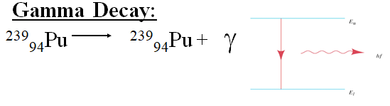Nucleus has energy levels

Energy of transition emitted as a high energy photon (λ ≈ 5 - .05 nm)

Usually after a beta or alpha decay

Many energies possible

Stopped by meters of lead

Used for food irradiation

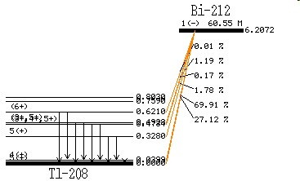 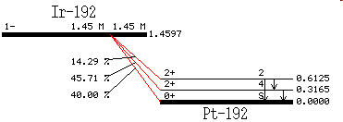

Gamma ray energies associated with alpha and beta decays – so Alpha and Gamma energies are discrete. (Like spectral lines we saw)

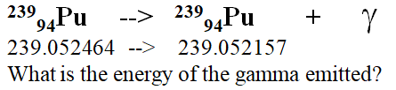

Whiteboards:

Tl-208 emits a 0.6210 MeV gamma and the neutral atom in the unexcited state has a mass of 207.9820047 u. What was the mass of the excited state before the gamma was emitted?

(207.9826714 u)

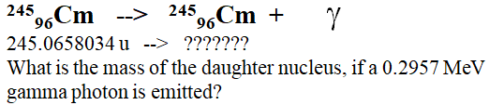 (245.065486 u)

**Noteguide for Activity and Half Life - Videos 30IJK Name**

**Videos 30I:**

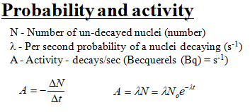Example - Radon 222 has an atomic mass of 222.02. How many grams of it do you have if your activity is 8.249x1016 decays/sec, and your decay probability is 2.098x10-6 s-1? N­A = 6.02x1023 atoms/mol

Whiteboards:

|  |  |
| --- | --- |
| What is the activity if you have a λ of 3.19x10-10 s-1, and you have 5.12x1023 un-decayed nuclei?  (1.63x1014 decays/sec) | What is the λ if 1.27x1020 un-decayed nuclei generate 1420 decays per second?  (1.12x10-17 s-1) |

**Videos 30J:**

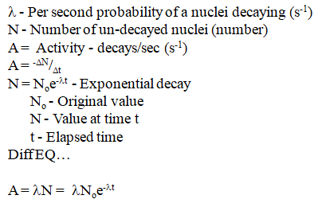

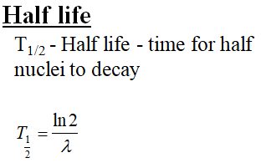

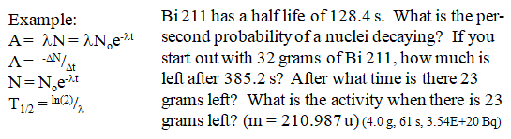

Whiteboards:

|  |  |
| --- | --- |
| 1. Oregonium has a decay probability of 8.91x10-8 s-1. What is its half life in days? (90 days) | 2. What is the nuclear decay probability of a substance that has a half life of 96.23 minutes?  (0.0001201 s-1) |
| 3. Oregonium has a decay probability of 8.91x10-8 s-1. If you have 1250 grams of Oregonium initially, how many grams do you have after 30.00 days? (x24x3600) (992 g) | 4. Tualatonium has a half life of 12 seconds. If you start with 64 grams of it, how much remains after a minute? (Cheat) (2.0 g) |
| 5. Tigardium has a half life of 8.34 seconds. The initial activity is 1350 counts/second, after what time is the activity 125 counts/sec? (28.6 s) | 6. A certain substance has an activity of 1245 counts/sec initially, and an activity of 938 counts/second after exactly 3.00 minutes. What is the half life of the substance? (441 s) |

**Video 30K:** Radiometric Dating

So - go read the account of Clair Patterson: https://en.wikipedia.org/wiki/Clair_Cameron_Patterson

(You won't believe it)

**Noteguide for Nuclear Stability- Videos 30L Name**

A nucleus is bound by the strong nuclear force. Since this force is extremely short range (1x10-15 m) as the nucleus gets bigger, nuclei become in general less stable because the Coulombic repulsion of the protons gets stronger, and the strong nuclear gets weaker. Ultimately there is an upper limit to the size of a stable nucleus.

Forces in a nucleus:

Coulombic force: Strong Nuclear Force:

A graph of neutrons vs. protons for stable nuclei:

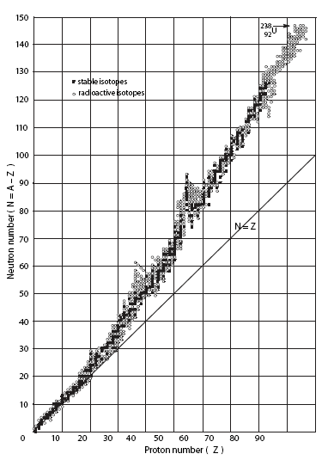

**Noteguide for Nuclear Power- Videos 30Q Name**

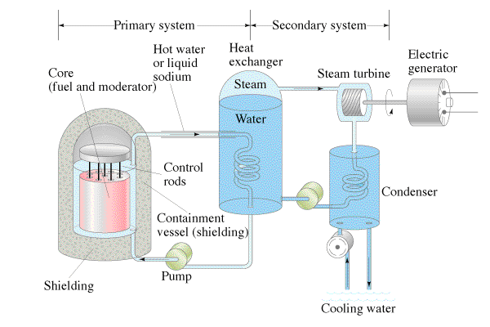

Pros: Cons:

Example Question: An 820 MW power plant is 30.% efficient. How much Uranium 235 will it use in a year? Assume that a single atom will yield 200. MeV of energy. Uranium 235 has a mass of 235.0439231u, NA is 6.02 x 1023.

Chernobyl: