**Noteguide for Electromagnetic Spectrum - Videos 27A Name**

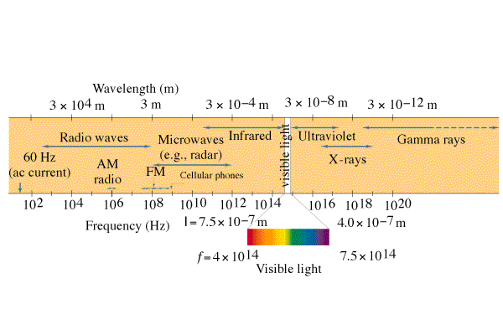

**Reviewing Waves:**

v = fλ

v = c = speed of light = 3.00 x 108 m/s

f = frequency (Hz)

λ = wavelength (m) 1 nm = 1 x 10-9 m

Example: What is the wavelength of a 91.1 MHz radio wave?

Whiteboards:

|  |
| --- |
| 1. What is the frequency of a 12.2 cm microwave? (ovens use this) (2.46 x 109 Hz) |
| 2. What is the frequency of a 600. nm light wave? (5.00 x 1014 Hz) |

**Noteguide for Photons - Videos 27BCD Name**

**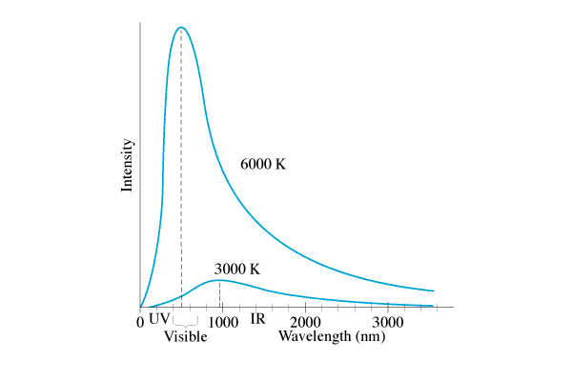27B: Planck**

**27C: Photon Theory:** Light is made of particles.

 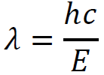

E = Photon energy (Joules)

h = Planck’s constant = 6.626 x 10-34 Js

f = frequency of oscillations (Hz, s-1)

c = speed of light = 3.00x108 m/s

λ = Wavelength in m

Example 1: What is the energy (in eV) of a 460. nm photon?

Example 2: A photon has an energy of 13.6 eV. What is its wavelength?

Whiteboards:

|  |  |
| --- | --- |
| 1. What is the energy (in J) of a photon with a frequency of 6.58 x 1014 Hz? (4.36 x 10-19 J) | 2. What is the wavelength of a photon with an energy of 5.45 x 10-18 J? (36.5 nm or 3.65E-8 m) |
| 3. What is the energy (in eV) of a 314 nm photon?  (3.95 eV) | 4. A photon has an energy of 6.02 eV. What is its wavelength? (206 nm) |

**27D: Photon vs. Wave theory:**

|  |  |  |
| --- | --- | --- |
|  | **Wave Model** | **Photon Model** |
| **Color:** | **Wavelength changes**  FG11_26  Small λ = Blue  FG11_26  Big λ = Red | **Energy per photon changes** (E = hf = hc/λ)  High E = Blue/UV/X-rays  Low E = Red/Microwaves/radio |
| **Brightness:** | **Amplitude Changes**  Bright = big  FG11_26FG11_26Dim = small | **# of Photons changes**  Bright = many  Dim = few |

**Noteguide for Photon Interactions - Videos 27D1 Name**

**Photon Interactions with matter:**

**Photo-electric Effect** - photon ejects electron from a metal surface

**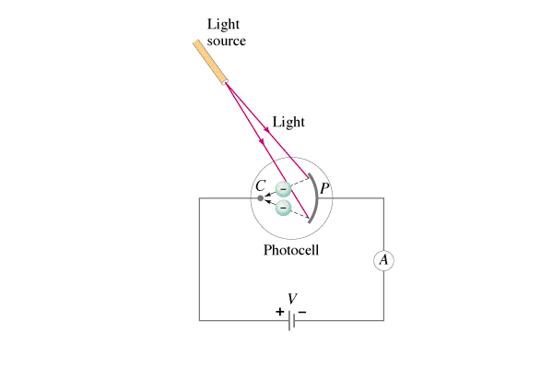**

**Compton Scattering** - Photon scatters (bounces) off an electron. Electron and photon go off in different directions, and photon's wavelength goes down. (Loses energy...)

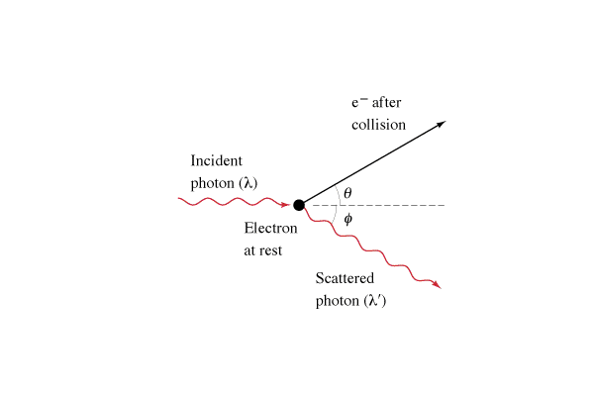

**Absorption** - Photon energy is the same as a transition energy, so it bumps an electron up an energy level and is absorbed

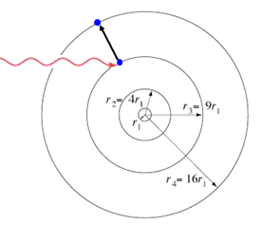

**Pair Production** - A photon passing by a mass (nucleus, or electron) spontaneously creates a matter-anti matter pair.

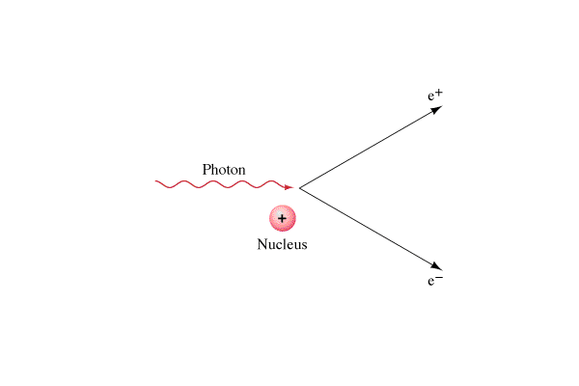 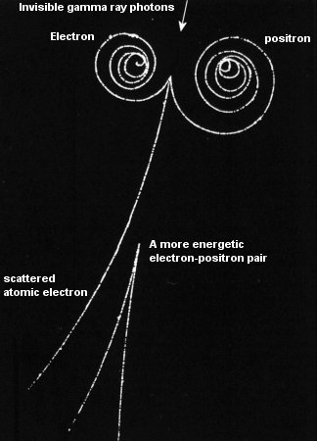

**Complementarity** - Either the wave model, XOR the photon model explains light

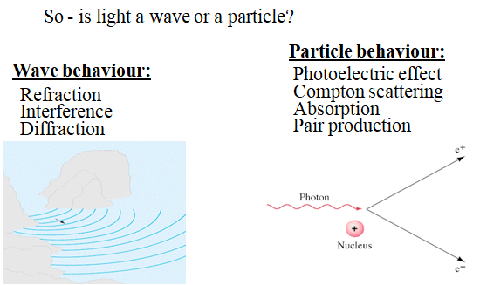

**Noteguide for Photo-Electric Effect - Videos 27EFG Name**

**27EF: Photo-Electric Effect** – Electrons being ejected from a metal by light.

Photon Energy = Work + Kinetic Energy

hf = φ + Emax

hf = hfo + eV

φ - Work function (Depends on material)

fo - Lowest frequency that ejects

e - Electron charge

V - The uh stopping potential

Example 1: A certain metal has a work function of 3.25 eV. When light of an unknown wavelength strikes it, the electrons have a stopping potential of 7.35 V. What is the wavelength of the light?

Example 2: 70.9 nm light strikes a metal with a work function of 5.10 eV. What is the maximum kinetic energy of the ejected photons in eV? What is the stopping potential?

Whiteboards:

|  |  |
| --- | --- |
| 1. Photons of a certain energy strike a metal with a work function of 2.15 eV. The ejected electrons have a kinetic energy of 3.85 eV. (A stopping potential of 3.85 V) What is the energy of the incoming photons in eV? (6.00 eV) | 2. Another metal has a work function of 3.46 eV. What is the wavelength of light that ejects electrons with a stopping potential of 5.00 V?  (147 nm) |
| 3. 112 nm light strikes a metal with a work function of 4.41 eV. What is the stopping potential of the ejected electrons? (6.67 V) | 4. 256 nm light strikes a metal and the ejected electrons have a stopping potential of 1.15 V. What is the work function of the metal in eV?  (3.70 eV) |

**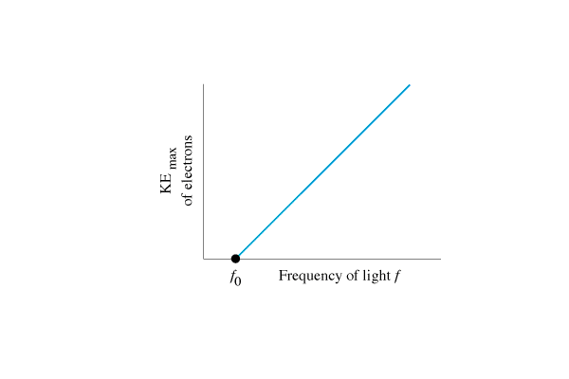27G:** Data:

Photon Theory Predicts:

Wave Theory Predicts:

**Noteguide for Pair Production - Videos 27G1 Name**

**Pair Production** - A photon passing by a mass (nucleus, or electron) spontaneously creates a matter-anti matter pair.

 

**Photon energy = Energy to create matter + Kinetic energy of pair**

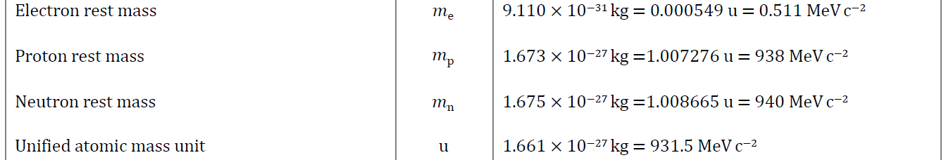

Example 1: What energy photon (in MeV) is needed to create a electron-positron pair each with a kinetic energy of 0.34 MeV? What is the wavelength of that photon?

Example 2: A 0.00025 nm photon creates a electron-positron pair. What is the kinetic energy of each particle?

Whiteboards:

|  |  |
| --- | --- |
| 1. A photon creates a electron-positron pair each with a kinetic energy of 0.170 MeV. What is the energy of the photon? (in MeV) (1.362 MeV) | 2. A 2134 MeV photon creates a proton, antiproton pair, each with how much kinetic energy?  (129 MeV) |
| 3. A photon with a wavelength of 5.27113x10-13 m creates a electron-positron pair with how much kinetic energy each? (answer in keV) (666 keV ) (heheheheh) | |

**Noteguide for de Broglie Waves - Videos 27H Name**

**de Broglie** – If light can act as a particle, then matter can act as a wave.

|  |  |
| --- | --- |
| The wavelength/momentum of a particle:    p = momentum (kg m/s)  h = Planck’s constant = 6.626x10-34 Js  λ = wavelength (m) | The momentum of a particle:    p = momentum (kg m/s)  m = mass (kg)  v = velocity (m/s) |
|  |  |

**Davisson-Germer:**

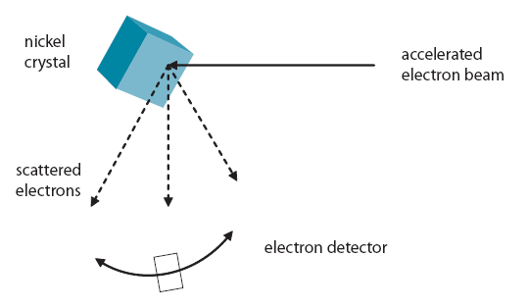

   

Example 1: What is the de Broglie wavelength of a 0.145 kg baseball going 40. m/s?

Example 2: What is the velocity of a proton (m = 1.673x10-27 kg) with a de Broglie wavelength of

600 nm?

Example 3: Through what potential must you accelerate an electron so that it has a wavelength of

1.0 nm?Whiteboards:

|  |  |
| --- | --- |
| 1. What is the de Broglie wavelength of an electron (m = 9.11x10-31 kg) going 1800 m/s?  (404 nm) | 2. What is the momentum of a 600. nm photon?  (1.10 x10-27 kg m/s) |
| 3. What is the mass of a particle that has a de Broglie wavelength of 450 nm, and a velocity of 40.0 m/s? (3.68x10-29 kg) | 4. Electrons in a microscope are accelerated through 12.8 V. (m = 9.11x10-31 kg) What de Broglie wavelength will they have?  (3.428x10-10 m) |

Part 2:

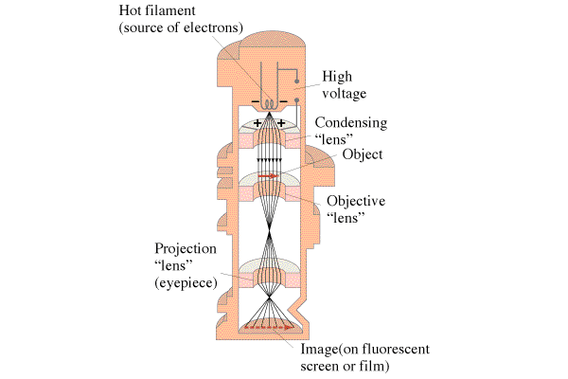 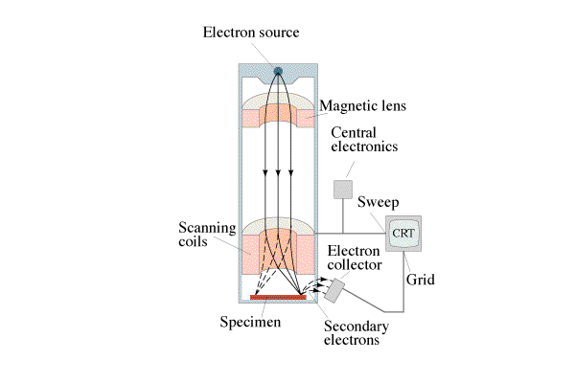 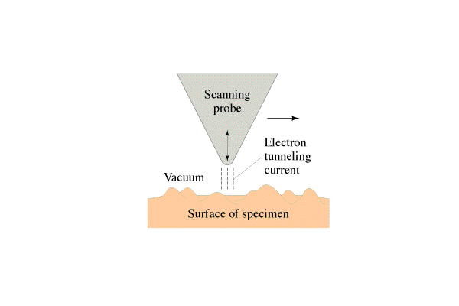

**Noteguide for Nuclear Radius - Videos 27I Name**



Atoms are ≈ 10-10 m in radius

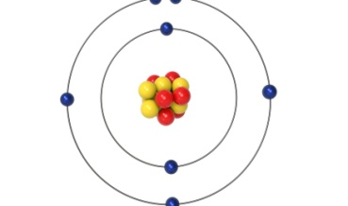Nuclei are ≈ 10-15 m in radius

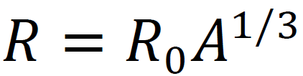

R - Nuclear radius (m)

Ro - Fermi Radius (1.20x10-15 m)

A - Mass # (#p +#n)

Example 1: What is the radius of a Uranium 235 nucleus? (A = 235)

Whiteboard:

What is the radius of a Carbon-12 nucleus? (2.75 fm or 2.75x10-15 m)

**Noteguide for Closest Approach - Videos 27J Name**

**Rutherford** – Discovered the nucleus by scattering alpha particles (2 protons, 2 neutrons bound together) off of gold foil.

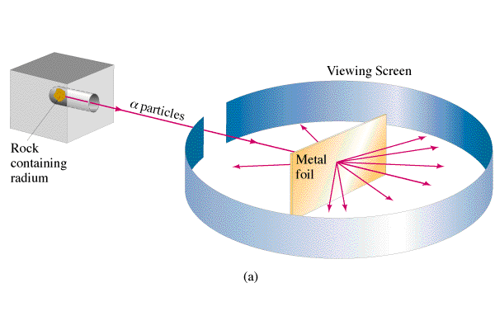

|  |  |
| --- | --- |
| Relationship between energy voltage and charge:    Ve = Voltage (V)  q = Charge (C)  Ep = Electrical Potential energy (J) | Voltage due to a point charge:    Ve = Potential near a point charge (V)  k = 8.99x109 Nm2/C2  q = Charge (C)  r = distance to charge (m) |
| Kinetic Energy:    Ek = Kinetic Energy (J)  m = mass (kg)  v = velocity (m/s) |  |

Example 1: What is the closest approach of an alpha (q = 2e, m = 6.644E-27 kg) particle going 2.6 x 106 m/s if it approaches a carbon nucleus head on?

Example 2: Through what potential must you accelerate an alpha particle to penetrate a Uranium (Z = 92) nucleus? (r = 7.4 fm) (1 fm = 1x10-15 m)

Whiteboards:

What is the closest approach in nm of an Alpha (2p2n) particle going 15,000 m/s to a Gold (Z = 79) nucleus? (49 nm)

An Alpha particle’s closest approach brings it to within 47 fm of a Gold nucleus.

What is its energy in eV? (4.8 MeV or 4.8x106 eV)

**Noteguide for Bohr Atom - Videos 27KL Name**

**27K:** Bohr develops a quantum theory for the atom to explain the spectral lines.

The spectral lines follow a pattern:

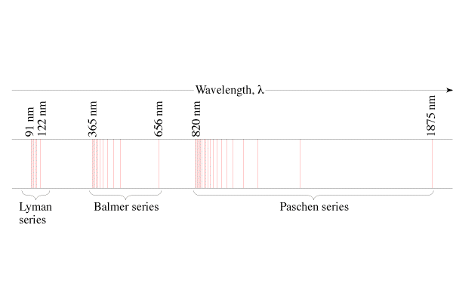

1/λ = R(1/22 - 1/n2), n = 3, 4, ...(Balmer) (Visible)

1/λ = R(1/12 - 1/n2), n = 2, 3, ...(Lyman) (UV)

1/λ = R(1/32 - 1/n2), n = 4, 5, ...(Paschen) (IR)

**Three Assumptions of the Bohr Model:**

**1.** Electrons exist in stationary states that don't radiate energy.

(More about this later - these are resonances)

**2.** Photons are created from the energy given off by downward electron transitions:

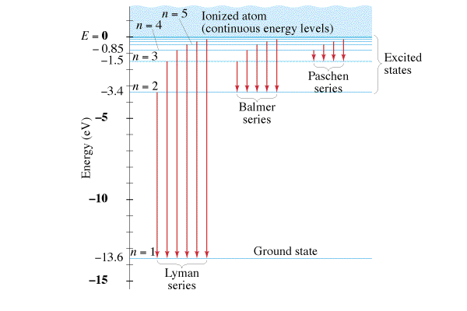

Example 1 – What is the wavelength of the first Lyman line?

**3.** Angular momentum of the electrons is quantised. (Even multiples of h-bar)

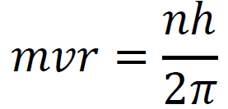Example 2 - Show that mvr = L = Iω,

**Ultimately, the energy levels can be simplified to:**

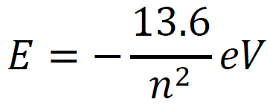n - principal quantum number (orbital)

E - Total energy of electron (KE + PE) in eV

Example 3: What is the energy level of the 4th orbital, and the 2nd orbital?

What wavelength of light corresponds to a 4 to 2 transition for a Hydrogen atom? (The 2nd Balmer line)

**Limitations of the Bohr Model:**

* Works well for H, but doesn’t even work for He
* Did not explain
  + Spectral fine structure
  + Brightness of lines
  + Molecular bonds
* Theory was not complete.
* But otherwise it generally kicked tuckus

Whiteboards:

|  |  |
| --- | --- |
| 1. What possible photon energies can you get from these energy levels? (there are 6 different ones)    (1, 4, 9, 3, 8, 5 eV) | 2. What is the wavelength of the photon released from the third Lyman spectral line  (from -.85 to -13.6 eV)? (97 nm) |
| 3. What is the wavelength of the photon associated with an electron transition from n = 6 to n = 1 in a hydrogen atom? Is the photon being absorbed, or emitted?(93.8 nm, emitted) | 4. What is the wavelength of the photon associated with an electron transition from n = 2 to n = 3 in a hydrogen atom? Is the photon being absorbed, or emitted?(657 nm absorbed) |

**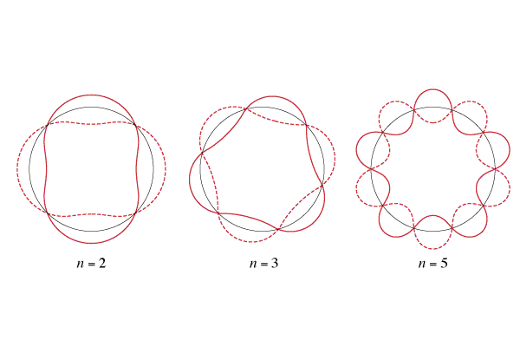27L:** Show that the quantisation amounts to the circumference of the orbit being integer multiples of the de Broglie wavelength. (Bohr did not base his quantum hypothesis on this - it was used after the fact to explain and justify)





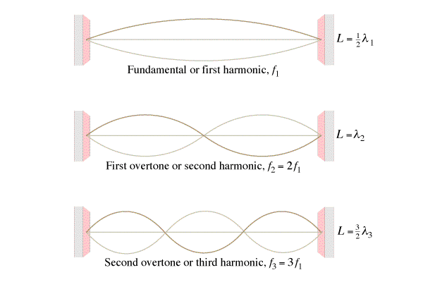

Schrodinger Wave Equation:

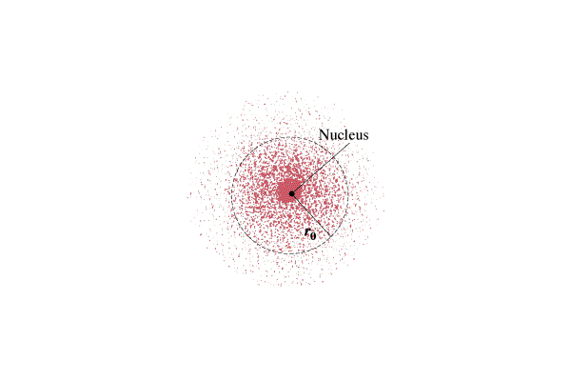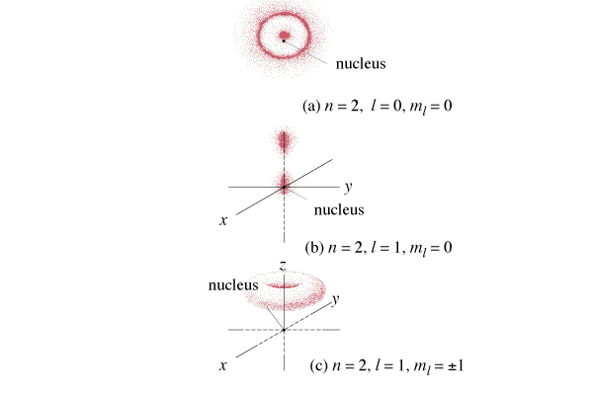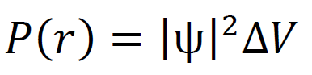

**Noteguide for Copenhagen and Heisenberg - Videos 27MNO Name**

**27M:**

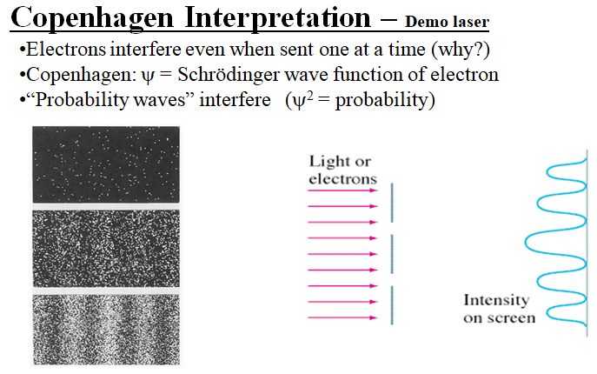

**27N: Heisenberg** – The more accurately you know an object’s position, the less accurately you can know its momentum because observing tiny things like electrons changes their momentum, and resolution is on the order of the wavelength of the photon you use.

Key formula:  Small λ = large p, Large λ = small p

Observing an electron with a small wavelength:

Observing an electron with a large wavelength:

|  |  |
| --- | --- |
| Momentum-position:    Δx = Range of position (m)  Δp = Range of momentum (kg m/s)  h = Planck’s Constant (6.626x10-34 Js) | Energy-time    ΔE = Range of energy (J)  Δt = Range of time (s)  h = Planck’s Constant (6.626x10-34 Js) |

Example 1: What is the uncertainty in the position of a 0.145 kg baseball with a velocity of 37.0 ± 0.3 m/s?

Example 2: An electron stays in the first excited state of hydrogen for a time of approximately Δt = 1.0 x 10-10 s

Determine the uncertainty in the energy of the electron in the first excited state.

Whiteboards

|  |  |
| --- | --- |
| 1. What is the uncertainty of the energy of an electron for an interval of 2.1x10-16 s?  (ΔE = 2.5 x 10-19 J) | 2. To effect an alpha decay, an alpha particle must “borrow” 27.0 MeV of energy. What time does it have to escape?  27.0 MeV = (27.0x106 eV)(1.602x10-19 J/eV)  (Δt =1.22 x 10-23 s) |
| 3. You know an electron’s position is ±0.78 nm, what is the minimum uncertainty of its velocity?  (v = 3.7 x 104 m/s) | 4. A proton has an uncertainty in its velocity of 5.20x106 m/s. (That’s the total range) What is the minimum uncertainty in its position?  (Δx = 6.06 x 10-15 m) |

**270:** The Einstein Bohr Debate:

Einstein objected to: Famous Einstein Quote:

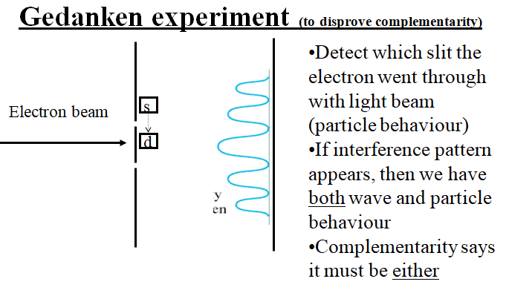

(Why this experiment would not work:)