IB Physics
27.1 Group Quiz
Name
Show your work, and circle your answers and use sig figs to receive full credit.
Part 1 – Photons and the Photoelectric Effect
EM Spectrum v = fλ and v = c = 3.00x10⁸ m/s (299,792,458 m/s)
1. What is the wavelength of a 3.40 GHz light wave? (8.82 cm)

2. What is the frequency of a light wave with a wavelength of 570. nm? (5.26x10¹⁴ Hz)

Photons: 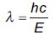
3. What is 13.6 eV in J? (2.18x10⁻¹⁸ J)

4. What is 1.56x10⁻¹⁸ J in eV? (9.74 eV)

5. What is the wavelength of a 7.40 eV photon? (168 nm)

6. What is the energy of a 108 nm photon in J? in eV? (1.84x10⁻¹⁸ J, 11.5 eV)

7. The range of human eyesight (the visible spectrum) is 380 nm (violet) to 740 nm (red). What are those energies in eV? (3.27 eV, and 1.68 eV)

Photoelectric Effect: Photon energy = Work + Kinetic Energy 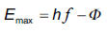
8) 312 nm light ejects photo-electrons from a metal with a work function of 2.56 eV. What is the stopping potential of the photo-electrons? (1.42 V)

9) Light ejects photo-electrons with a stopping potential of 4.12 V from a metal with a work function of 2.10 eV. What is the wavelength of the light? (199 nm)

10) 117. nm light ejects photo-electrons that have a stopping potential of 3.56 V from a metal. What is the work function of the metal in electron volts? (7.05 V)

Conceptual Questions:
27B: How did Max Planck’s interpretation of the energies of particles in their random thermal oscillations differ from a classical view? Initially, did he think that this was real, or was it in his opinion, a mathematical trick?

27C: How did Einstein’s photon theory come from Planck’s quantum theory, and how was it different from the prevailing wave theory of light?

27D: How do the photon and wave theory of light differ in explaining bright vs. dim light?

27D: How do photon and wave theory differ in explaining color?

27D1: List the four common photon interactions with matter. For each one, tell what it is (What happens) and also why it is something that a wave just wouldn’t do.

27E: What is the photoelectric effect? Why do the photoelectrons not have all the same KE? How did Einstein propose to measure the kinetic energies of photoelectrons?

27E: The photon and wave theories of light have different predictions about whether brightness or wavelength affects the energy of the ejected photoelectrons. What are they and why are they that way?

Part 2 – Pair production and de Broglie Wavelength
Pair Production: Photon energy = matter particle + antimatter particle + KE + KE
1. A photon creates a proton/anti proton pair each with 98.0. MeV of kinetic energy. What is the maximum wavelength the photon could have? (5.99x10⁻¹⁶ m)

2. A photon with a wavelength of 4.47x10⁻¹³ m creates an electron/positron pair each with what maximum kinetic energy? (0.877 MeV)

3. A 1.30x10⁻¹⁵ m photon creates a charged matter/anti matter pair each having a kinetic energy of 337 MeV. What is the rest mass of the particles created in MeV? (140. MeV)

de Broglie Wavelength: $p= \frac{h}{λ}$ $p=mv$ (Memorize the first one)
4. What is the de Broglie wavelength of an electron with a velocity of 8730 m/s? (83.3 nm)

5. What is the mass of a particle that has a de Broglie wavelength of 550. nm, and a velocity of 0.1814 m/s? (6.64x10⁻²⁷ kg)

6. What is the velocity of a proton with a de Broglie wavelength of 740. nm? (0.535 m/s)
Conceptual Questions:
G1: How do you identify pair production in bubble chamber tracks? (draw a picture)

G1: What happens to the anti-matter particles that pair production creates?

G1: Immediately after the big bang, there were many energetic photons, capable of creating matter/anti-matter particles of great size. The expansion of the new universe stretched the photons, decreasing their wavelength.

a. What happened to the energy of the photons when the wavelength increased?

b. What happened to the mass of the particles they could create?

c. If matter particles from the big bang were created by pair production, why is there still matter left? (i.e. why haven't all the matter particles annihilated their anti-matter partners?

H. Why don't we see the wave behaviour of things like baseballs?

H. Why are electrons used in electron microscopes? Why not use light?

H. If electrons can be waves, could electron orbits around atoms be standing waves? (i.e. there are only certain properly defined states they could be in...)

IB Physics

FA27.1 - Photon Theory

Name

Best Reason to Rebel

Show your work, circle your answers, and use sig figs to receive full credit.

1. What is the wavelength of a 150. kHz radio wave?

What is the frequency of a 2.00 m radio wave?

2. What is the wavelength of a 1.80 eV photon?

What is the energy in electron volts of a 150. nm photon?

3. 400. nm light ejects photo-electrons from a metal that have a stopping potential of 1.17 V. What is the work function of the metal in electron volts?

What wavelength of light would eject photo electrons with a stopping potential of 2.60 V?

4. A photon creates an electron/positron pair each having 0.211 MeV of kinetic energy. What is the wavelength of the photon?

5. What is the velocity of an electron with a wavelength of 12.0 nm?

Problems from 27.1 - Photon Theory
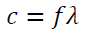
- What is the frequency of a 3.00 m long radio wave? (1.00x10⁸ Hz)
- What is the frequency of a 400. nm light wave? (7.50x10¹⁴ Hz)
- What is the frequency of a 12.0 cm microwave? (2.50x10⁹ Hz)
- What is the wavelength of a 91.1 MHz FM radio wave? (3.29 m)
- What is the wavelength of a 60.0 Hz radio wave? (5.00x10⁶ m)
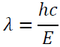
- What is the wavelength of a 2.13 eV photon? (583 nm)
- What is the energy in eV of a 400. nm light wave? (3.10 eV)
- What is the energy in eV of a 700. nm light wave? (1.77 eV)
- What is the wavelength of a 1.20 MeV photon? (1.03x10⁻¹² m)
- What is the energy of a 0.00130 nm photon in eV? (9.54x10⁵ eV)
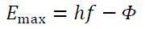
- 415 nm light ejects photo-electrons from a metal with a work function of 2.06 eV. What is the stopping potential of the photo-electrons? (0.930 V)
- 213 nm light ejects photo-electrons from a metal with a work function of 3.10 eV. What is the kinetic energy of the photo-electrons in eV? (2.73 eV)
- 117. nm light ejects photo-electrons that have a stopping potential of 3.56 V from a metal. What is the work function of the metal in electron volts? (7.05 eV)
- Light ejects photo-electrons that have a stopping potential of 1.17 V from a metal with a work function of 2.36 eV. What is the wavelength of the light? (352 nm)
- 315 nm light ejects photo-electrons from a metal that have a stopping potential of 2.65 V. What is the work function of the metal in electron volts? (1.29 eV)
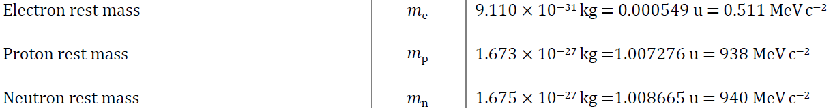
- A photon creates a proton/anti proton pair each with 180. MeV of kinetic energy. What is the maximum wavelength the photon could have? (5.55x10⁻¹⁶ m)
- A photon with a wavelength of 7.21x10⁻¹³ m creates an electron/positron pair each with what maximum kinetic energy? (0.349 MeV)
- A photon creates an electron/positron pair each with 3.20 MeV of energy. What is its wavelength? (1.67x10⁻¹³ m)
- A 5.85x10⁻¹⁶ m photon creates a neutron/anti neutron pair each with what kinetic energy? (121 MeV)
- A 3.20x10⁻¹⁵ m photon creates a charged matter/anti matter pair each having a kinetic energy of 53.9 MeV. What is the rest mass of the particles created in MeV? (140. MeV)
←This is not in the data packet
- What is the velocity of a proton with a de Broglie wavelength of 450. nm? (0.880 m/s)
- What is the mass of a particle that has a de Broglie wavelength of 926 nm, and a velocity of 0.265 m/s? (2.70x10⁻²⁷ kg)
- What is the de Broglie wavelength of an electron with a velocity of 1750 m/s? (416 nm)
- What is the velocity of proton with a de Broglie wavelength of 1.00 x 10⁻¹⁰ m? (3.96x10³ m/s)
- A particle going 1200. m/s has a de Broglie wavelength of 137 nm. What is the mass of the particle? (4.03x10⁻³⁰ kg)

IB Physics
27.2 Group Quiz
Name
Show your work, and circle your answers and use sig figs to receive full credit.
Closest Approach: E_{k} = ¹/₂mv² 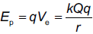 Q = 2e, q = Ze 1 fm = 10⁻¹⁵ m
1. An alpha particle (m = 6.64x10⁻²⁷ kg) going 5.36x10⁷ m/s will get how close to a lead (Z = 82) nucleus if it hits head on? (3.97 fm)

2. A speeding alpha particle (m = 6.64x10⁻²⁷ kg) hits a cobalt (Z = 27) nucleus head on. If it comes within 56.0 fm of the nucleus’ center, how fast was it going to start with? (8.19x10⁶ m/s)

3. A 36.0 MeV alpha particle (m = 6.64x10⁻²⁷ kg) can get how close to a gold nucleus (Z = 79)? (36.0 MeV is the KE)
(6.32 fm)

Bohr Atom: and 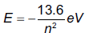
4. What is the wavelength of the photon associated with an electron transition from n = 2 to n = 1 in a hydrogen atom? Is the photon being absorbed, or emitted? (122 nm – emitted)

5. What is the wavelength of the photon associated with an electron transition from n = 2 to n = 5 in a hydrogen atom? Is the photon being absorbed, or emitted? (434 nm – absorbed)

Nuclear Radius: 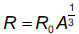 R_{o} = 1.2 x 10⁻¹⁵ m (1.2 fm)
6. What is the radius of Cl-36 nucleus? (3.96 fm)

7. What is the likely mass number of a nucleus with a radius of 7.064x10⁻¹⁵ m? (204)

Heisenberg Indeterminacy: 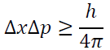 or 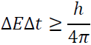
8. To effect an alpha decay, an alpha particle must “borrow” 23.0 MeV of energy. What time does it have to escape? (1.43x10⁻²³ s)

9. A proton has an uncertainty in its velocity of ±1.20x10⁶ m/s. What is the minimum uncertainty in its position? (13.1 fm)

Conceptual Questions:
I: How was Rutherford's atomic model different from Thomson's "plum pudding" model?

I: How did Rutherford discover the nucleus? What size did he determine for the atom and the nucleus?

I1: How does the density of a nucleus change with mass number? What is the density of the Uranium-235 nucleus? What is the density of the carbon-12 nucleus? Calculate both densities: (2.3x10¹⁷ kg m⁻³)
m = A(1.661x10⁻²⁷ kg), V = ⁴/₃πr³, ρ = ^{m}/_{V}

K: Specifically what phenomenon, what observed behavior of atoms was Bohr trying to explain with his quantum atomic model?

N: Energy indeterminacy accounts for nuclear decay - particles in the nucleus "borrow" energy to escape - Where does the energy come from that they "borrow", and where does it go after it has escaped?

O: What was the Einstein-Bohr debate about? What did Einstein object to in quantum mechanics?

Part A: Find the missing decay product:
1 | τ⁻ → π⁻ + πº + ??  υ_{τ} | ?? → π⁺ + πº + $\overline{{}_{τ}}$  τ⁺ | τ⁻ → υ_{τ} + ?? + $\overline{{}_{e}}$  e⁻ | τ⁺ → $\overline{{}_{τ}}$ + e⁺ + ??  υ_{e}
2 | τ⁻ → ?? + μ⁻ + $\overline{{}_{μ}}$  υ_{τ} | τ⁺ → ?? + μ⁺ + υ_{μ}  $$\overline{{}_{τ}}$$ | ?? → e⁻ + $\overline{{}_{e}}$ + υ_{μ}  μ⁻ | μ⁺ → e⁺ + ?? + $\overline{{}_{μ}}$  υ_{e}
3 | μ⁻ → e⁻ + $\overline{{}_{e}}$ + υ_{μ} + e⁺ + ??  e⁻ | μ⁺ → e⁺ + ?? + $\overline{{}_{μ}}$ + e⁺ + e⁻  υ_{e} | $K_{L}^{o}$ → π⁺ + ?? + $\overline{{}_{μ}}$  μ⁻ | K⁺ → ?? + υ_{μ}  μ⁺

Part B: For these reactions, indicate if it is possible, or indicate every law it violates:
1 | p + n → K⁺ + ηº + Ξº  No, baryon number, Strangeness | p + n → p + $\overline{p}$ + $\overline{n}$  No, charge and baryon number | n + n → Λº + Σº  No, Strangeness | n + n → Ω⁺ + Ω⁻  No, baryon number
2 | p + p → Ω⁺ + e⁺ + Λº + Σº + n  No, Le, Strangeness | p + p → p + n + n + Ω⁺  No, Strangeness | p + p → τ⁺ + υ_{τ} + μ⁺ + $\overline{υ_{μ}}$  No, Baryon and Lμ | p + n → n + n + τ⁺ + υ_{τ}  Yes
3 | p + $\overline{p}$ → τ⁻ + Λº + Ω⁺ + $\overline{υ_{τ}}$  No, Strangeness | p + $\overline{n}$ → τ⁺ + τ⁻  No, charge | $\overline{n}$ + n → τ⁺ + τ⁻  Yes | p + $\overline{p}$ → Σ⁻ + Ω⁺  No, Strangeness
4 | p + p → p + p + πº  yes | p + p → p + n + π⁺  yes | n + n → Ξ⁺ + $\overline{{}^{o}}$+ Ω⁻ + n + n + n  yes | π⁻ + p → πº + n + π⁻ + π⁺  yes

Part C: Write the quark combinations that make up a proton and a neutron: p = n =
Identify the following quark combinations as either a meson, or a baryon. Determine the baryon number, strangeness, and the charge of each:
 |  | Baryon or Meson? | B = ? | S = ? | 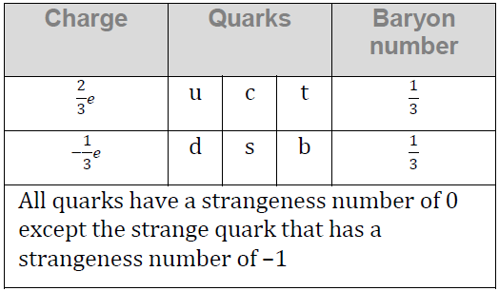  q = ?
1 | s$\overline{s}$ | M | 0 | 0 | 0
2 | dsc | B | +1 | -1 | 0
3 | $$\overline{u}\overline{u}\overline{u}$$ | B | -1 | 0 | -2
4 | s$\overline{u}$ | M | 0 | -1 | -1
5 | d$\overline{s}$ | M | 0 | +1 | 0
6 | sss | B | +1 | -3 | -1  Data Packet reference for decays:
7 | $$\overline{u}\overline{u}\overline{c}$$ | B | -1 | 0 | 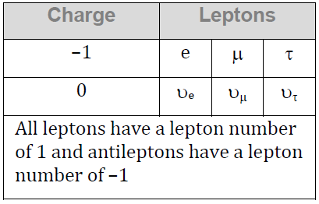  -2
8 | u$\overline{s}$ | M | 0 | +1 | +1
9 | c$\overline{d}$ | M | 0 | 0 | +1
10 | $$\overline{s}\overline{s}\overline{c}$$ | B | -1 | +2 | 0
11 | ucc | B | +1 | 0 | +2
12 | s$\overline{b}$ | M | 0 | -1 | 0

IB Physics
Feynman Diagrams Group Quiz
Name
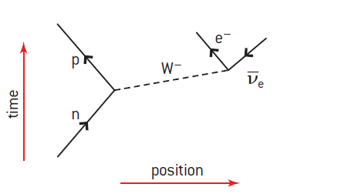
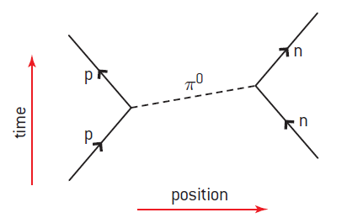
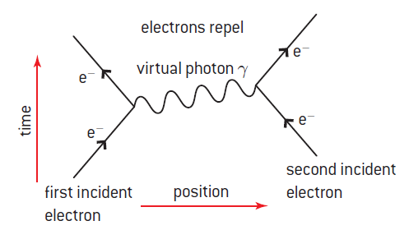
Examples: (Read Oxford 300-302)

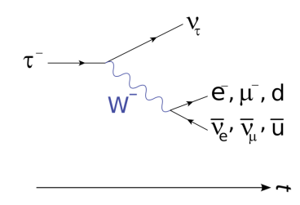

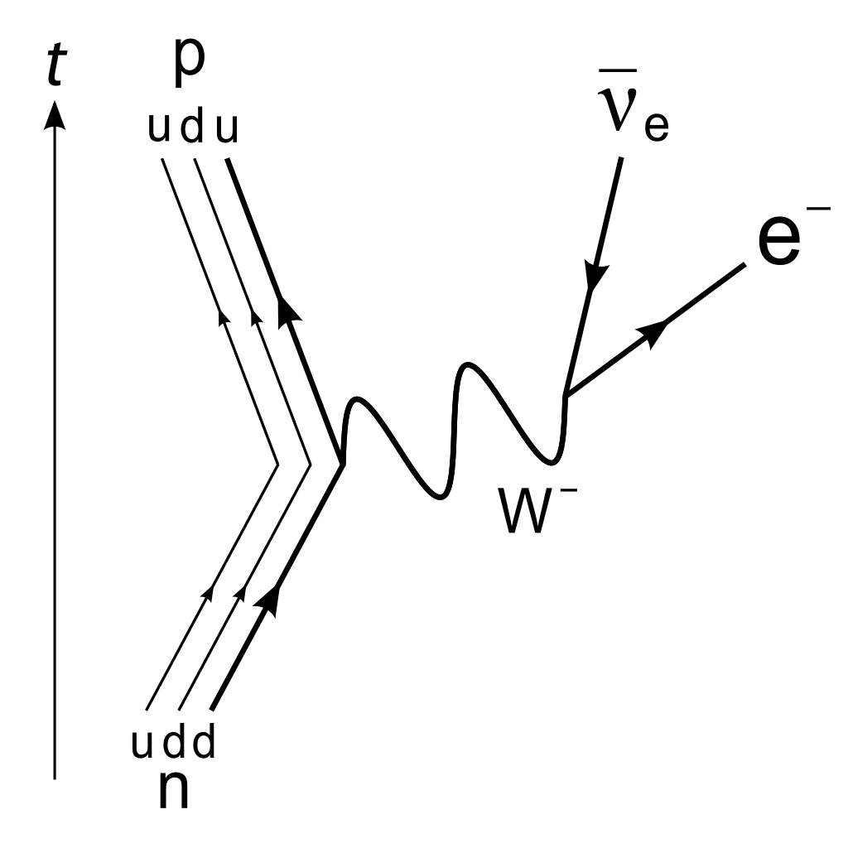
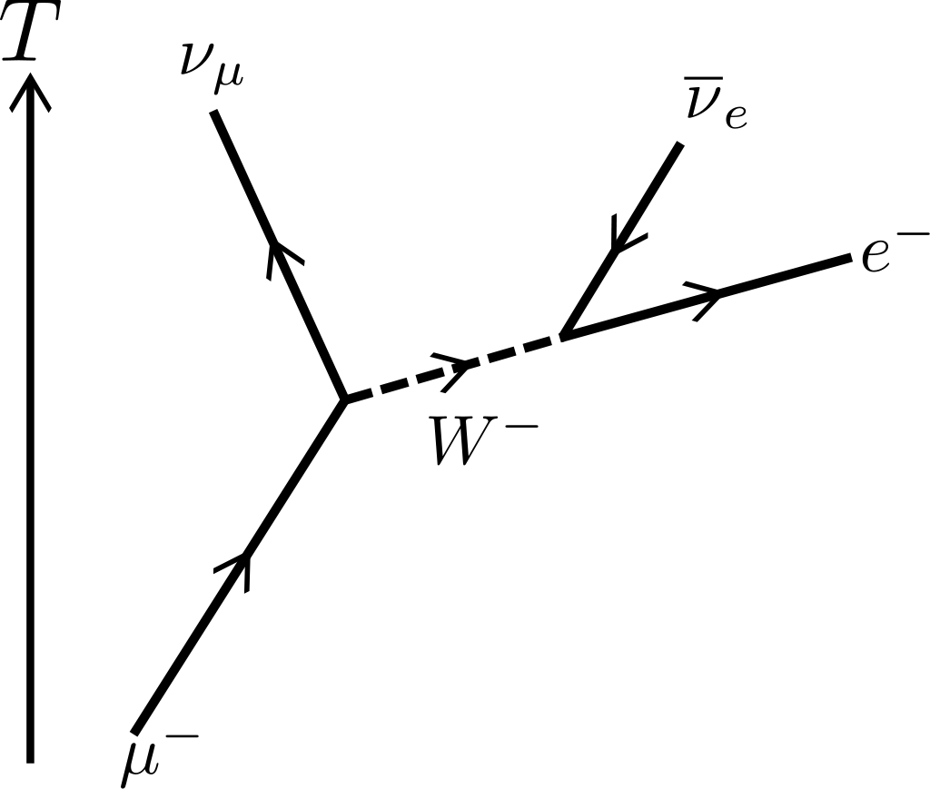

Beta Decay Beta Decay Muon decay Tau decay

Draw the following Feynman diagrams:
B⁻ decay: n → p + e⁻ + υ_{e} | B+ decay: p → n + e⁺ + υ_{e}
μ⁻ decay: μ⁻ → υ_{μ} + e⁻ + υ_{e} | μ⁺ decay: μ⁺ → υ_{μ} + e⁺ + υ_{e}

τ⁻ decay: τ⁻ → υ_{τ} + μ⁻ + υ_{μ} | τ⁺ decay: τ⁺ → υ_{τ} + μ⁺ + υ_{μ}
Electron - electron collision: (Label the exchange particle) | Neutron proton Collision: (Label the exchange particle)
Proton electron collision: p + e- → n + υ_{e} | Two types of Neutron electron Neutrino collisions:  n + υ_{e} → υ_{e} + n and n + υ_{e} → p + e⁻

IB Physics

FA27.2 - Atomic and Particle

Name

Best Reason to Conform

Show your work, circle your answers, and use sig figs to receive full credit.

1. How fast must an alpha particle (m = 6.64x10⁻²⁷ kg) go to get within 5.0x10⁻¹⁵ m of an Iron nucleus (Z = 26)

2. What is the wavelength of the photon associated with an electron transition from n = 2 to n = 7 in a hydrogen atom? Is the photon being absorbed, or emitted?

3. What is the radius of U-235?

If the uncertainty of an electron's position is 1.20x10⁻¹⁰ m, what is the minimum uncertainty (the total range) of its velocity?

4. For the decays, find the missing particle. For the reactions, indicate if it is possible, or indicate every law it violates:
μ⁺→ ?? + υ_{e} + $\overline{υ_{μ}}$  e+ | μ⁺ → e⁺ + ?? + $\overline{{}_{μ}}$ + e⁺ + e⁻  υ_{e} | p + p → p + n + ${\overline{Σ}}^{+}$ + Λº  ^{yes} | p + n → K⁺ + n + n + n + $\overline{p}$  No, charge, strangeness

5. Write the quark combinations that make up a proton and a neutron: p = n =

Identify the following quark combinations as either a meson, or a baryon. Determine the baryon number, strangeness, and the charge of each:

 | Baryon or Meson? | B = ? | S = ? | q = ?
usb | B | 1 | -1 | 0
d$\overline{s}$ | M | 0 | +1 | 0
uuc | B | 1 | 0 | +2
c$\overline{u}$ | M | 0 | 0 | 0

Problems from 27.2 - Atomic Physics

Closest Approach: 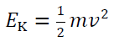 and 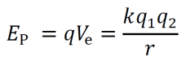 q₁ = 2e, q₂ = Ze
- An alpha particle (m = 6.64x10⁻²⁷ kg) going 5.14x10⁶ m/s will get how close to a silver (Z = 47) nucleus if it hits head on? (2.47x10⁻¹³ m)
- A speeding alpha particle (m = 6.64x10⁻²⁷ kg) hits a mercury (Z = 80) nucleus head on. If it comes within 17.0 nm of the nucleus’ center, how fast was it going to start with? (2.56x10⁴ m/s)
- An alpha particle (m = 6.64x10⁻²⁷ kg) going 4.12x10⁶ m/s will get how close to a bismuth (Z = 83) nucleus if it hits head on? (6.80x10⁻¹³ m)
- A speeding alpha particle (m = 6.64x10⁻²⁷ kg) hits a lead (Z = 82) nucleus head on. If it comes within 12.0 nm of the nucleus’ center, how fast was it going to start with? (3.08x10⁴ m/s)
- An alpha particle (m = 6.64x10⁻²⁷ kg) going 2.37x10⁶ m/s will get how close to a gold (Z = 79) nucleus if it hits head on? (1.95x10⁻¹² m)

Electron Transitions: 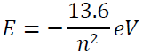 and
- What is the wavelength of the photon associated with an electron transition from n = 3 to n = 1 in a hydrogen atom? Is the photon being absorbed, or emitted? (103 nm, emitted)
- What is the wavelength of the photon associated with an electron transition from n = 3 to n = 6 in a hydrogen atom? Is the photon being absorbed, or emitted? (1095 nm, absorbed)
- What is the wavelength of the photon associated with an electron transition from n = 2 to n = 1 in a hydrogen atom? Is the photon being absorbed, or emitted? (122 nm, emitted)
- What is the wavelength of the photon associated with an electron transition from n = 2 to n = 4 in a hydrogen atom? Is the photon being absorbed, or emitted? (487 nm, absorbed)
- What is the wavelength of the photon associated with an electron transition from n = 6 to n = 2 in a hydrogen atom? Is the photon being absorbed, or emitted? (411 nm, emitted)

Nuclear Radius or Heisenberg: 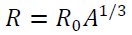 or or
- What is the radius of C-14 nucleus? (2.89x10⁻¹⁵ m)
- What is the likely mass number of a nucleus with a radius of 3.51x10⁻¹⁵ m? (25)
- To effect an alpha decay, an alpha particle must “borrow” 31.1 MeV of energy. What time does it have to escape? (1.06x10⁻²³ s)
- An Alpha particle takes 1.80x10⁻²³ s to "tunnel" through a potential barrier. What is the amount of energy it can "borrow" during this time in MeV? (18.3 MeV)
- An electron has an uncertainty in its velocity of ±2.10x10⁴ m/s. What is the minimum uncertainty in its position? (1.38x10⁻⁹ m)
- An electron has an uncertainty in its position of 2.40x10⁻¹⁰ m (total range) . What is the minimum uncertainty (the total range) of its velocity? (2.41x10⁵ m/s)
- A proton has an uncertainty in its position of 3.51x10⁻¹⁵ m (total range). What is the minimum uncertainty (the total range) of its velocity? (8.98x10⁶ m/s)
- A proton has an uncertainty in its velocity of ±4.30x10⁶ m/s. What is the minimum uncertainty in its position? (3.66x10⁻¹⁵ m)

IB Physics
FA 30.2 - Nuclear Reactions
Name

What you will miss the most about TuHS Physics

Murray Dedicated
Show your work, circle your answers, and use sig figs to receive full credit.
1 u = 1.6605E-27 kg = 931.5 MeV, ¹₁H = 1.007825 u, ¹₀n = 1.008665 u
1. What is the binding energy and the binding energy per nucleon of Ca-44?

2. Fill in the table (not all these reactions occur)
¹⁶₈O (α , t) ??  ¹⁷₉F | ?? (p , n) ²³⁹₉₄Pu  ²³⁹₉₃Np | ¹⁶₈O (α , ??) ¹⁹₁₀Ne  ¹₀n | ²⁸₁₄Si (?? ,n) ²⁸₁₅P  ¹₁p

3. Find the Q value for this nuclear reaction: ⁷₃Li(t,n)⁹₄Be. Label the reaction as either energy requiring (endoergic) or energy releasing (exoergic) (you will have to look up the masses in the table...)

4-5: Consider this fission reaction: ²³⁵₉₂U + ¹₀n → ¹⁴⁸₅₇La + ⁸⁵₃₅Br + some neutrons
U-235 = 235.043923 u, La-148 = 147.932191 u, Br-85 = 84.915608 u (These masses will be given to you here)
4. How many neutrons are released? (3)

5. What is the Q value for this reaction?

W30.2 - Problems from 30.2 - Nuclear Reactions - (you will get a table of neutral atom masses)

Binding Energy: ¹₁H = 1.007825 u
- Find the binding energy and the binding energy per nucleon of Helium-4 (28.30 MeV, 7.074 MeV)
- Find the binding energy and binding energy per nucleon of Fluorine-19. (147.8 MeV, 7.779 MeV)
- Find the binding energy and binding energy per nucleon of Silicone-28. (236.5 MeV, 8.448 MeV)
- Find the binding energy and binding energy per nucleon of Argon-36. (306.7 MeV, 8.520 MeV)
- Find the binding energy and binding energy per nucleon of Chromium-52. (456.3 MeV, 8.776 MeV)

6. Balancing Nuclear Reactions: Find the missing nucleus: d = deuterium, t = tritium
a. | b. | c. | d.
? (t,p) ⁴⁰₁₇Cl  ³⁸₁₇Cl | ⁵²₂₃V (n,?)⁵¹₂₂Ti  ²₁H or d | ⁶⁵₂₈Ni ( ?,n)⁶⁸₃₀Zn  ⁴₂He or α | ⁸¹₃₇Rb(p,γ)?  ⁸²₃₈Sr
?(α,p) ⁴⁴₂₂Ti  ⁴¹₂₁Sc | ⁵¹₂₄Cr (α,?)⁵⁵₂₆Fe  ⁰₀γ | ²²₁₀Ne(d,?)²³₁₁Na  ¹₀n | ²⁸₁₄Si(α,n)?  ³¹₁₆S
?(d,α)¹⁰₅B  ¹²₆C | ¹⁴⁵₆₆Dy (d,n)?  ¹⁴⁶₆₇Ho | ?(t,n)¹¹₅B  ⁹₄Be | ⁷₃Li(?,p)⁸₃Li  ²₁H or d

Finding the Q value: Find the Q value for the following reactions. Label the reaction as either energy requiring, (endoergic) or energy releasing (exoergic). You will need to look up the masses in a table.
- ⁷₃Li(p,α)⁴₂He. (Exo, Q = 17.35 MeV)
- ⁶₃Li(n,α)³₁H. (Exo, Q = +4.783 MeV)
- ⁷₃Li (α, n) ¹⁰₅B. (Endo, Q = -2.790 MeV)
- ¹²₆C(t,n)¹⁴₇N. (Exo, Q = 4.015 MeV)
- ¹⁴₇N(α,p)¹⁷₈O. (Endo, Q = -1.192 MeV)

Fission Reactions: For each of the following (fictitious) fission reactions, determine the number of free neutrons liberated, and the Q value of the reaction as a whole: (Use these masses – these are not stable nuclei so they are not in your reference)
- ²³⁵₉₂U + ¹₀n → ¹⁴¹₅₆Ba + ⁹⁰₃₆Kr + some neutrons. U-235 = 235.043923 u, Ba-141 = 140.914406 u, Kr-90 = 89.919524 u (5 neutrons, Q = +163.3 MeV)
- ²³⁵₉₂U + ¹₀n → ¹³⁸₅₅Cs + ⁹²₃₇Rb + some neutrons. U-235 = 235.043923 u, Cs-138 = 137.911011 u, Rb-92 = 91.919725 u (6 neutrons, Q = +158.2 MeV)
- ²³⁵₉₂U + ¹₀n → ¹³⁷₅₄Xe + ⁹⁵₃₈Sr + some neutrons. U-235 = 235.043923 u, Xe-137 = 136.911563 u, Sr-95 = 94.919358 u (4 neutrons, Q = +174.2 MeV)
- ²³⁵₉₂U + ¹₀n → ¹²⁶₄₈Cd + ¹⁰⁷₄₄Ru + some neutrons. U-235 = 235.043923 u, Cd-126 = 125.922354 u, Ru-107 = 106.909907 u (3 neutrons, Q = +181.0 MeV)
- ²³⁵₉₂U + ¹₀n → ¹²⁶₄₉In + ¹⁰⁸₄₃Tc + some neutrons. U-235 = 235.043923 u, In-126 = 125.916465 u, Tc-108 = 107.918480 u (2 neutrons, Q = +186.6 MeV)

IB Physics
FA 30.1 - Radioactive Decay
Name

What you will miss least about TuHS
Show your work, circle your answers, and use sig figs to receive full credit.
1 u = 1.6605x10⁻²⁷ kg = 931.5 MeV, ¹₀n = 1.008665 u
1. Find the missing particle or nucleus in these decays: (These are fictitious - ignore neutrinos for now)
⁸³₃₉Y → ?? + α  ⁷⁹₃₇Rb | ?? → ⁴⁹₂₂Ti + β⁻  ⁴⁹₂₁Sc | ⁵⁰₂₄Cr → ⁵⁰₂₃V + ??  β⁺ | ⁵⁴₂₆Fe → ?? + γ  ⁵⁴₂₆Fe

2. What is the kinetic energy of the alpha particle that 208Po (m = 207.981222 u) gives off becoming 204Pb (m = 203.973020) in MeV?

3. Imagine it is possible for ${}_{7}^{14}N$ undergo both β⁻ and β⁺ decay. Write the complete decay equation below for each (complete with neutrino or anti-neutrino)

${}_{7}^{14}N$ → ${}_{8}^{14}O$ + β⁻ + $\overline{{}_{e}}$
${}_{7}^{14}N$ → ${}_{6}^{14}C$ + β⁺ + υ_{e}

4. You have 24.0 grams of a radioactive substance with a half life of 14.0 minutes. In what time will you have 3.00 grams of it left?

5.The activity of a sample with a half-life of 23.5 minutes is initially 3.412x10⁶ counts/second. What will it be in 6.00 hours?

If K-40(m = 39.964 u) had a half life of 14.0 hours, (It's actually stable) what would be the activity of 0.0240 grams of it?
W30.1 - Problems from 30.1 - Radioactive Decay (Use your Isotope reference for this)
1. Find the missing particle or nucleus in these decays: (ignore neutrinos for this)
a. | b. | c. | d.
${}_{24}^{55}{Cr}$ → ${}_{22}^{51}{Ti}$ + ??  α | ${}_{24}^{55}{Cr}$ → ${}_{23}^{55}V$ + ??  β⁺ | ${}_{24}^{55}{Cr}$ → ${}_{25}^{55}{Mn}$ + ??  β⁻ | ${}_{24}^{55}{Cr}$ → ${}_{24}^{55}{Cr}$ + ??  γ
${}_{19}^{43}K$ → ?? + γ  $${}_{19}^{43}K$$ | ${}_{19}^{43}K$ → ?? + α  $${}_{17}^{39}{Cl}$$ | ${}_{19}^{43}K$ → ?? + β⁻  ${}_{20}^{43}{Ca}$ | ${}_{19}^{43}K$ → ?? + β⁺  $${}_{18}^{43}{Ar}$$
?? → ${}_{13}^{27}{Al}$ + β⁺  $${}_{14}^{27}{Si}$$ | ?? → ${}_{13}^{27}{Al}$ + α  $${}_{15}^{31}P$$ | ?? → ${}_{13}^{27}{Al}$+ γ  $${}_{13}^{27}{Al}$$ | ?? → ${}_{13}^{27}{Al}$ + β⁻  $${}_{12}^{27}{Mg}$$

Alpha Decay - Find the energy released in MeV of these alpha decays:
- 208Po (m = 207.981222 u) → 204Pb (m = 203.973020) + α (5.216 MeV)
- 152Dy (m = 151.9247139 u) → 148Gd (m = 147.9181098) + α (3.272 MeV)
- No-257 (m = 257.0968528 u) → Fm-253 (m = 253.0851763) + α (8.452 MeV)
- Pa-226 (m = 226.0279327 u) → Ac-222 (m = 222.0178289) + α (6.987 MeV)
- Am-234 (m = 234.0477940 u) → Np-230 (m = 230.0378126) + α (6.873 MeV)

Balanced Beta decays
7. Imagine it is possible for the following nuclei to undergo both β⁻ and β⁺ decay. Write the complete decay equation for each:
a. ${}_{9}^{19}F$  ${}_{9}^{19}F$ → ${}_{10}^{19}{Ne}$ + β⁻ + $\overline{{}_{e}}$  ${}_{9}^{19}F$ → ${}_{8}^{19}O$ + β⁺ + υ_{e} | b. ${}_{11}^{23}{Na}$  ${}_{11}^{23}{Na}$ → ${}_{12}^{23}{Mg}$ + β⁻ + $\overline{{}_{e}}$  ${}_{11}^{23}{Na}$ → ${}_{10}^{23}{Ne}$ + β⁺ + υ_{e} | c. ${}_{20}^{44}{Ca}$  ${}_{20}^{44}{Ca}$ → ${}_{21}^{44}{Sc}$ + β⁻ + $\overline{{}_{e}}$  ${}_{20}^{44}{Ca}$ → ${}_{19}^{44}K$ + β⁺ + υ_{e} | d. ${}_{24}^{55}{Cr}$  ${}_{24}^{55}{Cr}$ → ${}_{25}^{55}{Mn}$ + β⁻ + $\overline{{}_{e}}$  ${}_{24}^{55}{Cr}$ → ${}_{23}^{55}V$ + β⁺ + υ_{e}

Half Life and Decay Rates - Integer number of half life
- A radioactive substance has a half life of 13.0 s. If you have an activity of 480. counts per second initially, what is the activity in 65.0 s? (15.0 counts/s)
- A radioactive substance has a half life of 2.50 years. If you have 128. g initially, after what time do you have only 2.00 grams left? (15.0 years)
- A radioactive substance starts off with 3240 atoms, and in 48.0 minutes, is down to 405 atoms. What is its half life? (16.0 minutes)
- A radioactive substance has a half life of 47.0 s. If you have 1920 g initially, how much is left after 329 s? (15.0 grams)
- A radioactive substance has a half life of 12.0 minutes. If you have an activity of 5.12x10⁴ counts/sec initially, after what time do you have an activity of 1.28x10⁴ counts/sec? (24.0 minutes)
- A radioactive substance starts off with 3.20x10²⁰ atoms, and in 85.0 minutes, is down to 1.00x10¹⁹ atoms. What is its half life? (17.0 minutes)

Half life and Decay Rates:
- You have 45.0 grams initially of a sample with a half-life of 178 seconds. In what time will there be only 13.0 grams left? (319 s)
- You have 78.0 grams of undecayed nuclei initially, and in 68.0 hours you have only 45.0 grams left. What is the half-life in hours? (85.7 hours)
- A sample has a half-life of 13.7 seconds. If its activity is initially 196 counts per second, what will it be in 60.0 seconds? (9.42 counts/sec)
- A sample has a half-life of 34.0 minutes. If after 87.0 minutes the activity is 137 counts per second, what was the activity initially? (807 counts/sec)
- At first the activity of a radioactive sample is 278 counts per minute, and after 17.0 hours the activity is 171 counts per minute. What is the half-life of the sample in hours? (24.2 hours)
- What is the activity of 13.0 g of Co-60 (m = 59.934 u) if it has a half life of 5.2708 years? (5.44x10¹⁴ counts/sec)
- You have 0.150 g of S-35 (m = 34.969 u), and the activity is 2.37x10¹⁴ counts/s. What is the half life of S-35? (87.4 days)
- A sample of P-32 (m = 31.974 u) has a half life of 14.262 days. How many grams do you have if it has has an activity of 4.20x10¹⁵ counts/sec? (0.397 g)
- What is the activity of 1.20 μg of Sr-90 (m = 89.908 u) if it has a half life of 28.79 years? (6.13x10⁶ counts/s)
- If you have 0.0340 mg of O-15 (m = 15.003) and the activity is 7.736x10¹⁸ counts/sec. What is its half life? (122 s)
- A sample of C-11 (m = 11.0114 u) has a half life of 20.39 minutes. How many grams do you have if it has an activity of 3.10x10¹³ counts/sec? (1.00 μg)

Nuclear Decay Simulation
IB Physics II

The program decay.cpp allows you to program in the decay probability per second per atom, and it models the decay process atom by atom, displaying the amount left at the desired time.

Here's what to do:

1. Run the program, and select a random decay probability that is less than .01, but more than .001. Tell it to display the amount left every 1 seconds. Give it a DOS filename (filename.txt)
2. Keep pressing the spacebar and watch the nuclei decay before your very eyes. Go until you reach about 200 remaining nuclei. (a bit more than three half lives…) Then type a q to exit the program. Notice that it has made a file in the directory that the program was in.
3. Run Excel, and open your file. (You have to tell it to look for text files in the “Open” dialog box – it is a pulldown). The import wizard will launch, and tell it that it is delimited, and then comma separated. Make a graph of N - the number left, vs. t - the time in seconds. Draw a horizontal line at N = 1/2 No, and N = 1/4 No . Draw vertical lines down to the horizontal axis from where these intersect the plot. (It helps to go into the vertical axis and make the gridlines occur every 220 nuclei)
4. Go into your data and scroll down and find and write down the time that it reaches the first three half lives (880, 440 and 220) You might need to interpolate a bit. Subtract these from each other to find the time elapsed from 1760 to 880, from 880 to 440, and from 440 to 220.
5. Answer these questions:
A) Are the three half lives the same? Cite data.
B) Specifically, how does the curve suggest an exponential function? Give concrete evidence that it is exponential.
C) How does the half-life you measured compare to the half-life you would calculate from the decay probability you used? (Calculate the half life using T_{1/2} = ln(2)/λ and compare to the half life in A) – don’t forget to cite data)

(EC - do an exponential curve fit through the points. Does the fit have the same lambda as the one you used?)

IB Atomic and Nuclear Mock Test

1. Photoelectric Effect
(a) A certain metal has a work function of 3.10 eV. If the ejected photo-electrons have a stopping potential of 1.45 V, calculate the wavelength of the light. (273 nm)
(b) If light with a wavelength of 180 nm illuminates the same plate, what would be the stopping potential of the photo-electrons? (3.81 V)
(c) What would be the effect of increasing the intensity of the light on the electrons ejected from the metal? What would be the effect of using light of a shorter wavelength on the electrons ejected from the metal? (more electrons/same Vs, a few more electrons/higher Vs)
(d) What was Einstein's idea for the Photoelectric effect experiment, and how did the results of Millikan’s photo-electric effect experiment support Einstein’s corpuscular theory of light? (watch video)

2. Particle Physics
(a) A high energy photon with a wavelength of 3.84 fm creates a Muon/Anti Muon pair each with 56.0 MeV of kinetic energy. Show that the rest mass of a Muon is approximately 106 MeV.
(b) Calculate the largest wavelength of photon that could create this pair. (5.87 fm)
(c) Pair production always creates a matter/anti-matter pair. Apply the concept of conservation of Energy, Muon number, and charge. (watch the video)
A partial Feynman diagram shows Muon decay:
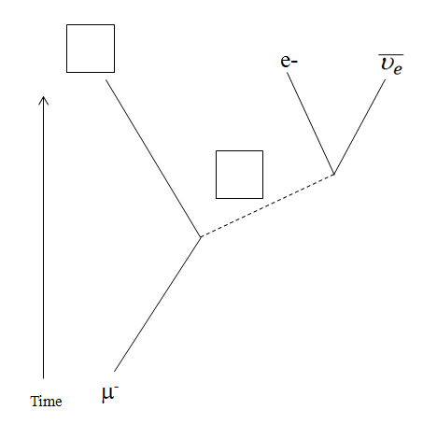
(d) Fill in the correct exchange particle, and resulting particle in the boxes. (watch video)
(e) For the four solid lines denoting the non-exchange particles, indicate with arrows their direction. (watch video)
(f) Distinguish between Mesons, Leptons, Baryons (watch video)
(g) State the quark composition of a proton and neutron (udu, udd)

3. Atomic Models
Given this energy level diagram for Hydrogen:
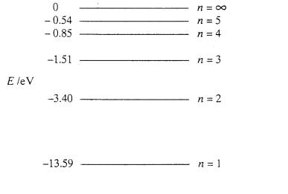
(a) What possible photon energies are there for downward transitions from n = 4? (0.66 eV, 2.55 eV, 12.74 eV)
(b) A spectral line is observed to have a wavelength of 1282 nm. State what part of the EM spectrum this is, and indicate which transition is responsible for this spectral line. (0.97 eV, so 5 to 3)
(c) Calculate the wavelength of the photon associated with a transition from n = 3 to n = 1. (103 nm)
(d) Explain the three atomic models proposed by Thomson, Rutherford, and Bohr, and the discoveries that led to each one. (watch video)
(e) The atmospheres of stars create absorption spectra. Explain how absorption or dark line spectra are created, and how scientists use them.

4. Alpha Decay
92-Uranium 229 will alpha decay into Thorium 225.
(a) Calculate the energy of this decay given this data: (6.476 MeV)
U-229: 229.033496 amu, Th-225: 225.023941 amu, Alpha: 4.002603 amu.
(b) Calculate the radius of a Thorium 225 atom. (7.30 fm)
(c) What kinetic energy in MeV must an alpha particle have to get this close to the Thorium nucleus? (35.5 MeV)
(d) If an Alpha particle can escape in 1.14x10⁻²³ seconds, what energy must it “borrow” in MeV? (29.0 MeV)
(e) Explain what is meant by tunneling in the context of an alpha decay (watch video)
(f) Explain why nuclei cannot be arbitrarily large - why there is an upper limit on the size of stable nuclei by reference of the nature of the electromagnetic and strong nuclear forces.

5. Beta Decay
53-Iodine-138 decays by Beta minus into an isotope of Xenon
(a) Write the complete equation for the decay. (watch video)
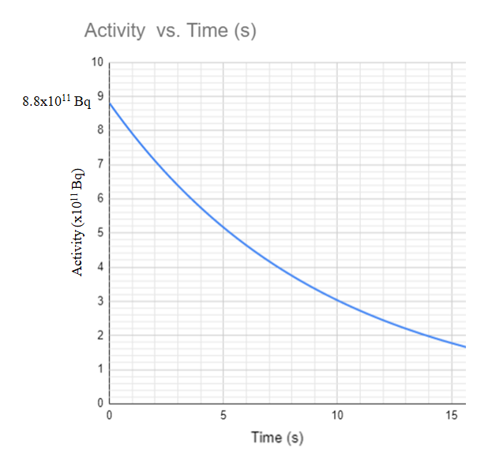
(b) The sample initially has an activity of 8.8x10¹¹ Bq. Using the graph above, determine the half life in seconds of this decay. (6.5 s)
(c) What is the mass of the sample if the molar mass of I-138 is 137.922 grams/mole? (1.89 ng)
(d) What time will it take for the activity to reach 1.1x10¹¹ Bq? (19.5 s - no calculator needed!)
(e) What will be the activity of the sample after 4 minutes? (7 Bq)

