IB Physics
Feynman Diagrams Group Quiz
Name
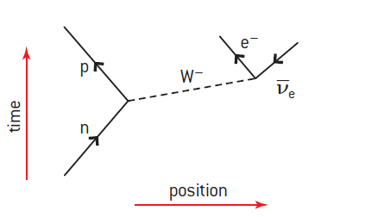
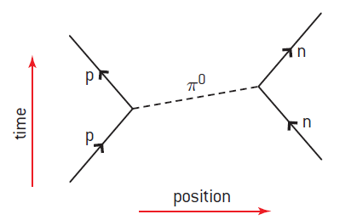
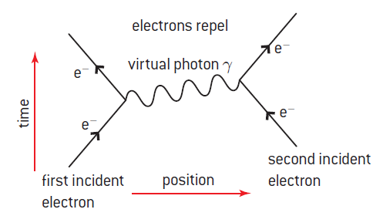
Examples: (Read Oxford 300-302)

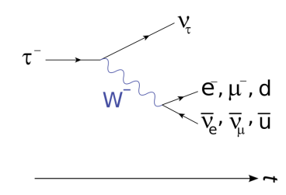

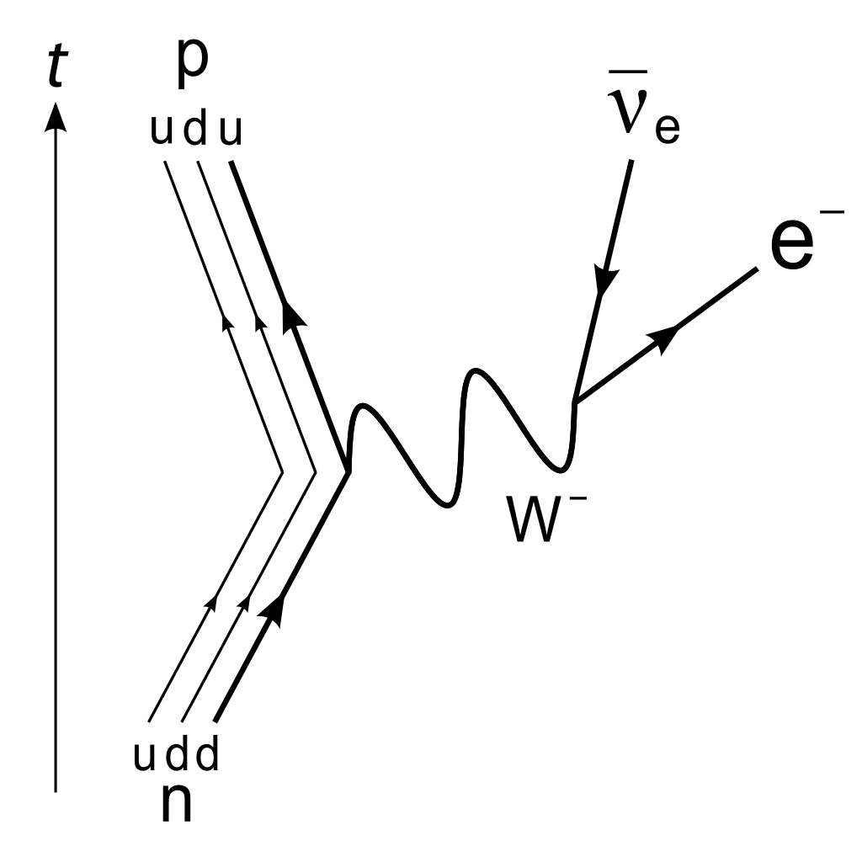
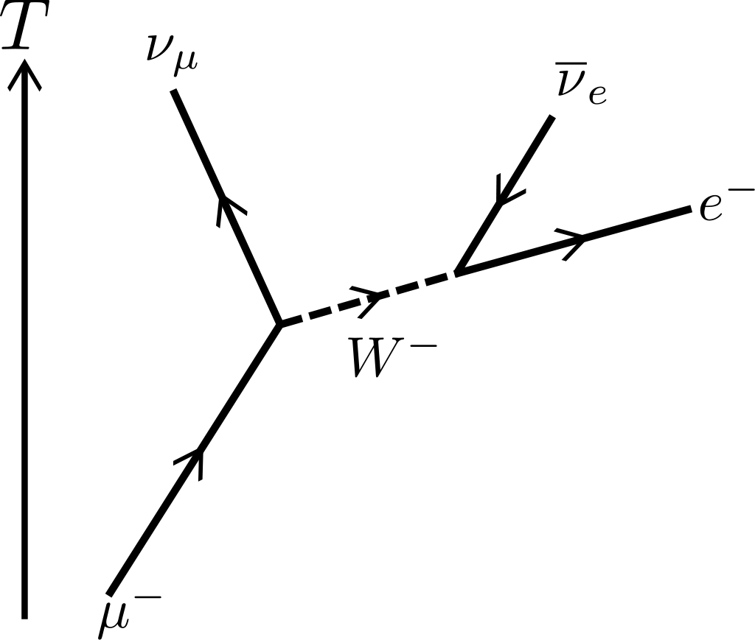

Beta Decay Beta Decay Muon decay Tau decay

Draw the following Feynman diagrams:
B⁻ decay: n → p + e⁻ + υ_{e} | B+ decay: p → n + e⁺ + υ_{e}
μ⁻ decay: μ⁻ → υ_{μ} + e⁻ + υ_{e} | μ⁺ decay: μ⁺ → υ_{μ} + e⁺ + υ_{e}

τ⁻ decay: τ⁻ → υ_{τ} + μ⁻ + υ_{μ} | τ⁺ decay: τ⁺ → υ_{τ} + μ⁺ + υ_{μ}
Electron - electron collision: (Label the exchange particle) | Neutron proton Collision: (Label the exchange particle)
Proton electron collision: p + e- → n + υ_{e} | Two types of Neutron electron Neutrino collisions:  n + υ_{e} → υ_{e} + n and n + υ_{e} → p + e⁻

