IB Physics
27.2 Group Quiz
Name
Show your work, and circle your answers and use sig figs to receive full credit.
Closest Approach: E_{k} = ¹/₂mv² 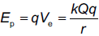 Q = 2e, q = Ze 1 fm = 10⁻¹⁵ m
1. An alpha particle (m = 6.64x10⁻²⁷ kg) going 5.36x10⁷ m/s will get how close to a lead (Z = 82) nucleus if it hits head on? (3.97 fm)

2. A speeding alpha particle (m = 6.64x10⁻²⁷ kg) hits a cobalt (Z = 27) nucleus head on. If it comes within 56.0 fm of the nucleus’ center, how fast was it going to start with? (8.19x10⁶ m/s)

3. A 36.0 MeV alpha particle (m = 6.64x10⁻²⁷ kg) can get how close to a gold nucleus (Z = 79)? (36.0 MeV is the KE)
(6.32 fm)

Bohr Atom: 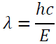 and 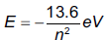
4. What is the wavelength of the photon associated with an electron transition from n = 2 to n = 1 in a hydrogen atom? Is the photon being absorbed, or emitted? (122 nm – emitted)

5. What is the wavelength of the photon associated with an electron transition from n = 2 to n = 5 in a hydrogen atom? Is the photon being absorbed, or emitted? (434 nm – absorbed)

Nuclear Radius: 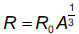 R_{o} = 1.2 x 10⁻¹⁵ m (1.2 fm)
6. What is the radius of Cl-36 nucleus? (3.96 fm)

7. What is the likely mass number of a nucleus with a radius of 7.064x10⁻¹⁵ m? (204)

Heisenberg Indeterminacy: 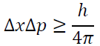 or 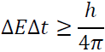
8. To effect an alpha decay, an alpha particle must “borrow” 23.0 MeV of energy. What time does it have to escape? (1.43x10⁻²³ s)

9. A proton has an uncertainty in its velocity of ±1.20x10⁶ m/s. What is the minimum uncertainty in its position? (13.1 fm)

Conceptual Questions:
I: How was Rutherford's atomic model different from Thomson's "plum pudding" model?

I: How did Rutherford discover the nucleus? What size did he determine for the atom and the nucleus?

I1: How does the density of a nucleus change with mass number? What is the density of the Uranium-235 nucleus? What is the density of the carbon-12 nucleus? Calculate both densities: (2.3x10¹⁷ kg m⁻³)
m = A(1.661x10⁻²⁷ kg), V = ⁴/₃πr³, ρ = ^{m}/_{V}

K: Specifically what phenomenon, what observed behavior of atoms was Bohr trying to explain with his quantum atomic model?

N: Energy indeterminacy accounts for nuclear decay - particles in the nucleus "borrow" energy to escape - Where does the energy come from that they "borrow", and where does it go after it has escaped?

O: What was the Einstein-Bohr debate about? What did Einstein object to in quantum mechanics?

Part A: Find the missing decay product:
1 | τ⁻ → π⁻ + πº + ??  υ_{τ} | ?? → π⁺ + πº + $\overline{{}_{τ}}$  τ⁺ | τ⁻ → υ_{τ} + ?? + $\overline{{}_{e}}$  e⁻ | τ⁺ → $\overline{{}_{τ}}$ + e⁺ + ??  υ_{e}
2 | τ⁻ → ?? + μ⁻ + $\overline{{}_{μ}}$  υ_{τ} | τ⁺ → ?? + μ⁺ + υ_{μ}  $$\overline{{}_{τ}}$$ | ?? → e⁻ + $\overline{{}_{e}}$ + υ_{μ}  μ⁻ | μ⁺ → e⁺ + ?? + $\overline{{}_{μ}}$  υ_{e}
3 | μ⁻ → e⁻ + $\overline{{}_{e}}$ + υ_{μ} + e⁺ + ??  e⁻ | μ⁺ → e⁺ + ?? + $\overline{{}_{μ}}$ + e⁺ + e⁻  υ_{e} | $K_{L}^{o}$ → π⁺ + ?? + $\overline{{}_{μ}}$  μ⁻ | K⁺ → ?? + υ_{μ}  μ⁺

Part B: For these reactions, indicate if it is possible, or indicate every law it violates:
1 | p + n → K⁺ + ηº + Ξº  No, baryon number, Strangeness | p + n → p + $\overline{p}$ + $\overline{n}$  No, charge and baryon number | n + n → Λº + Σº  No, Strangeness | n + n → Ω⁺ + Ω⁻  No, baryon number
2 | p + p → Ω⁺ + e⁺ + Λº + Σº + n  No, Le, Strangeness | p + p → p + n + n + Ω⁺  No, Strangeness | p + p → τ⁺ + υ_{τ} + μ⁺ + $\overline{υ_{μ}}$  No, Baryon and Lμ | p + n → n + n + τ⁺ + υ_{τ}  Yes
3 | p + $\overline{p}$ → τ⁻ + Λº + Ω⁺ + $\overline{υ_{τ}}$  No, Strangeness | p + $\overline{n}$ → τ⁺ + τ⁻  No, charge | $\overline{n}$ + n → τ⁺ + τ⁻  Yes | p + $\overline{p}$ → Σ⁻ + Ω⁺  No, Strangeness
4 | p + p → p + p + πº  yes | p + p → p + n + π⁺  yes | n + n → Ξ⁺ + $\overline{{}^{o}}$+ Ω⁻ + n + n + n  yes | π⁻ + p → πº + n + π⁻ + π⁺  yes

Part C: Write the quark combinations that make up a proton and a neutron: p = n =
Identify the following quark combinations as either a meson, or a baryon. Determine the baryon number, strangeness, and the charge of each:
 |  | Baryon or Meson? | B = ? | S = ? | 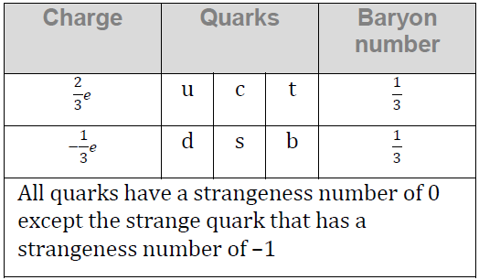  q = ?
1 | s$\overline{s}$ | M | 0 | 0 | 0
2 | dsc | B | +1 | -1 | 0
3 | $$\overline{u}\overline{u}\overline{u}$$ | B | -1 | 0 | -2
4 | s$\overline{u}$ | M | 0 | -1 | -1
5 | d$\overline{s}$ | M | 0 | +1 | 0
6 | sss | B | +1 | -3 | -1  Data Packet reference for decays:
7 | $$\overline{u}\overline{u}\overline{c}$$ | B | -1 | 0 | 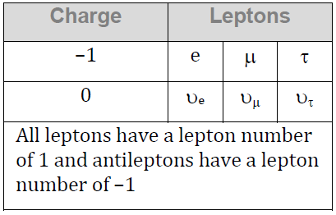  -2
8 | u$\overline{s}$ | M | 0 | +1 | +1
9 | c$\overline{d}$ | M | 0 | 0 | +1
10 | $$\overline{s}\overline{s}\overline{c}$$ | B | -1 | +2 | 0
11 | ucc | B | +1 | 0 | +2
12 | s$\overline{b}$ | M | 0 | -1 | 0

