## Note guide for General Relativity

(Videos A, B, C, D, E from Chapter 33)

**Principle of Equivalence:**

* There is no experiment that will discern the difference between the effect of gravity and the effect of acceleration.
* Gravitational and inertial mass are equivalent.

**Apparent Curvature of light:**

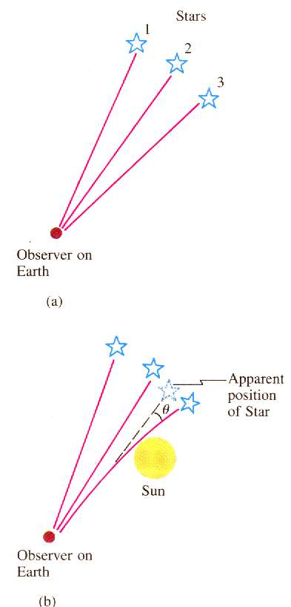

**Curvature of Space:**

|  |  |
| --- | --- |
| Schwarzschild Radius:   Rs = Schwarzschild radius (m)  G = 6.67x10-11 Nm2kg-2  c = 3.00x108 m/s  M = black hole mass (kg)  (Point of no-return near a black hole – if you go within this radius you cannot escape – or rather the escape velocity is greater than the speed of light. You can quantumly tunnel out – this is called Hawking radiation and it happens because of the Heisenberg uncertainty principle) | **Example:** What is the maximum radius of a black hole that is 30. million times the mass of the sun?  Msun = 1.99 x 1030 kg |

|  |  |
| --- | --- |
| Frequency Shift due to gravity field:   Δf = frequency shift (Hz)  g = gravitational field strength (N/kg)  Δh = distance parallel to the gravity field (m)  f = original frequency (Hz)  c = 3.00x108 m/s  (As photons climb out of a gravity field, they lose energy and their frequency gets slower – remember E = hf )  Remember – **low** clocks run s**low** | **Example:** A radio station at the bottom of a 320 m tall building broadcasts at 93.4 MHz. What is the change in frequency from top to bottom?  What frequency do they tune to at the top? (use g = 9.8 N/kg, and then g = 2.5x1013 N/kg) |
| Gravitational Time Dilation:   Δt = Time we observe at a distance (s)  Δto = Actual time that elapses near the black hole (s)  Rs = The Schwarzschild radius (m)  r = Distance from the black hole center that Δto happens  (We are outside the gravity of the black hole (at some large distance) and we are observing a clock some distance ***r*** from the black hole center. Since l**ow** clocks run s**low**, the clock might register 5 (***Δto***) minutes, but take 15 (***Δt***) minutes to do it) | **Example:** A graduate student is 5.5 km beyond the event horizon of a black hole with a Schwarzschild radius of 9.5 km. If they are waving (in their frame of reference) every 3.2 seconds, how often do we see them waving if we are far away? |