Note guide for The Standard Model (The Big Bang)

The precepts of the Big Bang
- The laws of Physics are the same throughout the Universe.
- The Universe is expanding
- The Universe is isotropic and homogeneous
- General relativity works.
- The early Universe was hotter than it is today
- The Universe is evolving.
- The Cosmological principle – Any model of the universe that requires us as observers to be in a special place or time in order for it to work is not likely to be correct

Gamow et al

Penzias and Wilson (accidental discovery of the cosmic microwave background radiation (CMBR))
COBE – Finds that the cosmic background radiation is black body.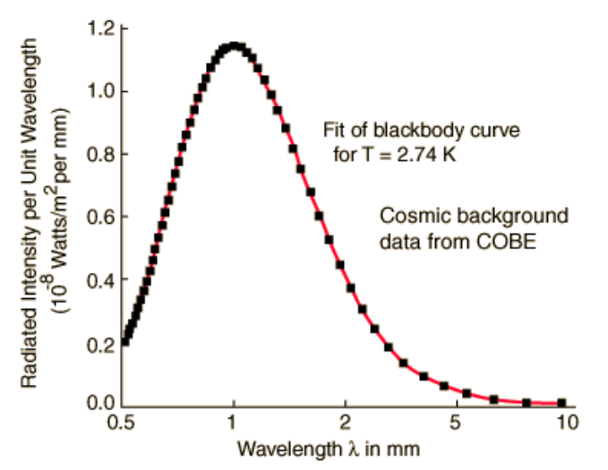
Wien’s Law – Temperature  (Hotter is bluer – shorter wavelength)  λmax = 2.90 x 10-3 m/K  T  λmax = Peak black body wavelength  T = The star’s surface temperature in Kelvins | Example: COBE found the “temperature” of the CMBR to be 2.736 K. What is its λmax?
COBE Anisotropy findings –

BOOMERANG and WMAP – much more accurate version of COBE
1) the universe was 13.7 billion years old, plus or minus about 200 million years,
2) it is composed of 4% matter, 22% dark matter, and 74% dark energy (later)
3) the Hubble Constant is 71±2.5(km/sec)/MPc not 50 or 100 as some researchers had suggested, and
4) the universe is flat (similar to what the BOOMERANG craft had seen).
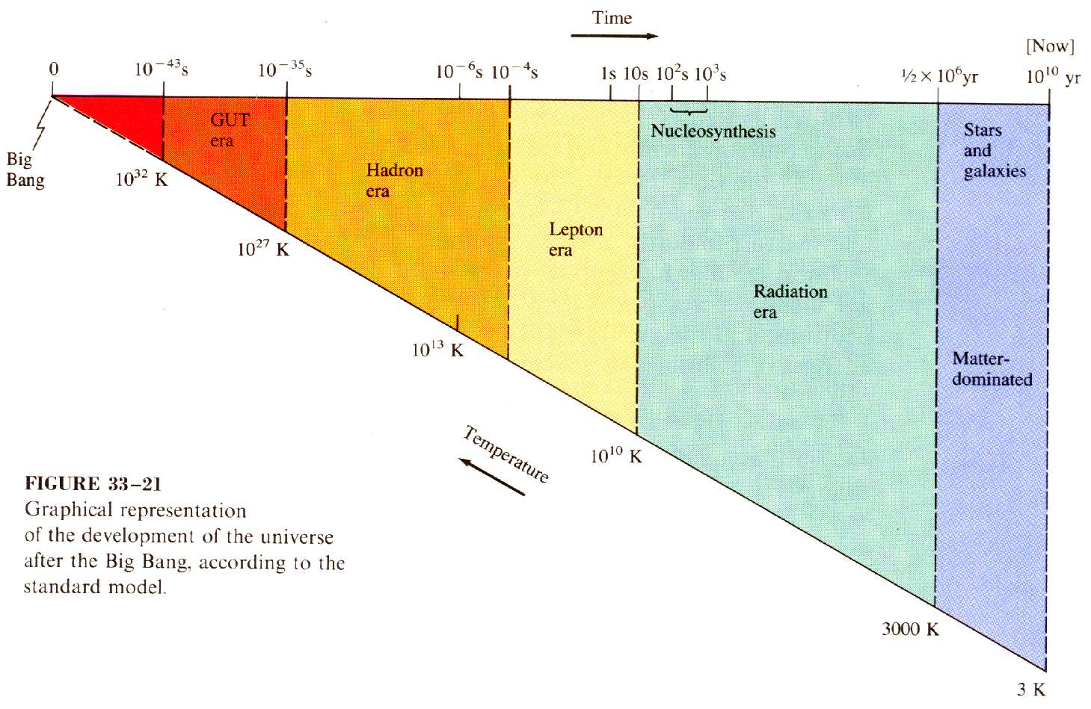
Basic concepts:
Adiabatic expansion
Stretching of radiation
Matter becoming energy, Energy becoming matter
Matter as “condensed” energy
Wien’s Law – Temperature  (Hotter is bluer – shorter wavelength)  λmax = 2.90 x 10-3 m/K  T  λmax = Peak black body wavelength  T = The star’s surface temperature in Kelvins  $$E=\frac{\text{hc}}{λ}$$  E = Photon Energy in J  h = Planck’s Constant (6.626x10⁻³⁴ Js)  c = the speed of light (3.00x10⁸ m/s)  λ = Peak black body wavelength  1 eV = 1.602x10⁻¹⁹ J | Proton creation energy  = 2x938 MeV ≈ 2GeV  Electron Creation Energy  = 2x0.511 MeV ≈ 1MeV  Matter Ionisation energy ≈ 1.3 eV
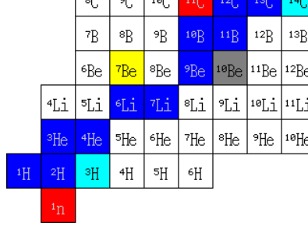
Big Bang Nucleosynthesis theory (BBN theory)

