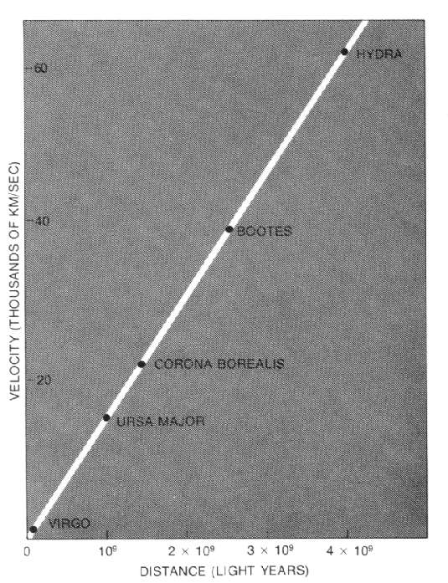
Note guide for Expanding Space

Olber’s Paradox
Were the universe infinite in age and size…

Red Shift of the “spiral nebulae” -

Approximate Redshift  $$\frac{Δλ}{λ}≃\frac{v}{c}$$  Δλ = Amount the wavelength shifts (longer)  λ = Original wavelength  v = Recession velocity  c = 3.00x10⁸ m/s  (The real formula – not in data packet)  $$λ'=λ\sqrt{\frac{1+\frac{v}{c}}{1−\frac{v}{c}}}$$  λ’ = Red shifted wavelength  λ = Original wavelength | Example: What is the change in wavelength of the 656 nm line of a galaxy receding at 20,000 km/s? What is the new wavelength?
Hubble’s law  $$v=\text{Hd}$$  H = Hubble’s constant (71 ± 2 km/s/Mpc)  d = Distance to object in Mega parsecs.  v = Recession velocity  Calculates the rate an object recedes from us due to the expansion of the Universe based on its distance from us | Example: What is the distance to a galaxy that has a 480 nm line that comes in at 497 nm?
Example: Estimate the age of the universe from the a Hubble constant of 71 km/s/MPc
(1 ly = 9.46x10¹¹ m, 1 parsec = 3.26 ly, 1000 m = 1 km)

