Note guide for General Relativity

Principle of Equivalence:
- There is no experiment that will discern the difference between the effect of gravity and the effect of acceleration.
- Gravitational and inertial mass are equivalent.

Apparent Curvature of light:
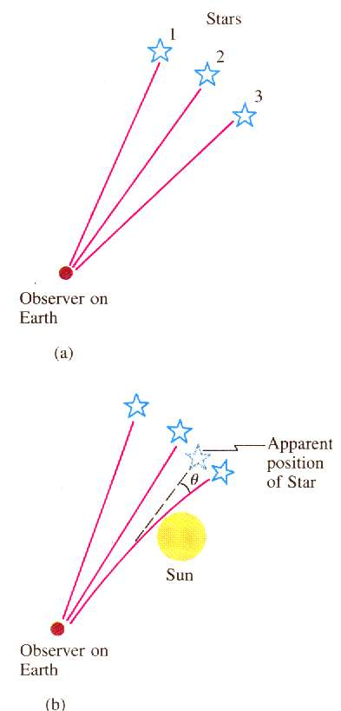

Curvature of Space:

Schwarzschild Radius:  $$R_{s}=\frac{2\text{GM}}{c^{2}}$$  R_{s} = Schwarzschild radius (m)  G = 6.67x10⁻¹¹ Nm²kg⁻²  c = 3.00x10⁸ m/s  M = black hole mass (kg)  (Point of no-return near a black hole – if you go within this radius you cannot escape – or rather the escape velocity is greater than the speed of light. You can quantumly tunnel out – this is called Hawking radiation and it happens because of the Heisenberg uncertainty principle) | Example: What is the maximum radius of a black hole that is 30. million times the mass of the sun?  Msun = 1.99 x 10³⁰ kg

Frequency Shift due to gravity field:  $$\frac{Δf}{f}=\frac{gΔh}{c^{2}}$$  Δf = frequency shift (Hz)  g = gravitational field strength (N/kg)  Δh = distance parallel to the gravity field (m)  f = original frequency (Hz)  c = 3.00x10⁸ m/s  (As photons climb out of a gravity field, they lose energy and their frequency gets slower – remember E = hf )  Remember – low clocks run slow | Example: A radio station at the bottom of a 320 m tall building broadcasts at 93.4 MHz. What is the change in frequency from top to bottom?  What frequency do they tune to at the top? (use g = 9.8 N/kg, and then g = 2.5x10¹³ N/kg
Gravitational Time Dilation:  $$Δt=\frac{{Δt}_{o}}{\sqrt{1−\frac{R_{s}}{r}}}$$  Δt = Time we observe at a distance (s)  Δt_{o} = Actual time that elapses near the black hole (s)  R_{s} = The Schwarzschild radius (m)  r = Distance from the black hole center that Δt_{o} happens  (We are outside the gravity of the black hole (at some large distance) and we are observing a clock some distance r from the black hole center. Since low clocks run slow, the clock might register 5 (Δt_{o}) minutes, but take 15 (Δt) minutes to do it) | Example: A graduate student is 15 km from the center of a black hole with a Schwarzschild radius of 9.5 km. If they are waving (in their frame of reference) every 3.2 seconds, how often do we see them waving if we are far away?

