Special Relativity Part II – Simultaneity, Kinetic Energy and Relative Velocity
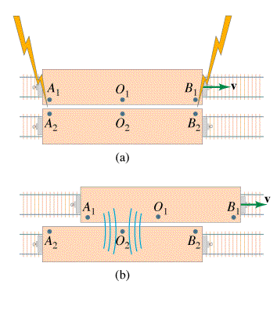
Simultaneity – Simultaneity is relative. What is simultaneous in one frame of reference is not in another.

Kinetic Energy – When a mass dilates, the additional mass is energy mass.
Rest Energy of object  $E_{o}=m_{o}c^{2}$  E_{o} = Rest energy (J)  m_{o} = rest mass (kg)  c = the speed of light (3.00x10⁸ m/s) | Lorentz Factor  $γ=\frac{1}{\sqrt{1−\frac{v^{2}}{c^{2}}}}$  c = the speed of light (3.00x10⁸ m/s)  v = velocity of moving frame (m/s)
Moving energy (total energy)  $E={γm}_{o}c^{2}$  E = total energy (KE + rest) (J)  m_{o} = rest mass (kg)  γ = Lorentz factor | Kinetic Energy  $E_{k}=(γ−1)m_{o}c^{2}$  E_{k} = Kinetic Energy (J)  m_{o} = rest mass (kg)  c = the speed of light (3.00x10⁸ m/s)  γ = Lorentz factor
$p={γm}_{o}u$ u = velocity, p = momentum | $E^{2}=p^{2}c^{2}+m_{o}^{2}c^{4}$
Example – What is the kinetic energy of a 10.0 kg object going .60 c?

Example – A 0.144 kg baseball has 2.0x10¹⁵ J of kinetic energy. What is its mass, what is its velocity?
Example – An electron (rest mass 0.511 MeV) is accelerated through 0.155 MeV, What is its velocity?

Relative Velocity
For velocity within the Frame  $u_{x}^{'}=\frac{u_{x}−v}{1−\frac{u_{x}v}{c^{2}}}$  u_{x}’ = velocity of the object relative to the moving frame  u_{x} = velocity of object relative to us  v = velocity of the moving frame  c = the speed of light (3.00x10⁸ m/s) | Addition: (not in data packet)  $u_{x}=\frac{v+u_{x}^{'}}{1+\frac{{\text{vu}}_{x}^{'}}{c^{2}}}$  u_{x}’ = velocity of the object relative to the moving frame  u_{x} = velocity of object relative to us  v = velocity of the moving frame  c = the speed of light (3.00x10⁸ m/s)

Example – Tom is on a flatbed car going 0.85 c to the east. He throws a javelin at 0.56 c forward (relative to him, in the direction he is going) How fast is the javelin going with respect to the ground?

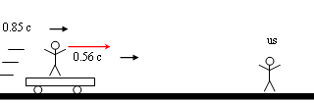

Example – Mary is on a flatbed car going 0.67c toward us, and when she throws a baseball at us, we measure it going 0.82c. With what speed did Mary throw it in her frame of reference?

