Special Relativity Part I – Time and Mass dilation, Length Contraction
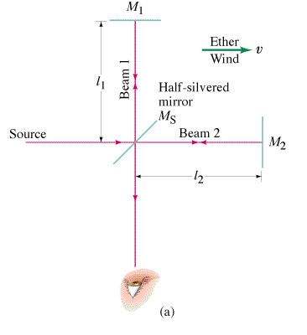
Michelson-Morley – Attempted to find our velocity relative to the “ether” – a supposed medium for light.

Einstein’s Gedanken – If we could catch up with a light wave what would we see?

First Postulate of Relativity:
The laws of physics are the same in all inertial frames of reference
There is no experiment you can do to ascertain whether you are moving.
(i.e. all motion is relative)
Second Postulate of Relativity:
The speed of light is the same no matter what speed the source or observer is going
(i.e the speed of light is a law of physics)

So if the speed of light is constant regardless of the velocity of the observer and the source, then other things that we don’t think should change, must change. Moving clocks run slower, moving particles gain mass, and a moving reference frame shrinks in the direction of motion. Time, mass and length are all relative.

Time Dilation – moving clocks run slower.
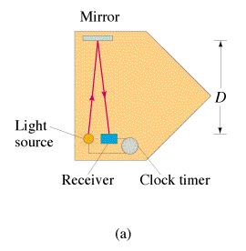
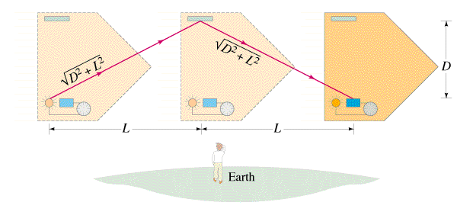

Write the derivation here:

Lorentz Factor: (Approaches infinity as v -> c)  $γ=\frac{1}{\sqrt{1−\frac{v^{2}}{c^{2}}}}$  c = the speed of light (3.00x10⁸ m/s)  v = velocity of moving frame (m/s) | Moving Clocks run slower: (Time dilation)  $Δt={γΔt}_{0}$  Δt_{o} = proper time (un dilated)  Δt = dilated time  γ = Lorentz factor
Moving objects gain mass: (Mass dilation)  $m={γm}_{0}$  m_{o} = rest mass (un dilated)  m = dilated mass  γ = Lorentz factor  (not in data packet?) | Moving objects contract in length:  $L=\frac{L_{o}}{γ}$  L_{o} = rest length  L = contracted length  γ = Lorentz factor
The happiness momentum formula:  $p={γm}_{o}u$  p = momentum  m_{o} = rest mass (un dilated)  u = velocity,  γ = Lorentz factor | Only the dimension parallel to the velocity shrinks:    At rest Moving
Solution for velocity:

