The Cosmological Distance Ladder
Overlapping rungs:
1.Earth
2.Earth-Mars
3.Earth’s orbit
4.Parallax
5.Spectral “Parallax”
6.RR Lyrae variables
7.Cepheid variables
8.Type I Supernovae
9.Type II Supernovae
10.Galaxy brightness

Earth
Geo-Metry

Earth-Mars
Triangulation from Paris and Cayenne

Earth-Sun
If you know the Earth-Mars distance, Kepler’s law
RE3 = RM3
TE2 TM2
now lets you figure out the radius of Earth’s orbit.

Parallax
Triangulation of near stars using the Earth’s orbit about the sun as a baseline

Spectroscopic Parallax
H-R diagram, type of star, M, and m
Use m – M = 5log(d/10) (d in pc)

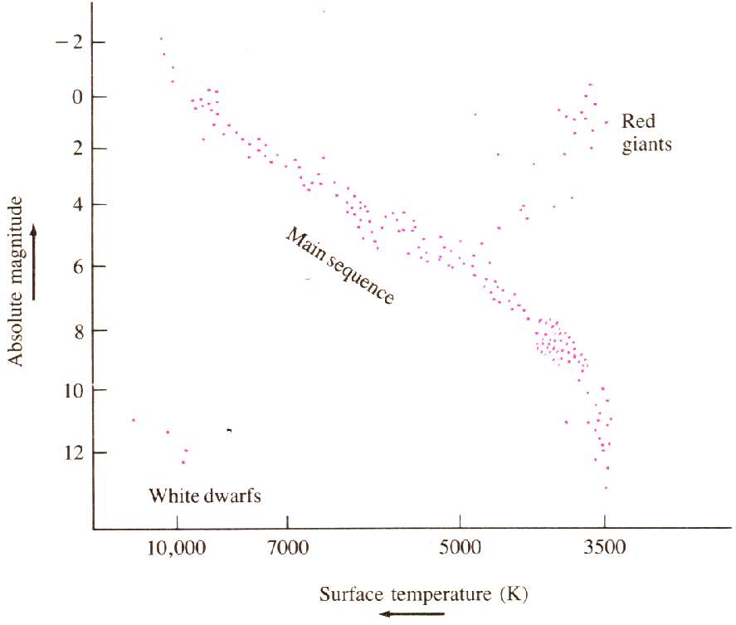

RR Lyrae
.They all have about the same absolute magnitude (0 < M < 1)
M and m, Use m – M = 5log(d/10) (d in pc)

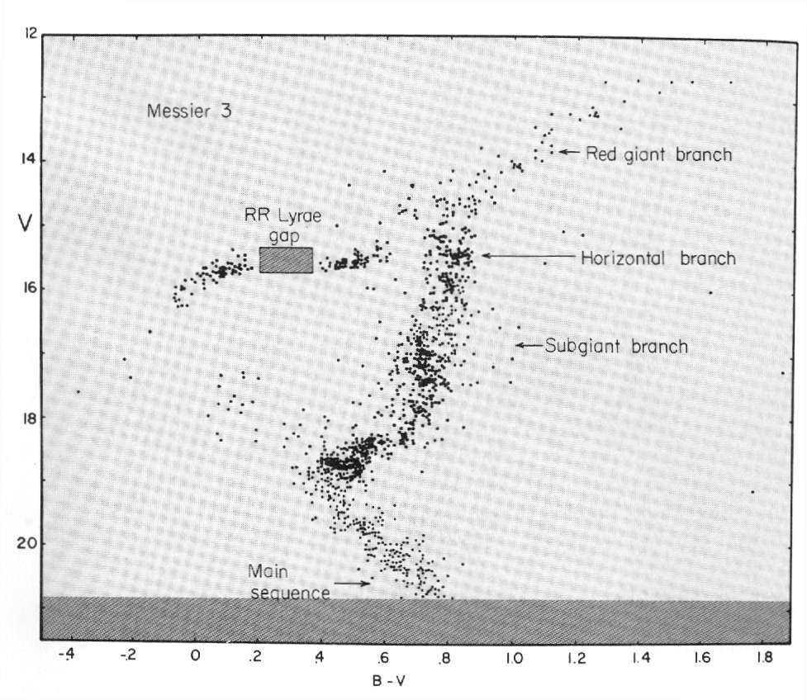

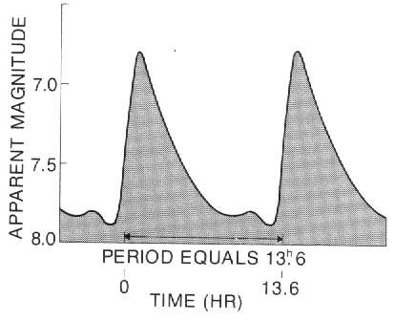

Cepheids
1912, Henrietta
Longer period is brighter
M and m, Use m – M = 5log(d/10) (d in pc)

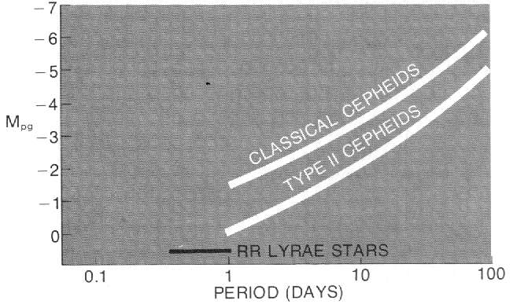

Type I Supernovae
Binary system
All same size

Type II Supernovae
Neutrino refrigeration

Galaxy Brightness

