Units of Distance Noteguide

The Astronomical Unit - The Earth - Sun distance.
Kepler:

RE3 = RM3

TE2 TM2

And a triangulation of Mars to find how far Earth was from Mars

1 A.U. is 1.496 x 108 km ≈ 1.5 x 108 km = 1.5 x 10¹¹ m

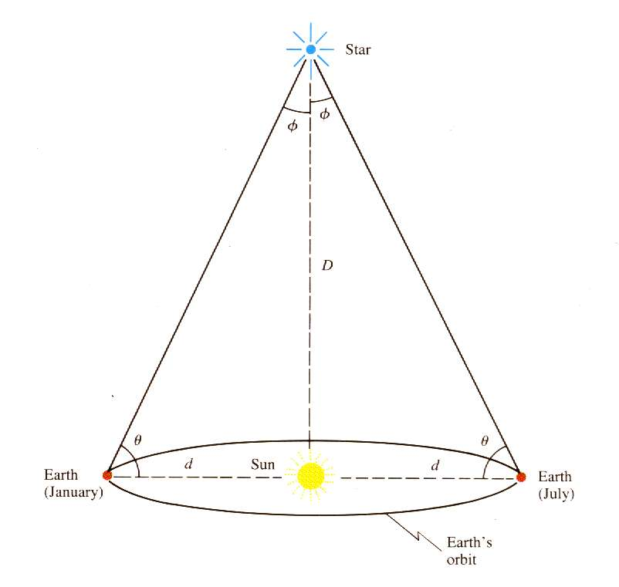

Parallax - The distance d in parsecs is defined as 1/p where p is the parallax angle in arc-seconds (1 arc-second - 1/3600 of a degree)

Example: A star has an annual parallax of .037”. What is its distance in parsecs? How far away is it in km?
(1 pc = 3.09 x 10¹³ km)

Light Year - The distance traveled by light in a year
1 ly = 9.46x1012 km ≈ 1013 km
1 parsec = 3.26 ly

All together:
1 A.U. = 1.496 x 108 km
1 ly = 9.46x1012 km
1 parsec = 3.086 x 1013 km = 3.26 ly

