Special Relativity Part II – Simultaneity, Kinetic Energy and Relative Velocity

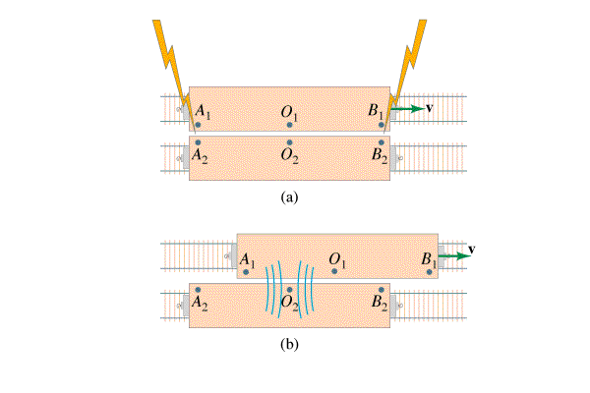

**Simultaneity** – Simultaneity is relative. What is simultaneous in one frame of reference is not in another.

**Kinetic Energy** – When a mass dilates, the additional mass is energy mass.

|  |  |
| --- | --- |
| Rest Energy of object    Eo = Rest energy (J)  mo = rest mass (kg)  c = the speed of light (3.00x108 m/s) | Lorentz Factor    c = the speed of light (3.00x108 m/s)  v = velocity of moving frame (m/s) |
| Moving energy (total energy)    E = total energy (KE + rest) (J)  mo = rest mass (kg)  γ = Lorentz factor | Kinetic Energy    Ek = Kinetic Energy (J)  mo = rest mass (kg)  c = the speed of light (3.00x108 m/s)  γ = Lorentz factor |
| u = velocity, p = momentum |  |

**Example** – What is the kinetic energy of a 10.0 kg object going .60 c?

**Example** – A 0.144 kg baseball has 2.0x1015 J of kinetic energy. What is its mass, what is its velocity?

**Example** – An electron (rest mass 0.511 MeV) is accelerated through 0.155 MeV, What is its velocity?

**Relative Velocity**

|  |  |
| --- | --- |
| For velocity within the Frame    ux’ = velocity of the object relative to the moving frame  ux = velocity of object relative to us  v = velocity of the moving frame  c = the speed of light (3.00x108 m/s) | Addition: (not in data packet)    ux’ = velocity of the object relative to the moving frame  ux = velocity of object relative to us  v = velocity of the moving frame  c = the speed of light (3.00x108 m/s) |

**Example –** Tom is on a flatbed car going 0.85 c to the east. He throws a javelin at 0.56 c forward (relative to him, in the direction he is going) How fast is the javelin going with respect to the ground?

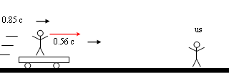

**Example –** Mary is on a flatbed car going 0.67c toward us, and when she throws a baseball at us, we measure it going 0.82c. With what speed did Mary throw it in her frame of reference?

