Noteguide for Transformers - Videos 21E Name
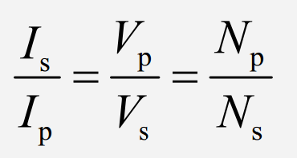
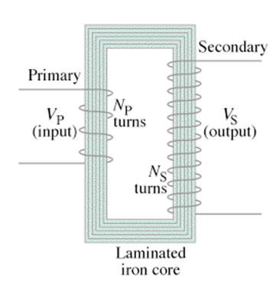
Example: A transformer has 120 primary windings, and 1450 secondary. If there is an AC voltage of 15 V, and a current of 350 mA on the primary, what is the current and voltage on the secondary?

Whiteboards:
1. A transformer has 120 primary windings, and 2400 secondary windings. If there is an AC voltage of 90. V , and a current of 125 mA in the primary, what is the voltage across and current through the secondary? (1800 V, 6.25 mA) | 2. A transformer is operating at 12.5 W. It steps 110 VAC down to 9.6 VAC. There are 320 primary windings.  A) How many secondary windings are there?  B) What is the current in the primary and secondary?  (28 windings, 0.11 A, 1.3 A)
3. An AC Arc welder can deliver 550 Amps of current. If it draws 18 amps from the wall at 120 VAC, what is the delivered voltage? If the primary has 1200 windings, how many does the secondary have? (3.9 V, 39)

