Noteguide for The Definition of the Ampere - Video 20I Name

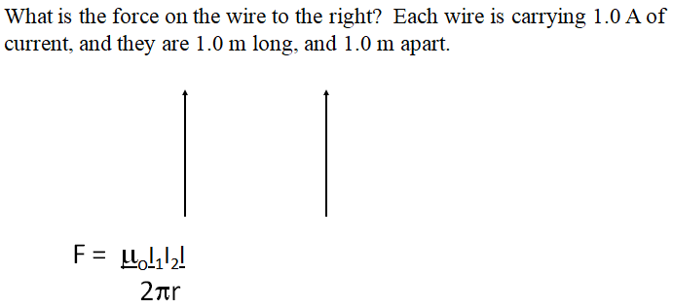

Definition of an ampere:
An ampere is defined as the current flowing in each of two long, straight and parallel wires exactly one meter apart so that there is a force of exactly 2 x 10⁻⁷ N per meter of length acting on the wires.
(A coulomb is an Amp Second)

