Noteguide for Ampere's Law - Videos 20H Name

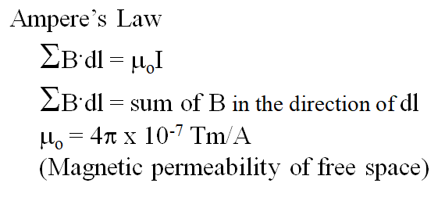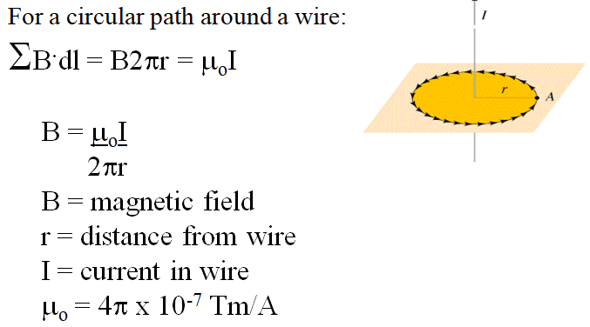

Whiteboards:
1. What is the magnetic field 13 cm from a wire that is carrying 45 A? (6.9x10⁻⁵ T) | 2. At what distance from a wire carrying 1.20 A is the magnetic field 1.50 x 10⁻⁴ T? (1.6x10⁻³ m )
3. If a wire has a magnetic field of 1.15 x 10⁻⁴ T at a distance of 2.51 cm from its center, what is the current flowing in the wire? (14.4 A)

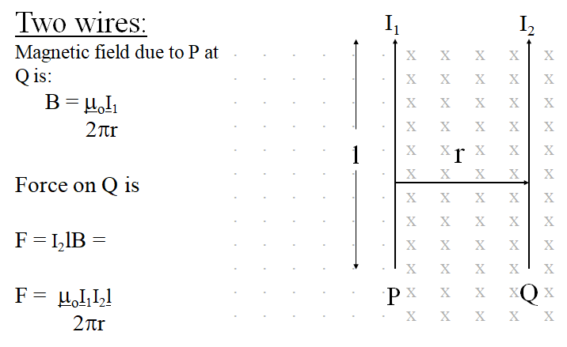
Whiteboards:
1. 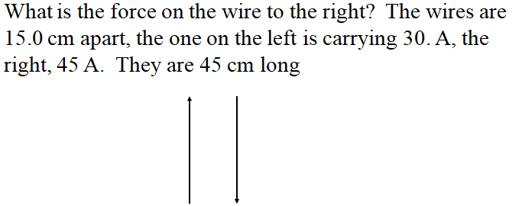  (8.1x10⁻⁴ N to the right) | 2. 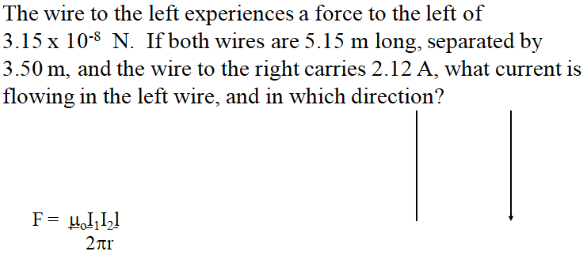  (5.05x10⁻² A up the page)
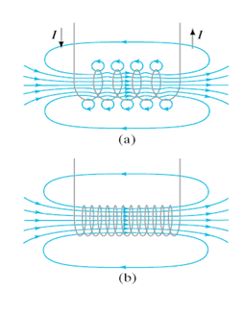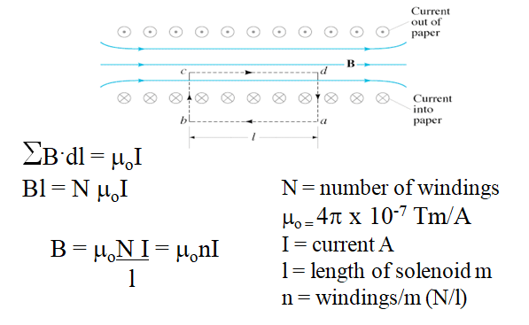

Whiteboards:
1. A solenoid has 360 windings. It is 13 cm long, and carries a current of 1.75 A. What is its internal B-Field? (0.0061 T) | 2. A solenoid needs to generate 1.0 T of B-field. it is 20 cm long, and has 100. windings. What current does it need? (1600 A)

