Noteguide for The Hall Effect - Videos 20E Name

Two Possible Scenarios:

Positive Charge Carriers in wire: (incorrect)  Conventional Current is to the right  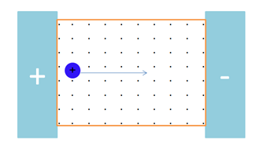 | Negative Charge Carriers in wire: (correct)  Conventional Current is to the right  