Noteguide for Particles in a Magnetic Field - Videos 20C Name

Recall
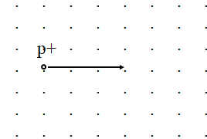
F = IlBsinθ
Derive
F = qvBsinθ
  - F = force on moving particle
  - q = charge on particle (in C) (+ or -???)
  - v = particle’s velocity
  - θ = angle twixt v and B
Whiteboards
1. What is the force acting on a proton moving at 2.5 x 10⁸ m/s to the North in a 0.35 T magnetic field to the East? (1.4 x 10⁻¹¹ N, Downward)  q = 1.602 x 10⁻¹⁹ C | 2. What magnetic field would exert 1.2 x 10⁻¹² N on an alpha particle going 17% the speed of light?  alpha = 2p2n (0.073 T)  q = 2(1.602 x 10⁻¹⁹ C) = 3.204 x 10⁻¹⁹ C  v = 0.17x3.00 x 10⁸ m/s = 5.1 x 10⁷ m/s

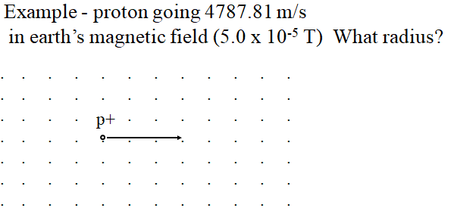

Whiteboards
1. If the electron is going 1.75 x 10⁶m/s, and the magnetic field is .00013 T, what is the radius of the path of the electron? (7.7 cm)  m = 9.11 x 10⁻³¹ kg  q = 1.602 x 10⁻¹⁹ C | 2. What B-Field do you need to make a proton going 2.13 x 10⁷ m/s go in a 3.2 cm radius circle ACW in the plane of this page? (7.0 T into the page)  m = 1.673 x 10⁻²⁷ kg  q = 1.602 x 10⁻¹⁹ C

Whiteboards: (Try to predict the direction they curve - remember electrons go opposite)
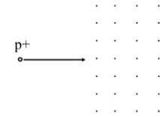 |  | 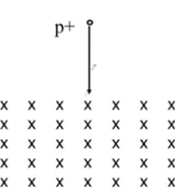
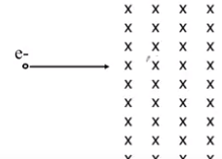 | 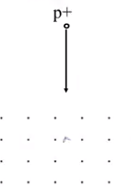

Particle Accelerators:
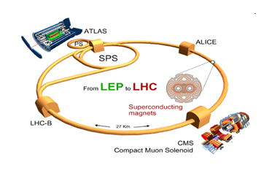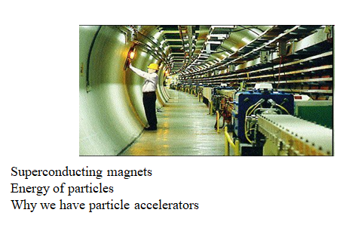

The Aurora Borealis: (Northern Lights)
