Noteguide for Force on Current-Carrying Wires - Videos 20B Name

Example: A 0.15 T magnetic field is 27º east of North What’s the force on a 3.2 m long wire if the current is 5.0 A to the West?

Whiteboards
1. What current in what direction would you need to have a force of 10.0 N to the west in 50.0 cm of wire perpendicular to Earth’s magnetic field of  0.5 x 10⁻⁴ T to the North? (4 x 10⁵ A upward) | 2. A 17 cm wire forms a 37º angle with an unknown magnetic field. What is the magnetic field if the force equals 0.015 N and I = 5.0 A?  (2.9 x 10⁻² T)
3. 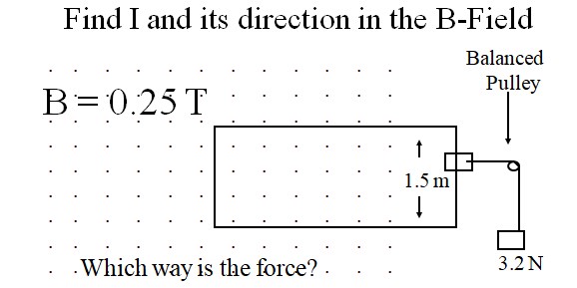  (8.5 A, ACW) | 4. 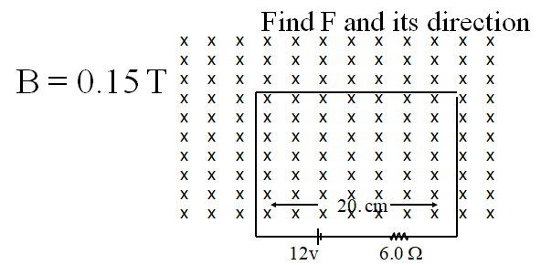  (0.060 N, Up)

