Noteguide for Electrical Current - Videos 18A Name

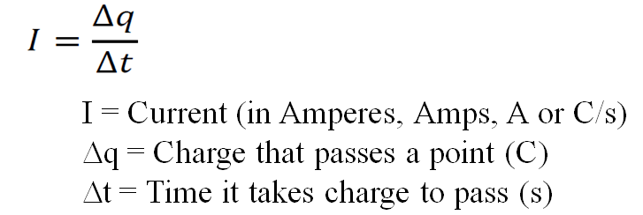

Example: What charge passes a certain point if a current of 250 mA flows for 12 minutes?

Whiteboards:
1. What is the current flowing if 13.5 C goes through a light bulb in 7.5 seconds? (1.8 A) | 2. What charge passes a certain point if you have a current of 2.10 A for 45.0 seconds (94.5 C)
3. What time will it take 65 C of charge to flow if you have a current of 120 mA? (540 s) | 4. How much charge in 2.5 Amp Hours?  (1 amp hour = 1 amp flowing for 1 hour) (9000 C)

Noteguide for Ohm's Law - Videos 18B Name

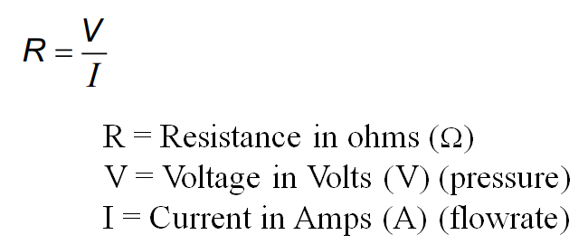
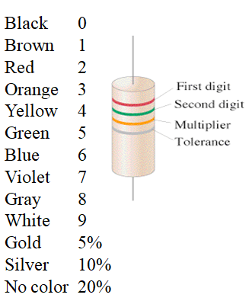

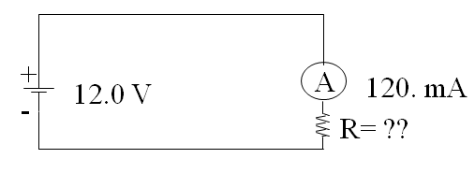
Example 1: What is the resistance in the circuit above?

Example 2: If there is a 220 Ω resistor in the circuit above, what is the current?

Whiteboards:
1. What is the resistance of a light bulb if it draws 250 mA of current from a 6.15 V battery?  (1000 mA = 1 A) (24.6 Ω ) | 2. What current will flow if you plug a paperclip with a resistance of 0.065 Ω into a 12 V source?  (180 A)
3. What voltage do you need to push 1.5 Amps of current through a 210 ohm resistor? (315 V) | 4. What current flows through an 8.1 ohm speaker when there is a voltage of 3.45 V? (0.43 A)
5. An unknown resistor draws 0.0128 Amps of current from a 23.9 V source. What is the resistance? (1870 Ω) | 6. A 1200 ohm resistor is hooked up to an unknown voltage source, and it draws 87.5 mA of current. What is the voltage? (105 V)

Noteguide for Resistivity - Videos 18C1 Name

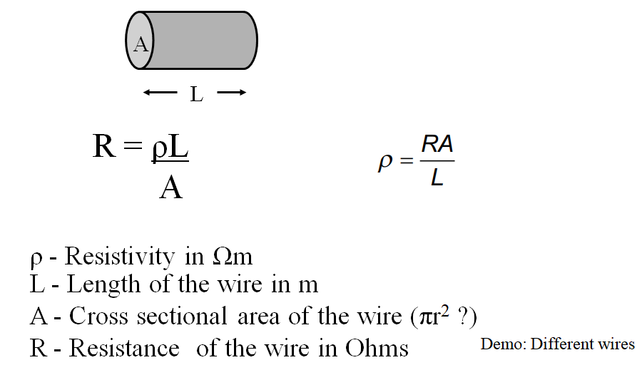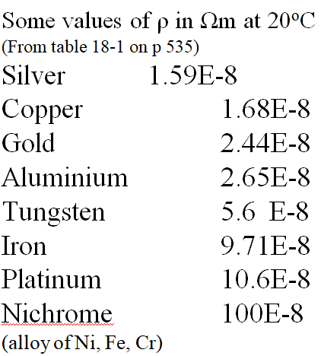

Ex #1: A steel wire is 2.7 m long, and has a resistance of 7.3 ohms. What is its diameter?

Whiteboards:
1. A copper wire is 1610 m long (1 mile) and has a cross sectional area of 4.5 x 10⁻⁶ m². What is its resistance? (This wire is about 2.4 mm in dia)  (6.0 Ω) | 2. An Aluminium wire is 3.2 mm in diameter, and has a resistance of 142 ohms. What length is it?  (43,000 m)
3. A piece of wire has a diameter of 0.42 mm, and a length of 53 cm. What is its resistivity if it has a resistance of 4.9 ohms? (what kind of wire is it?) (130x10⁻⁸ Ωm)

Noteguide for Electron Drift - Videos 18C2 Name

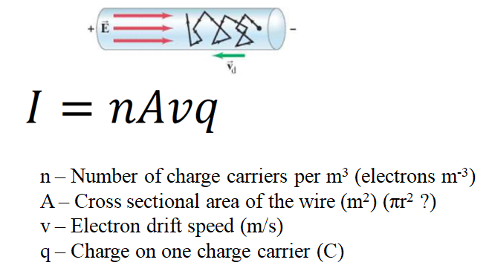

Ex #1: A 2.4 mm diameter copper (n = 8.5x10²⁸ carriers/m3) wire has a current of 5.8 amps flowing down it. What is the electron drift speed? (9.4x10⁻⁵ m/s)

Whiteboards:
1. A 1.8 mm diameter copper  (n = 8.5x10²⁸ carriers/m³) wire has an electron drift speed of 0.082 mm/s. What is the current flowing in the wire? (2.8 Amps ) | 2. A 3.4 mm wire of some material has an electron drift velocity of 0.016 mm/s when a current of 12 A flows. What is the density of charge carriers per cubic meter? (5.2x10²⁹ carriers/m³)
3. A copper (n = 8.5x10²⁸ carriers/m3) wire carrying 4.5 A has an electron drift speed of 0.13 mm/s. What is the diameter of the wire? (1.8 mm - 1.8x10⁻³ m)

Noteguide for Power - Videos 18D Name

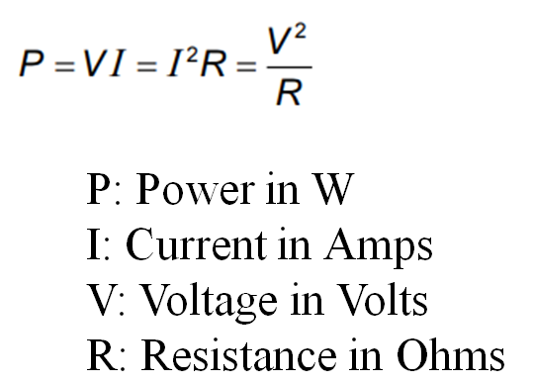

Example 1: If a car stereo uses 850 Watts of power, how many Amps does it use at 12 V?

Example 2: If you have 128 mA of current running through a 560 ohm resistor, what power will it dissipate, and what is the voltage across it?

Whiteboards:
1. A heating element draws 2.07 A from a 12.0 volt source. What is the power it consumes?  (24.8 W) | 2. What is the current flowing in a 75 W light bulb connected to 120 V? (0.625 A)
3. What is the power used by a 0.135 ohm heating element connected to a 24.0 V source? (4270 W) | 4. A 345 mW light bulb draws 12.8 mA of current. What is its resistance? (2110 Ω)
5. A 0.25 Watt 1000. ohm resistor can be connected to what maximum voltage? (16 V) | 6. What maximum current can flow through a 50.0 ohm resistor that is rated at 10.0 Watts? (447 mA)

Noteguide for AC and RMS - Videos 18E Name
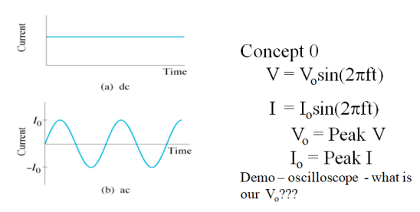
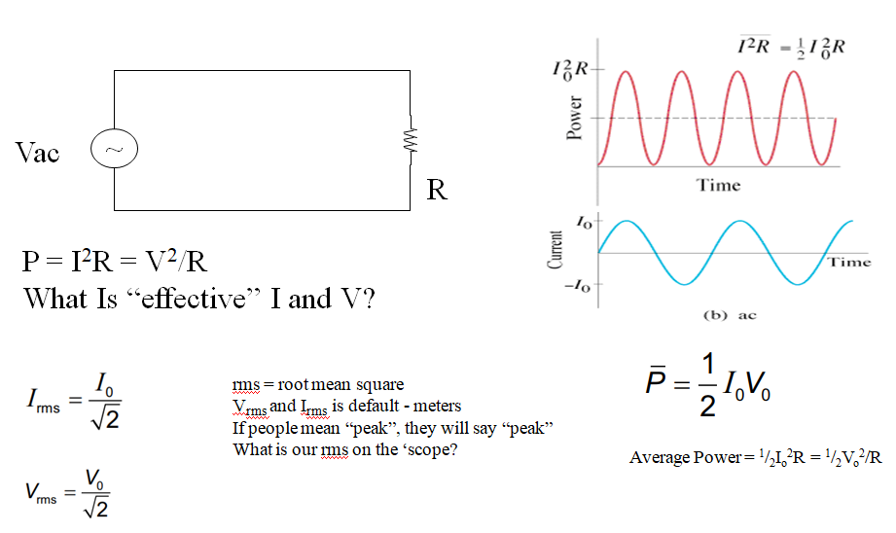

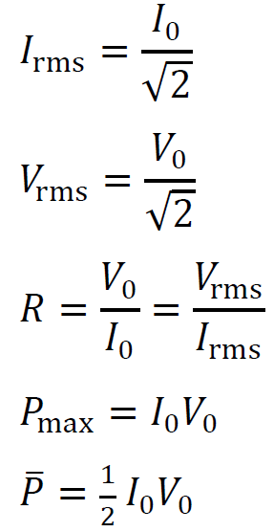

Example - A 13.50 ohm resistor has a peak voltage of 207.0 Volts across it. What is the rms voltage across it, and what is the peak and rms current through it, and the average power and peak power that it dissipates

Whiteboards:
1. What is the rms voltage if the peak voltage is 340 V? (240 V) | 2. A circuit has an rms current of 1.45 A. What is the peak current? (2.05 A)

(Do the ones on the back too)

More Whiteboards: (What a good student you are!!)
3. 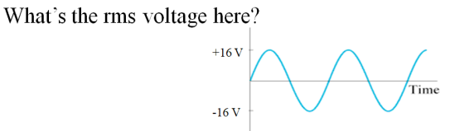 (11 V) | 4. What is the peak voltage if the rms voltage is 12 V? (17 V)
5. An 60.0 V alternating current is attached to a device that draws 3.5 amps. What is the power used? (210 W) | 6. An alternating current with a peak voltage of 18.5 V is connected to a 27.5 ohm resistor. What power is dissipated? (6.22 W)
7. A 40. Watt light is connected to a 120 Volt source. What is the peak current through the light bulb, its resistance, and what is the peak power that it dissipates? (0.47 A, 360 ohms, 80. W) | 8. A 100.2 ohm heating element is dissipating 1530 W of power. What are the peak current and peak voltage through and across the element? (find rms…) What is the peak power?  (5.5 A, 554 V, 3060 W)

Noteguide for Series Circuits - Videos 18F Name

24 V
1 Ω
2 Ω
5 Ω
V₁
A₁
A₃
A₂
V₂
V₃

Try these:
(First whiteboard)
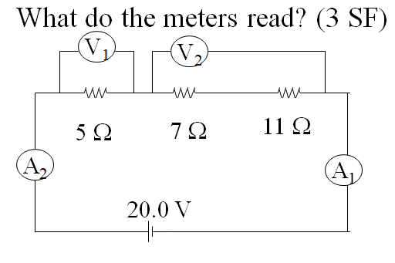
(Both Ammeters: 0.870 A, V1 = 4.35 V, V2 = 15.7 V)

(Third Whiteboard)
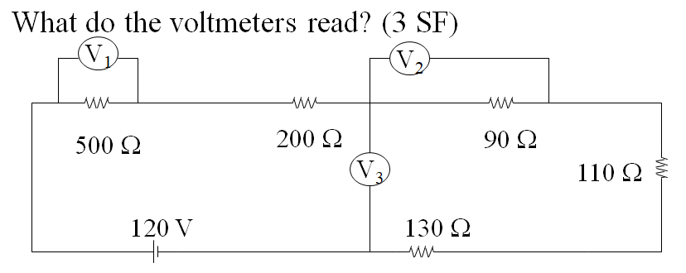
(V1 = 58.3 V, V2 = 10.5 V, V3 = 38.4 V)

Noteguide for Parallel Circuits - Videos 18G Name

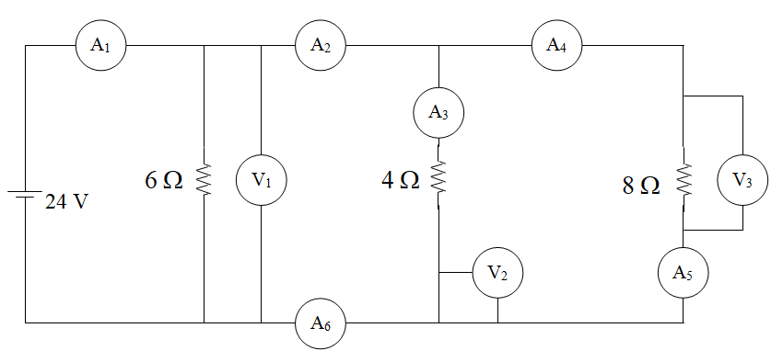

Try These:
(First whiteboard)
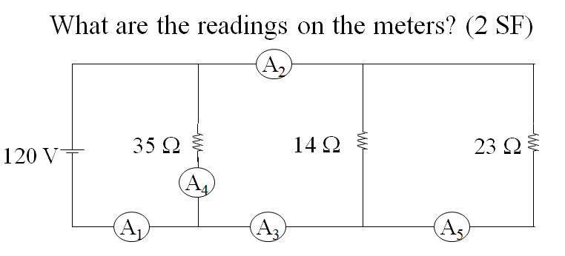
(A1 = 17, A2 = 14, A3 = 14, A4 = 3.4, A5 = 5.2 A)

(Second whiteboard)
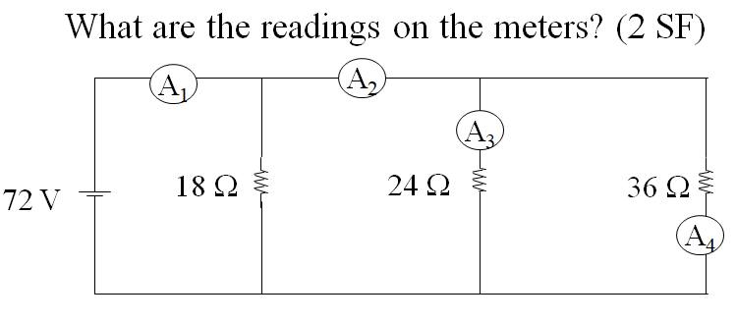
(A1 = 9.0, A2 = 5.0, A3 = 3.0, A4 = 2.0 A)

Noteguide for Series and Parallel Resistance - Videos 18H Name

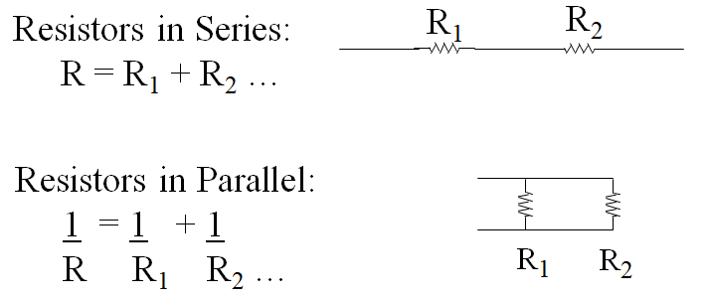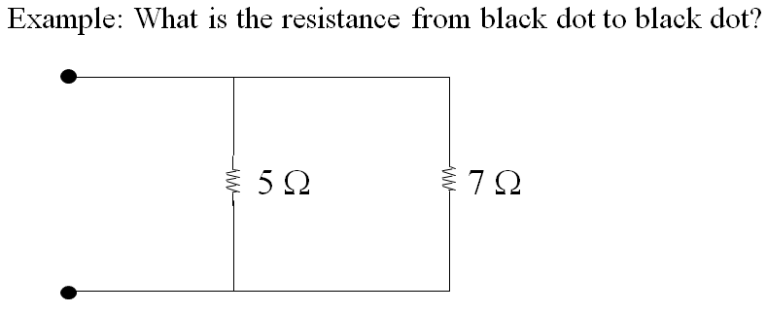

Whiteboards: (Find the resistance from the black dot to the black dot)
1. 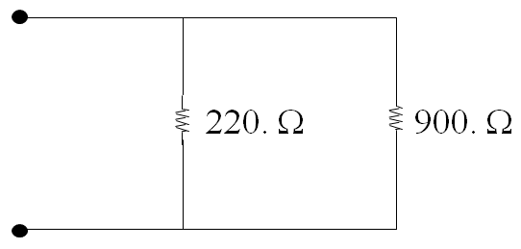(177 Ω) | 2. 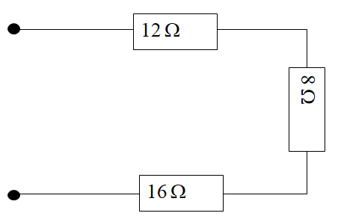(36 Ω )
3. 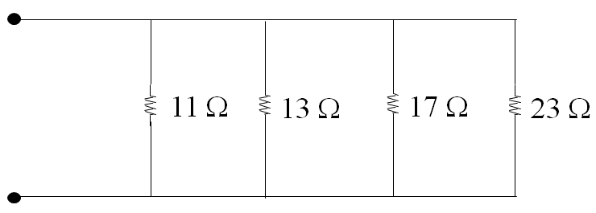(3.7 Ω ) | 4. 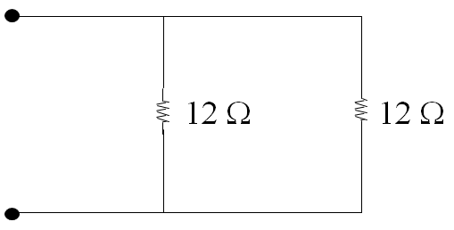( 6 Ω )
5. 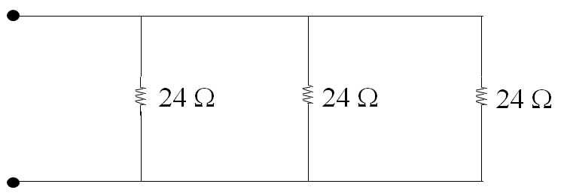(8 Ω )

Noteguide for Network Resistance - Videos 18I Name
Example 1:
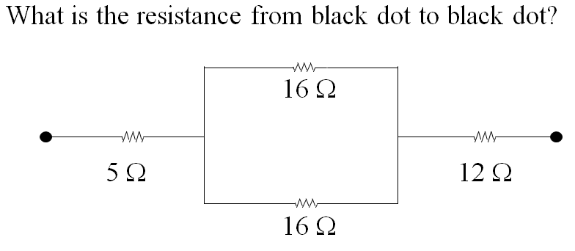

Example 2:
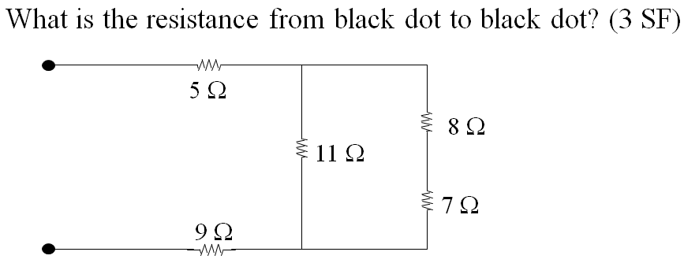

Example 3:
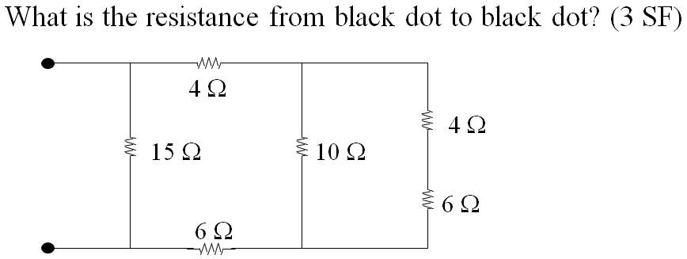

(Try the whiteboards on the back)

Try to find the resistance that is across the battery in each circuit. Ignore the Voltmeters and Ammeters for now:
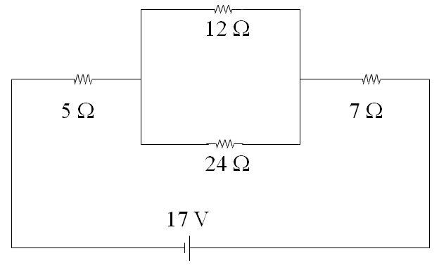(20 Ω)

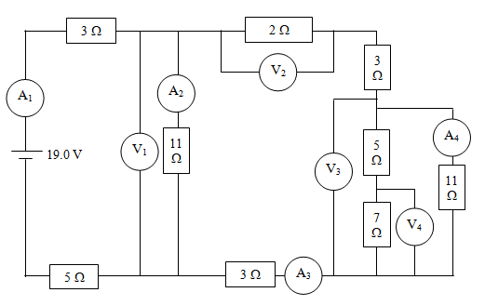(14.1 Ω)

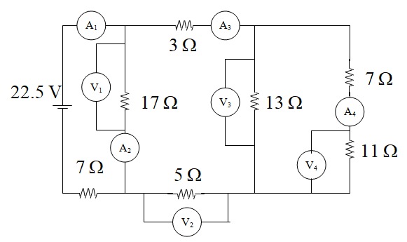(15.1 Ω)

Noteguide for Network Resistance - Videos 18J1&2 Name

Net Example 1 – Find current through and power dissipated by each resistor
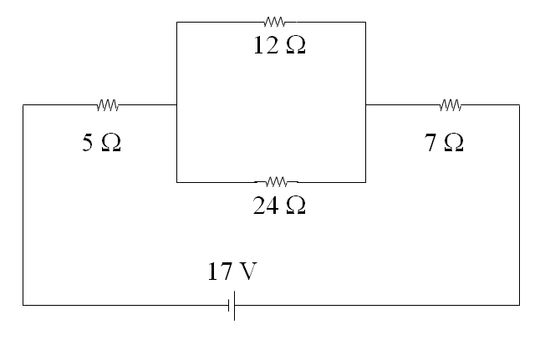
Net Example 2 (single popper)
R (Ω) | I (A) | P (W)
5 | 0.85 | 3.613
12 | 0.5667 | 3.853
24 | 0.2833 | 1.927
7 | 0.85 | 5.058

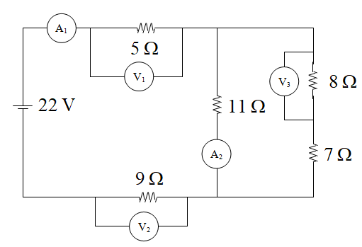
Net Example 3 (double popper)
6.3462
1.0813 | A1
5.4064 | V1
9.7316 | V2
6.862
0.6238 | A2
0.4575
3.6597 | V3

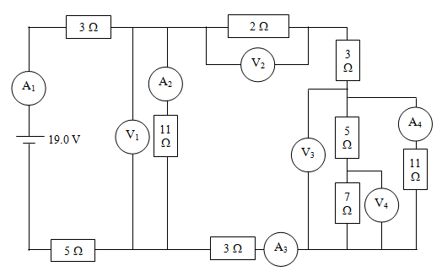

Net Example 4 (double popper)
5.73913
13.73913
6.108963
1.346662 | A1
8.226707 | V1
0.747882 | A2
0.598779 | A3
1.197559 | V2
3.436472 | V3
0.312407 | A4
0.286373
2.004609 | V4

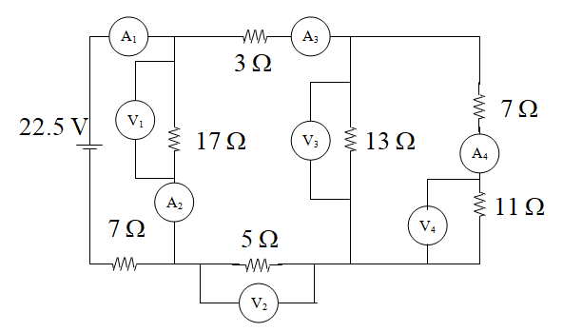

7.548387
15.54839
8.120912
1.488006 | A1
12.08396 | V1
0.710821 | A2
0.777184 | A3
3.885921 | V2
5.866488 | V3
0.325916 | A4
3.585076 | V4

Noteguide for Kirchhoff's Laws - Videos 18L Name
Junction Rule:
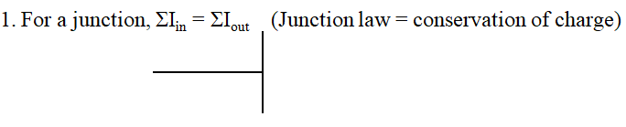

Loop Rule
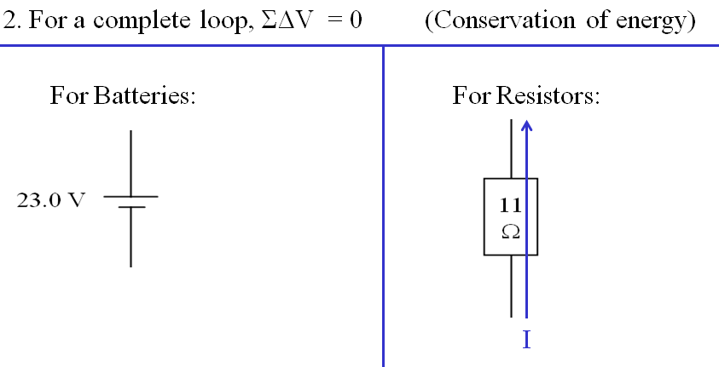

I will give some examples:

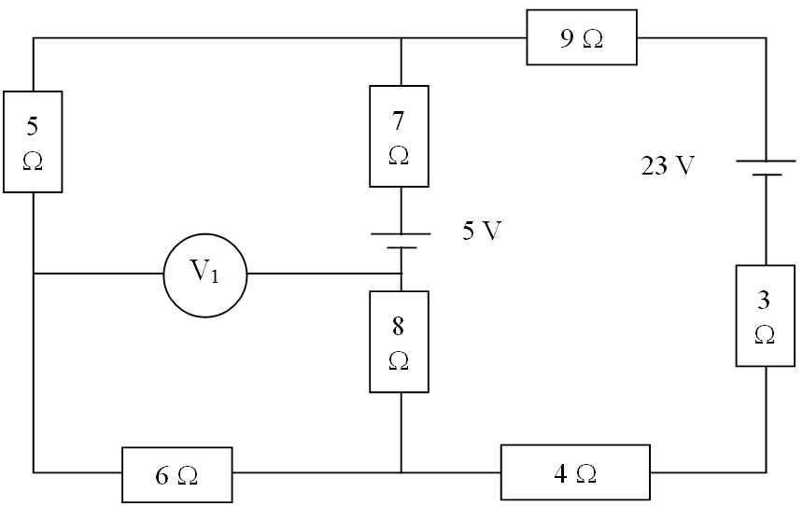

Putting it all together:

Find Current through:
5 Ω
7 Ω
3 Ω
Voltage across:
8 Ω
9 Ω
Power dissipated by:
4 Ω
6 Ω
|V₁|

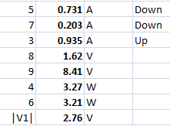

Noteguide for Adding Capacitors - Videos 18N Name

