Practice for 19.2:
Round your answers to three sig figs (retain five), and show your work.
1
45.0 V
3 Ω
6 Ω
5 Ω
8 Ω

23 Ω

7 Ω

A₁
12 Ω
19 Ω

V₂
V₁
V₃

Find:

A₁ =

V₁ =

V₂ =

V₃ =
Find the current through:

19 Ω

6 Ω
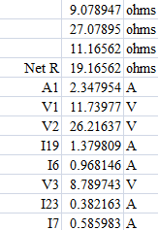

23 Ω

7 Ω

2
26.0 V
5 Ω
7 Ω
3 Ω
A₁
2 Ω

1 Ω

6 Ω

4 Ω

8 Ω

9 Ω

V₁
V₃
V₂

Find:

A₁ =

V₁ =

V₂ =

V₃ =
Find the current through:

4 Ω

2 Ω
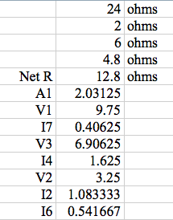

6 Ω

7 Ω

3
18.0 V
3 Ω
4 Ω
2 Ω
A₁
V₁
9 Ω

4 Ω

6 Ω

8 Ω

7 Ω

5Ω
V₃
V₂

Find:

A₁ =

V₁ =

V₂ =

V₃ =
Find the current through:

9 Ω

3 Ω
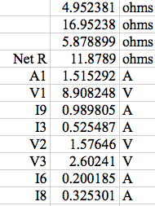

6 Ω

8 Ω

4
45.0 V
5 Ω
7 Ω
3Ω

9 Ω

A₁
V₁
11 Ω

6 Ω
10 Ω

V₃
12 Ω

V₂

Find:

A₁ =

V₁ =

V₂ =

V₃ =
Find the current through:

11 Ω

7 Ω

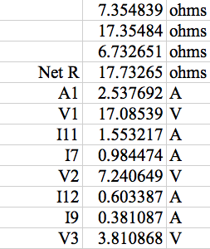
12 Ω

9 Ω

5
31.0 V
2 Ω
3 Ω
4 Ω
11 Ω

5 Ω

7 Ω

8 Ω

A₁
V₁
V₃
6 Ω

V₂

Find:

A₁ =

V₁ =

V₂ =

V₃ =
Find the current through:

5 Ω

7 Ω
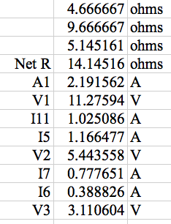

6 Ω

11 Ω

