Noteguide for Kirchhoff's Laws - Videos 18L Name
Junction Rule:

Loop Rule

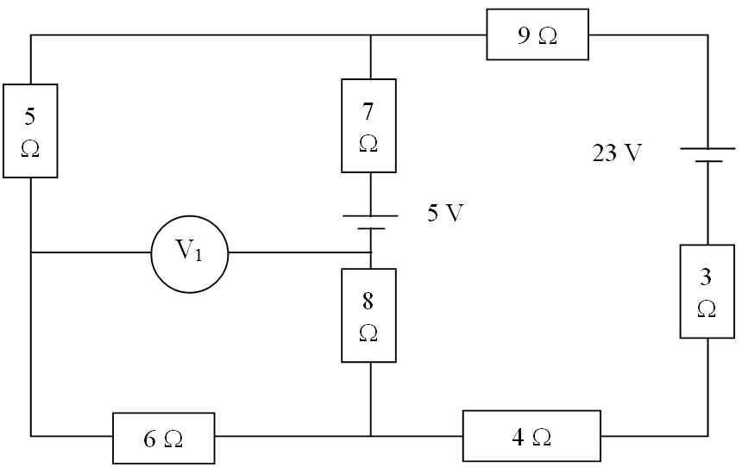

Find Current through:
5 Ω
7 Ω
3 Ω
Voltage across:
8 Ω
9 Ω
Power dissipated by:
4 Ω
6 Ω
|V₁|

