Noteguide for Kirchhoff's Laws - Videos 18L Name
Junction Rule:
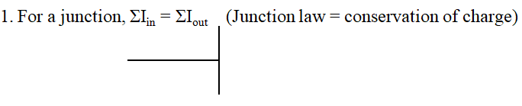

Loop Rule
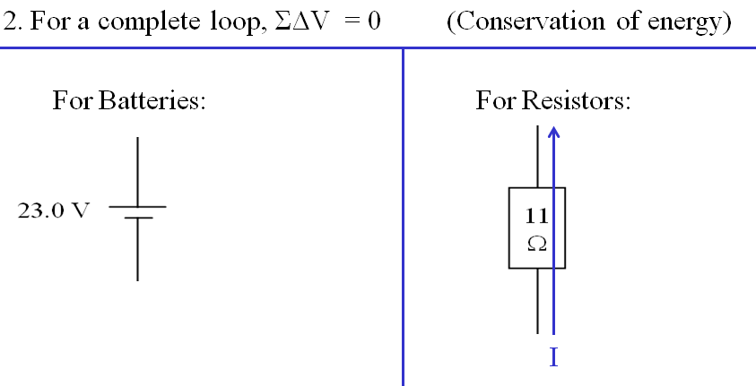

I will give some examples:

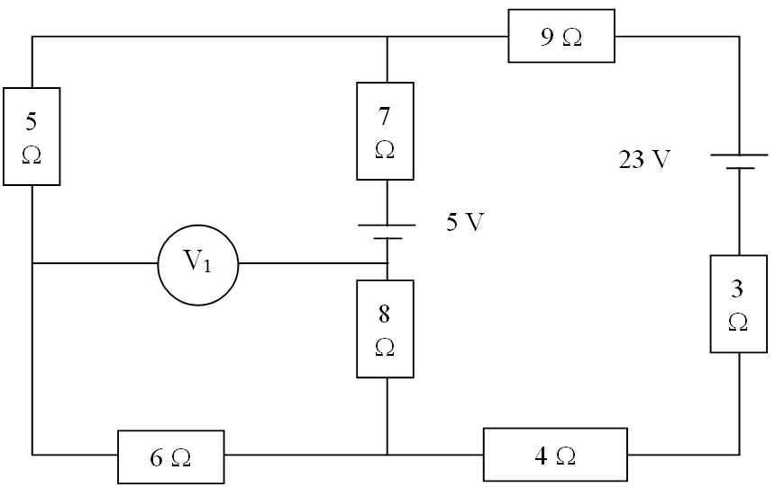

Putting it all together:

Find Current through:
5 Ω
7 Ω
3 Ω
Voltage across:
8 Ω
9 Ω
Power dissipated by:
4 Ω
6 Ω
|V₁|

