Noteguide for Network Resistance - Videos 18J1&2 Name

Net Example 1 – Find current through and power dissipated by each resistor
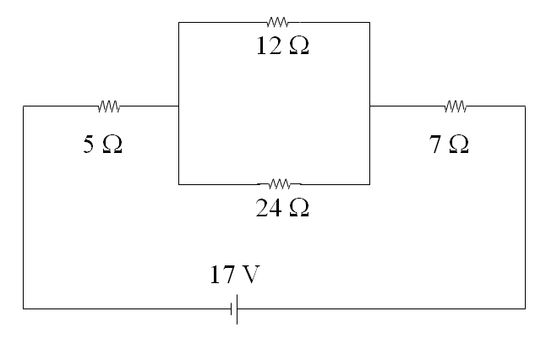
Net Example 2 (single popper)
R (Ω) | I (A) | P (W)
5 | 0.85 | 3.613
12 | 0.5667 | 3.853
24 | 0.2833 | 1.927
7 | 0.85 | 5.058

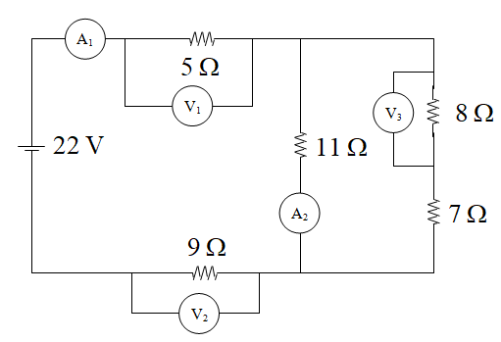
Net Example 3 (double popper)
6.3462
1.0813 | A1
5.4064 | V1
9.7316 | V2
6.862
0.6238 | A2
0.4575
3.6597 | V3

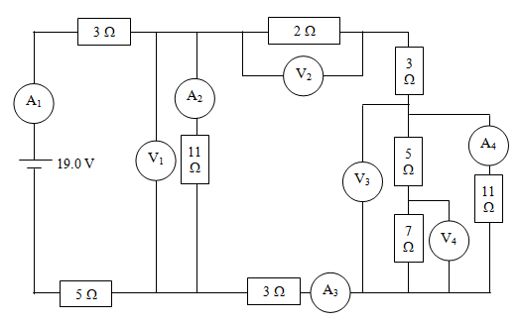

Net Example 4 (double popper)
5.73913
13.73913
6.108963
1.346662 | A1
8.226707 | V1
0.747882 | A2
0.598779 | A3
1.197559 | V2
3.436472 | V3
0.312407 | A4
0.286373
2.004609 | V4

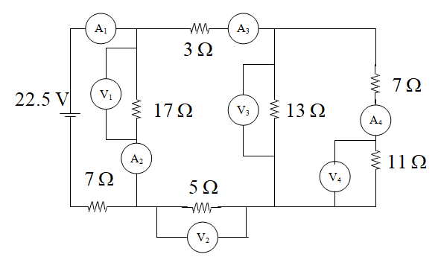

7.548387
15.54839
8.120912
1.488006 | A1
12.08396 | V1
0.710821 | A2
0.777184 | A3
3.885921 | V2
5.866488 | V3
0.325916 | A4
3.585076 | V4

