Noteguide for Power - Videos 18D Name

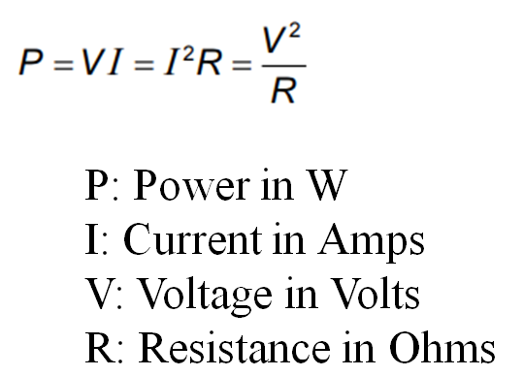

Example 1: If a car stereo uses 850 Watts of power, how many Amps does it use at 12 V?

Example 2: If you have 128 mA of current running through a 560 ohm resistor, what power will it dissipate, and what is the voltage across it?

Whiteboards:
1. A heating element draws 2.07 A from a 12.0 volt source. What is the power it consumes?  (24.8 W) | 2. What is the current flowing in a 75 W light bulb connected to 120 V? (0.625 A)
3. What is the power used by a 0.135 ohm heating element connected to a 24.0 V source? (4270 W) | 4. A 345 mW light bulb draws 12.8 mA of current. What is its resistance? (2110 Ω)
5. A 0.25 Watt 1000. ohm resistor can be connected to what maximum voltage? (16 V) | 6. What maximum current can flow through a 50.0 ohm resistor that is rated at 10.0 Watts? (447 mA)

