1
Old CRT Oscilloscope – the output of a transformer.
- Connect the oscilloscope to the leads coming from the transformer.
- On the horizontal scale (Time/DIV), change the time to 5 ms. Each horizontal division will be then 5 x 10⁻³ seconds. This will be useful later.
- On the vertical scale, for channel 1, set Volts/DIV to 5 V. (We are using Channel 1) Each vertical division will be then 5 volts.
- Click the toggle switch that indicates AC/GND/DC on the left side to GND. The trace should be flat and read 0 V. Turn the vertical position knob until it is at zero on the scale. Click it back to AC.
- Look at the waveform – it should be roughly sinusoidal. Draw an accurate diagram of the sine wave.
- Read the peak voltage. (Count how many divisions the wave goes above zero. Multiply the number of divisions by the vertical scale (5 V/Div), and calculate the peak voltage. Calculate the RMS from the peak. (divide by root 2) – is this what is labeled on the transformer?)
- Measure the period of the waveform. It helps to use the "Position x <->" knob near the top to put one of the peaks right on t = 0 in the middle of the screen. Count how many divisions from peak to peak, multiply by the seconds per division to get period T. (It should be at 5 x 10⁻³ seconds/div)
- Label the height of the peak voltage, and the time between peaks on your diagram of the sine wave.
- Calculate the frequency of the waveform from the period. (f = 1/T)
- Mess with the scale knobs - both time and voltage, and see what happens to the graph. Put them back to what they should be.

2
A computer oscilloscope
- Turn on the computer Bart, type these commands from the C:\> prompt:
  - cd vernier
  - cd mpli
  - mplix
- Choose Oscilloscope by typing "L" and then press enter.
- We are using input A, so type "B" and "C" to turn off these channels, and then type a "T" to access the Triggering menu. Make it trigger on Channel A, automatic, and Return to Scope. (Type letters, press enter to select)
- It is connected to a microphone. The up and down arrows on the keyboard affect the vertical (Voltage) scale. The right and left arrows change the time scale. Mess with it. Try singing a pure "OOOO" and then "EEEEE". Staying on one note, sing "OREO" trying to make your voice metallic sounding.

3
A modern oscilloscope
- Connect the ground alligator to the green wire on the "Input" side, and the oscilloscope input lead to the red wire on the input side. (To clip, pull the tip back) Press the "Autoset" button on the top row and watch the oscilloscope set up a pretty picture for you. (The “Menu Off” button on the lower right of the screen will make the menu go away) You can see the time scale and the voltage scale in the small boxes right below the image. Write these down and draw an accurate diagram of the sine wave.
- Find the knobs that control the voltage (vertical) scale (Right below the illuminated “1”), and the time "Horizontal scale". Turn them and see what happens to the graph.
- Press the "Measure" button on the second row, then hit the left button under the screen for “Add Measurement”. Then use the “a” knob to select channel “1”, and the “b” knob to select “snapshot” (or don’t touch the knobs at all) and finally hit the “OK” button at the bottom of the right side, and see it make all the calculations of RMS, Period, and Frequency that you made by hand with the first oscilloscope. My how life has gotten easier! Check your calculations of period and frequency from station 1. Pressing the “Menu off” button three times makes these menus go away.
- Connect the leads to the output side. (Alligator to green, oscilloscope lead to red) Either press "Autoset" again, or find the triggering level knob on the right, and adjust it so the little cursor on the right side of the screen goes up, and freezes the image. Draw an accurate diagram of the waveform you see on the screen.
- You are seeing the voltage after it passes through a clever arrangement of diodes. (See the diagram below). Current can flow in the direction of the arrow, and is blocked when it tries to flow the other way. Compare this layout to the circuit diagram below. Note that a diode has a white stripe across the cathode - the end into which current cannot flow. Figure out which way the current goes when A is + and B is -, and vice versa. Notice that in either case the current flows out of the +, and into the -. What you see on the scope is approximately the absolute value of the sine wave. (minus the 0.6 or so volts across the diodes)
- The up and down variations in the voltage are called "ripple" and are undesirable. Move the right side of the white jumper one hole to the right to connect a capacitor in parallel to the output, and see what happens to the output. Press “Autoset” again to make the picture pretty. Turn the vertical scale CW one click from autoset, and you can see how the capacitor fills in the valleys between the peaks you saw before. Unplug and plug the right side of the capacitor and see the waveform go back and forth from ripply to nearly smooth. Draw an accurate diagram of the waveform you see on the screen. Notice how the ripple has been reduced by the capacitor.
- Capacitors store charge and electrical energy, so they charge up on the peaks, and discharge to fill the valleys. Pretty cool.
- Move the right side of the white jumper one hole to the left to leave the setup the way you found it.
A
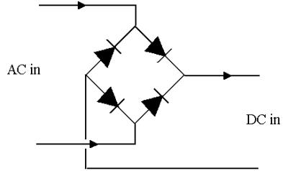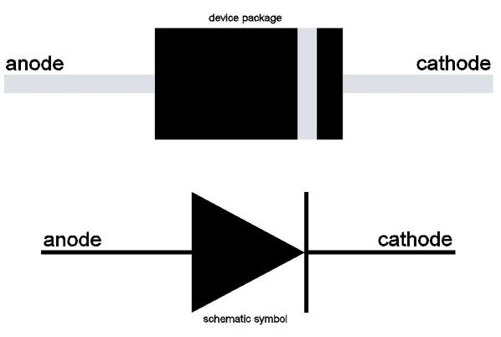
AC in
DC out
-
+
B

(Diode Full Wave Bridge) (Actual Diode layout)

3
A modern oscilloscope (Part 2)

Check out the modern power supply. Count the diodes. (Some are attached to the big heat sink) Look at the breadboarded circuit you were just measuring, look at this power supply.

Pretty sure they are substantially the same.

