Internal Resistance of a Battery

When you draw current from a battery, the terminal voltage drops because all batteries or cells have an internal resistance which we can imagine as a small resistor in series with the cell. The formula then for the EMF is 𝜀 = I(𝑅+𝑟) where I is the current leaving the battery, R is the external resistance, and r the internal.

The model for a battery with internal resistance is this:
r
V_{o}

What this means is that the terminal voltage of the battery (The voltage you would measure if you did so from the black dot to the black dot in the diagram above) will drop as you draw more and more current from the battery. In fact, if we look at the relationship between the current and the terminal voltage, it should be V = V_{o} - Ir, where Vo is the battery's potential, I is the current we are drawing from it, and r is its internal resistance. If we graph V vs I, we will get a graph with a y intercept of V_{o}, and a slope of -r, so that is the plan, to get the internal resistance from the slope of the best fit line.

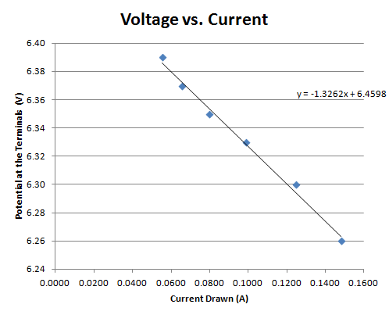 Notice how the terminal voltage is dropping as the current increases | A  V  r  The circuit you will use to measure voltage across and current drawn from the battery.

1. Run this DC circuit construction simulation PHET:
https://phet.colorado.edu/sims/html/circuit-construction-kit-dc/latest/circuit-construction-kit-dc_en.html
Choose "Lab"
2. Set up the circuit
3. Click the cell and pick a potential between 5 and 50 Volts. Don't change this value after this.
4. Click the + next to Battery Resistance (Battery Resistance is the same as Internal Resistance) and pick some non-zero value of battery resistance (1-10 ohms) Don't change this value from now on. The goal of this lab is to construct a graph that will tell us the potential, and the Battery Resistance (Internal Resistance) of our battery. Of course this is stupid, because we already know them, but, IB requires that we do this lab, and I can't think of any other way to do this.
5. Open a Google sheet, and make a table for your currents and voltages. Make Current the Independent and Voltage the Dependent variable. (So Current goes in the left hand column, and Voltage in the right hand column in the spreadsheet)
6. Now click the resistor, and notice that it is actually a variable resistor. Pick 10 spaced out non-zero values of the resistance (Like maybe 100, 90, 80, 70, 60, 50, 40, 30, 20, 10 ohms?) and record in your spreadsheet what the values were for the Current and the Voltage that corresponded to that current. You don't need to record the resistances.
7. In Google sheets, edit the graph, click Series, and add a trendline to your data. Label it with your equation.
4. Answer these questions:
a. What was the internal resistance of the battery from the linear model you added to the graph? (Remember, V = V_{o} - Ir, so r is the negative slope of your graph) How does this compare to the "Battery Resistance" you chose in step 4? Cite what they both were.
b. What was the potential of the battery from the linear model you added to the graph? (Remember V = V_{o} - Ir, so the potential is the y-intercept V_{o}) How does this compare to the value you chose in step 3? Cite what they both were.
c. As batteries wear out, their voltage drops more severely with current drawn. (This is how you test a car battery - you put a load on it, and see how severely the voltage drops) What is happening to their internal resistance? (why do you know?)

