Group Work for 18L Name
1
5 Ω
1 Ω
3 Ω

12.0 V
6 Ω

7 Ω

8 Ω
V₁
4 Ω

9.0 V

Find the current and direction (up or down) through:

3 Ω

6 Ω

7 Ω
Find the voltage across:

6 Ω

8 Ω
Find power dissipated by:

1 Ω
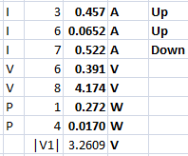
4 Ω
Find:

|V₁| =

2

9 Ω
8 Ω
15.0 V
7 Ω

45.0 V
4 Ω

6 Ω

2 Ω
V₁
3 Ω

Find the current and direction (up, down) through:

7 Ω

4 Ω

6 Ω
Find the voltage across:

8 Ω

2 Ω
Find power dissipated by:

3 Ω
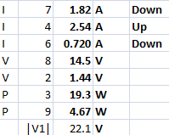
9 Ω
Find:

|V₁| =

3

3 Ω
2 Ω
11.0 V
4 Ω

17.0 V
5 Ω

7 Ω

8 Ω
V₁
6 Ω

Find the current and direction (up or down) through:

4 Ω

5 Ω

7 Ω
Find the voltage across:

6 Ω

8 Ω
Find power dissipated by:

2 Ω

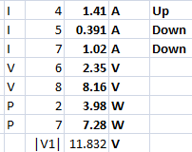
7 Ω
Find:

|V₁| =
4

9 Ω

13 Ω

38.0 V
13.0 V

V₁
11 Ω

8 Ω

14 Ω

7 Ω
12 Ω

Find the current and direction (up, down, left, right) through:

11 Ω

14 Ω

8 Ω
Find the voltage across:

13 Ω

9 Ω
Find power dissipated by:

12 Ω

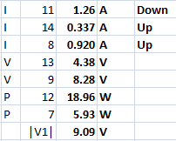
7 Ω
Find:

|V₁| =

