Group Work for 18FGH Name
Round your answers to three sig figs (retain five), and show your work.
A
35.0V
3.1 Ω
4.5 Ω
6.7 Ω
A₁
A₂
V₁
V₃
V₂
1.7 Ω

A_{1 (2.19 A)} | A_{2 (2.19 A)} | V_{1 (3.72 V)}
V_{2 (6.78 V)} | V_{3 (24.5 V)} | Least power dissipated by a resistor: (the 1.7 ohm: 8.13 W)

15.0 V
5 Ω

3 Ω

2 Ω

A₁
A₂
A₃

A_{1 (15.5 A)} | A_{2 (8.00 A)} | A_{3 (3.00 A)} | Greatest power dissipated by a resistor  (the 2 ohm: 112.5 W)

B
45.0 V
4.1 Ω
5.4 Ω
6.3 Ω
4.7 Ω
A₁
A₂
V₁
V₂
V₃

A_{1 (2.20 A)} | A_{2 (2.20 A)} | V_{1 (20.9 V)}
V_{2 (24.1 V)} | V_{3 (10.3 V)} | Greatest power dissipated by a resistor:  (the 6.3 ohm: 30.4 W)

117 V
81Ω

63Ω

45 Ω

A₁
A₂
A₃

A_{1 (5.90 A)} | A_{2 (5.90 A)} | A_{3 (3.30 A)} | Least power dissipated by a resistor  (the 81 ohm: 169. W)

C Find these resistances from the black dot to the black dot:
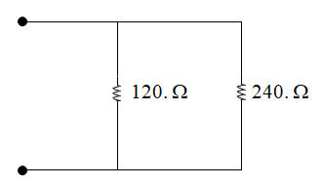 (80 Ω) | 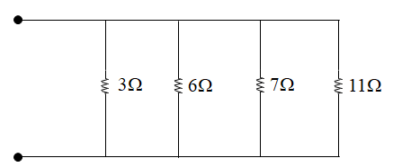(1.36 Ω)
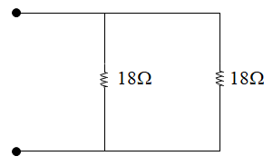 (9 Ω) | 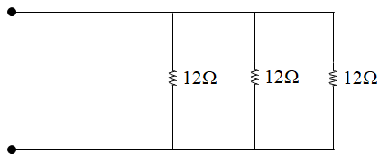 (4 Ω)
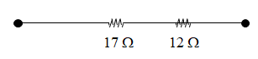  (29 Ω) | 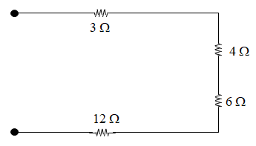(25 Ω)
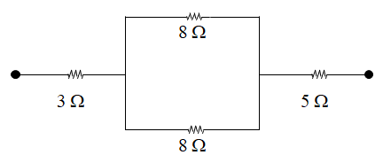  3 + (8⁻¹ + 8⁻¹)⁻¹ + 5 = 12 Ω (Challenge) | 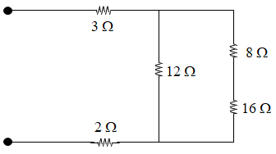  3+(12⁻¹+(16+8)⁻¹)⁻¹+2 = 13 Ω (Challenge)
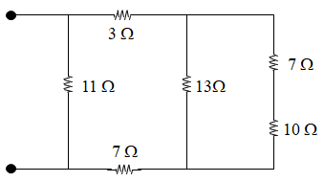 (6.73 Ω) | Draw a picture of a pretty pony here:

