IB Physics
16 A-D Group Quiz
Name
Show your work, and circle your answers and use sig figs to receive full credit.
1. What is the force of attraction between a -10.1 μC charge and a +34.1 μC charge if their centers are 67.0 cm apart? Is it a force of attraction or repulsion?

2. Two point charges have a force of repulsion of 45.3 N when they are 2.30 m separated. What is the force of repulsion if they are separated by only 1.25 m?

3. 450. Kg wrecking ball experiences a force of attraction to a 5.10 kg shot of 6.30x10⁻¹⁰ N. What distance separates their centers?

4. Two point masses have a force of attraction of 2.30x10⁻¹² N when they are separated by 56.0 cm. What is their separation if the force of attraction is 5.80x10⁻¹² N?

5. Find the net force and direction on masses A, B and C: 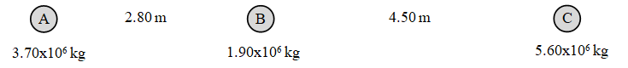
3.70x10⁶ kg
1.90x10⁶ kg
5.60x10⁶ kg
4.50 m
2.80 m
A =
35.0 cm
23.0 cm

B =

C =

6. Find the net force and direction on charges A, B and C:
3.70x10⁶ kg
1.90x10⁶ kg
5.60x10⁶ kg
4.50 m
2.80 m
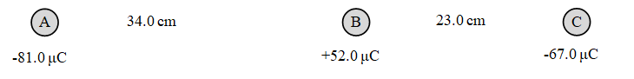
A =
35.0 cm
23.0 cm

B =
35.0 cm
23.0 cm

C =

7. Each grid line is a meter. Charge A is -430. µC, and charge B is +120. µC, and C is +780. µC. Calculate the force on charge C. Draw the force vector and label its magnitude and direction.

- | A
 |  |  |  | + | B
 |  | + | C

9. Each grid line is a meter. Mass A is 1.20x10⁶ kg, and mass B is 3.10x10⁶ kg, and C is 6.80x10⁶ kg. Calculate the force on mass A. Draw the force vector and label its magnitude and direction.

 |  | m | B
A
m
 |  |  |  | m | C

