IB Physics
16 JQ Group Quiz
Name
Show your work, and circle your answers and use sig figs to receive full credit.
1. An electron is accelerated from rest through a potential to a velocity of 3.44x10⁶ m/s. What potential was required?

2. A proton is accelerated from rest through 115 kV. What is its velocity?

3. A proton accelerated from rest is going 7.20x10⁶ m/s. Through what voltage was it accelerated?

4. What is the velocity of an electron accelerated through 28.0 Volts from rest?

5. A +180. µC charge with a mass of 170. g is approaching another fixed +150. µC charge directly. If it is moving at a speed of 41.0 m/s when it is 2.00 m away, what is its speed when it is 1.00 m away? How close will it get before it is stopped by the repulsion? What will be its speed later when it is very far away? Assume no other force acts on the moving charge.

6. A 3.20 g rifle bullet leaves the surface of the moon with a speed of 1000. m/s going straight up. a) What is the greatest height it reaches? b) What is its height when it is going 500. m/s? c) What velocity is it going when it reaches a height of 300. km above the moon's surface? The mass of the moon: 7.35x10²² kg, The radius of the moon: 1.737x10⁶ m

IB Physics
FA 16.2 - Vector Field
Name

Favorite YouTube Video (besides Physics ones)
Show your work, and circle your answers and use sig figs to receive full credit.
When you have finished this, go to the website and check your answers. If you got a problem wrong, cross it off on the front, and do it correctly on the back.
1. A uniform electrical field exerts a force of 0.890 N to the left on a -410. µC charge. What is the change in electrical potential if you move 2.60 m to the left? Is it an increase in potential, or a decrease?

2. If you move a mass vertically from point A to point B in a uniform gravitational field, the potential changes from -12.0 J/kg to +23.0 J/kg in a distance of 17.0 m. What force does the field exert on a 5.20 kg mass, and which point is at a higher elevation, A or B? Does the field point toward A or B?

3. What is the electric field 34.5 cm above a -12.0 μC charge?

4. Find the gravitational field at p and at point q:
6.20x10²⁴ kg
8.70x10²² kg

m

m
6.30x10⁶ m
(p)
(q)
2.30x10⁶ m
1.70x10⁶ m

5. Find the electric field at point p. Draw the electric field vector, and label its magnitude and direction. Charge A is -1.80 µC, B is +2.60 µC, and each grid line is a meter.

 | A
 |  |  |  | p
+ | B

Problems from A16.2 Vector Fields:
(Assume all these fields are uniform)
- A gravitational field increases the potential of a mass from 35.0 J/kg at point A to 89.0 J/kg at point B in a vertical distance of 2.50 m. What is the field strength, and what force does it exert on a 23.0 kg mass? Does the field point toward B or A? (21.6 N/kg, 497 N, toward A)
- An electric field exerts a Southerly force of 1.30 N on a +780. µC charge. What is the change in potential if you displace yourself 5.30 m to the north? (+8830 V)
- A gravitational field exerts a force of 140. N on a 17.0 kg mass away from point B and toward point A that is vertically displaced from B a distance of 45.0 m. What is the field strength? What is the change in gravitational potential if you go from B to A? (8.24 N/kg, -371 J/kg)
- An upward electric field has a strength of 23,400 N/C. What is the change in potential if you displace yourself upward 3.40 cm? What force will it exert on an electron? A proton? (-796 J/C or V, 3.75x10⁻¹⁵ N down, 3.75x10⁻¹⁵ N up)
- If you move 12.0 m West in an electrical field, your electrical potential drops by 340. V. What is this electrical field? What force does this field exert on a charge of -56.0 µC? (28.3 V/m (or N/C) to the West, 1.59x10⁻³ N East)
- A gravitational field has a strength of 1.10x10⁻⁷ N/kg to the right. If I move a mass 2.30 m to the left, what is the change in gravitational potential? What force does this exert on a 1.00 gram object? (+2.53x10⁻⁷ J/kg, 1.10x10⁻¹⁰ N)
- An electrical field changes electrical potential from 210. V to 560. V when you move down 4.50 cm. What is the magnitude and direction of the electrical field, and what force does it exert on a +2.40 µC charge? (7780 V/m (or N/C) up, 0.0187 N up)
- An electrical field exerts a force of 78.0 N to the left on a -12.0 µC charge. What is the magnitude and direction of this electrical field? What is the change in electrical potential if you move 13.0 cm to the left? (6.50x10⁶ N/C right, +8.45x10⁵ V)
- The leftmost of two vertical parallel plates is held at -12.0 V, and the rightmost is held at +16.0 V. If they are separated by 3.20 cm, what is the electrical field between them? What force would it exert on an electron between the plates? (875 V/m to the left, 1.40x10⁻¹⁶ N to the right)
- If you move a mass vertically from point A to point B in a uniform gravitational field, the potential changes from -45.0 J/kg to -12.0 J/kg in a distance of 3.40 m. What is the gravitational field strength, and which point is at a higher elevation, A or B? Does the field point toward A or B? What force does it exert on a 2.30 kg mass (g = 9.71 N/kg toward A, B is higher, 22.3 N)

(← not in data packet - memorize this!!!!)
- The electric field is 52.0 N/C downwards 54.0 cm above a charge. What is the charge, and is it positive or negative? (-1.69x10⁻⁹ C, negative)
- What is the electric field 230. m above a +21.0 µC charge? What direction is it? (3.57 N/C up)
- Near a -18.0 μC charge there is an upward electric field of 450. N/C. How far away is the point where this happens, and where is it, above or below the charge? (19.0 m, below)
- There is an electric field of 310. N/C upwards 88.0 cm above an unknown charge. What is the charge, and is it positive or negative? (2.67x10⁻⁸ C, positive)
- What is the electric field 2.70 m to the left of a +8.20 μC charge? What direction is it? (1.01x10⁴ N/C, left)
- At what distance from the center of a 6.90x10²⁴ kg planet is the gravitational field 4.50 N/kg? (1.01x10⁷ m)
- What is the acceleration of gravity on the surface of a planet with a mass of 6.39x10²³ kg and a radius of 3.39x10⁶ m? (Mars) (3.71 N/kg)
- What is the gravitational field 4.50 m to the right of a 2.80x10¹² kg point mass? What direction? (9.22 N/kg left)
- Near a 3.40x10¹² kg point mass there is a field of 5.60 N/kg to the left. What distance are we from the point mass, and where is the mass in relation to us? (6.36 m, the mass is to our left)
- There is a gravitational field of 14.0 N/kg to the right, 7.20 m from a point mass. What is the mass, and where are we in relation to the mass? (1.09x10¹³ kg, we are to the left of the mass)
21.
A. Find the gravitational field at p and q: (p: 8.29 N/kg left, q: 8.23 N/kg left)
3.50x10²⁴ kg
2.50x10²⁴ kg

m

m
4.30x10⁶ m
(p)
(q)
6.20x10⁶ m
4.80x10⁶ m

B. Find the gravitational field at p and q: (p: 10.7 N/kg right, q: 28.3 N/kg left)
5.90x10²⁴ kg
9.70x10²⁴ kg

m

m
6.30x10⁶ m
(p)
(q)
5.60x10⁶ m
4.90x10⁶ m

C. Find the electrical field at p and q: (p: 2.37 N/C left, q: 452 N/C left)
+1.20 µC
-8.60 µC

+

-
18.0 m
(p)
(q)
32.0 m
13.0 m

D. Find the electrical field at p and q: (p: 54.9 N/C right, q: 2.01 N/C right)
-3.50 µC
-4.70 µC

-

-
26.0 m
(p)
(q)
21.0 m
24.0 m

22. Each grid line is a meter. Calculate the field at point p.
A. Charge A is +1.30 µC, B is +3.10 µC  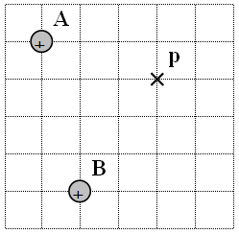  2698 N/C up and right at 31.6º with the x axis | B. Mass A is 9.40x10¹² kg, mass B is 1.80x10¹² kg  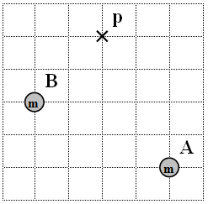  38.8 N/kg down and right (barely) at 85.0º with the x axis
C. Charge A is -6.50 µC, B is -4.10 µC  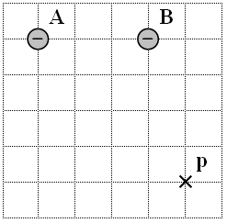  3850 N/C, up and left at 61.8º with the x axis | D. Mass A is 1.40x10¹² kg, mass B is 1.20x10¹² kg  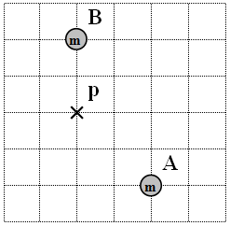  14.4 N/kg to the right and up at 54.9º with the x axis
E. Charge A is -3.70 µC, B is +5.30 µC  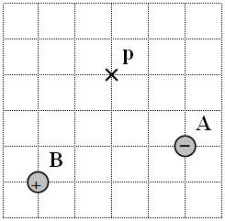  4970 N/C right and up (barely) at 1.26º with the x axis | F. Mass A is 2.90x10¹² kg, mass B is 8.70x10¹² kg  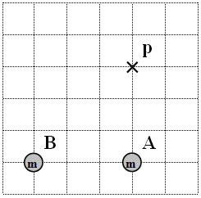  49.8 N/kg left and down at 62.8º with the x axis

IB Physics
FA 17.1 - Energy
Name

Favorite Movie
Show your work, and circle your answers and use sig figs to receive full credit.
When you have finished this, go to the website and check your answers. If you got a problem wrong, cross it off on the front, and do it correctly on the back.
1. If it takes +34.0 J of work to move a -250. µC charge from plate A to plate B, what is the potential difference, and which plate is more positive, A or B?

2. What is the velocity of a proton accelerated through 3.70 Volts from rest?

3. Find the electric potential at point p and point q. Charge A is -3.10 µC, B is +2.60 µC, and each grid line is a meter.
 | A |  |  | p
 |  |  | q
+ | B

4. What work would it take to move a +370. µC charge from point q to point p?

5. A 5.20 kg piece of rock is in an elliptical orbit around a 4.80x10²⁴ kg planet. At one point in time, its velocity is 6790 m/s when it is at a distance of 8.40x10⁶ m from the planet's center. What is its distance from the planet's center when it is going 5860 m/s?

Problems from A17.1 Energy:
- A 2.30 kg mass is moved from a potential of 45.0 J/kg to -12.0 J/kg. What work was done? (-131 J)
- A -1.20 μC charge is moved doing +47.0 J of work. What was the change in electrical potential? (-3.92x10⁷ V or J/C)
- You do +0.132 J of work moving a charge from a potential of +45.0 V to +12.0 V. What is the charge? (-4.00x10⁻³ C)
- You do -62.0 J of work moving a mass from a potential of +78.0 J/kg to 53.0 J/kg. What is the mass? (2.48 kg)
- A +3500. μC charge is moved doing -0.0780 J of work. If it started at a potential of 100. V, what was the final potential? (+77.7 V)
- What work would you need to do to move a 2.30 kg mass from a potential of -895 J/kg to -145 J/kg? (+1725 J)
- If you do +45.0 J of work moving a 15.0 kg mass, what is the change in potential? (+3.00 J/kg)
- What work would you do moving a -4.50 μC charge from a potential of -120. V to a potential of +480. V? (-2.7x10⁻³ J)

- Look up mass and charge in your data packet. Practice so you know where they are.
- What is the velocity of an electron accelerated through 13.0 Volts from rest? (2.14x10⁶ m/s)
- Through what potential must you accelerate an electron from rest to make it go 3.80x10⁵ m/s? (0.411 V)
- What is the velocity of an electron accelerated through 820. Volts from rest? (1.70x10⁷ m/s)
- A particle with a charge of 0.0280 μC is accelerated through 1520 V from rest and ends up going 37.5 m/s. What is its mass? (6.05x10⁻⁸ kg)
- A particle is accelerated through 1500. V and attains a velocity of 3.80x10⁵ m/s. If it has a mass of 6.64x10⁻²⁷ kg, what is the charge on it? (3.20x10⁻¹⁹ C)
- What is the velocity of a proton accelerated through 150,000 V? (5.36x10⁶ m/s)
- A proton accelerated from rest is going 6.50x10⁶ m/s. Through what voltage was it accelerated? (2.21x10⁵ V)
- What is the velocity of a proton accelerated through 5000. V? (9.79x10⁵ m/s)

,
- A +130. µC charge with a mass of 12.5 grams is at rest 45.0 cm from a +390. µC fixed charge. The first charge is released from its position and flies away. What is its velocity when it is 95.0 cm from the second charge? What is its velocity when it is very far away? Assume that no other force acts on the moving charge. (292 m/s, 403 m/s)
- A +160. µC charge with a mass of 230. g is approaching another fixed +160. µC charge directly. If it is moving at a speed of 34.0 m/s when it is 2.00 m away, what is its speed when it is 1.00 m away? how close will it get before it is stopped by the repulsion? What will be its speed later when it is very far away? Assume no other force acts on the moving charge. (12.5 m/s, 0.928 m, 46.4 m/s)
- Two identical charges each with a charge of +45.0 µC and a mass of 56.0 grams are placed 34.0 cm from each other. If they are released simultaneously, what speed do they have when they are 50.0 cm from each other? What speed do they have when they are very far away? Assume no other forces act on the charges. (17.5 m/s, 30.9 m/s)
- A charge of +46.0 µC is at rest 1.80 m from a -52.0 µC charge that is also at rest. Each charge has a mass of 48.0 g. If they are released simultaneously, what is their velocity when they are 1.00 m from each other? With what velocity do they collide if they each have a radius of 2.50 cm? (14.1 m/s, 93.3 m/s)
- An alpha particle with a mass of 6.64x10⁻²⁷ kg and a charge of +2e (e = 1.602x10⁻¹⁹ C) is needs what speed to get 1.30x10⁻¹⁵ m from a gold nucleus with a charge of +79e. Assume the gold nucleus does not move. (9.19x10⁷ m/s)
6 - 8: The mass of the moon: 7.35x10²² kg, The radius of the moon: 1.737x10⁶ m
- A rifle bullet with a mass of 4.20 grams is fired straight up off the surface of the moon at a speed of 560. m/s. What is the greatest height the bullet will rise to above the surface before coming back down? What is its speed when is has gone 50.0 km straight up? What speed would the bullet need to be able to escape the gravity of the moon? (1.02x10⁵ m, 394 m/s, 2380 m/s)
- A 12.0 kg piece of rock headed directly toward the moon is going 870. m/s at an elevation of 100. km above the moon. With what speed does it strike the surface? What was its speed when it was 50.0 km above the surface? (1030 m/s, 952 m/s)
- A 2.80 g rifle bullet leaves the surface of the moon with a speed of 1050 m/s going straight up. What is the greatest height it reaches? What is its height when it is going 780. m/s? What velocity is it going when it reaches a height of 300. km above the moon's surface? What speed would it need to escape the moon's gravity? What is its height when it is going only 100. m/s? (422 km, 167 km, 521 m/s, 2380 m/s, 417 km)
- A 13,500 kg spaceship orbits a 4.50x10²⁴ kg planet in an elliptical orbit. At one point, its speed is 6910 m/s when it is 7.60x10⁶ m from the planet's center. If later in its orbit is moving 5440 m/s, what is its distance to the center of the planet? If part of its orbit is at a distance of 8.50x10⁶ m from the center of the planet, what is the velocity of the spaceship? (9.87x10⁶ m, 6280 m/s)
- A 120. kg space probe orbits a 3.60x10²⁴ kg planet in a circular orbit at a speed of 5660 m/s. What distance is it from the planet? What is its total energy (kinetic and potential) ? What speed would it need to escape gravity from this distance from the planet? What would its total energy be at this speed? Suppose it somehow attained escape velocity at this distance from the planet, and was escaping on some trajectory, at what distance from the planet's center would it be when it was going 4000. m/s? What would be its speed when it was 7.50x10⁸ m from the planet? (7.50x10⁶ m, -1.92x10⁹ J, 8.00x10³ m/s, 0 J, 3.00x10⁷ m, 800. m/s)

, or , Potentials in an array add as scalars. (Numbers)
27. Each grid line is a meter. Calculate the potential at points p and q.
A. Charge A is +1.50 µC, B is +2.10 µC  What work would it take to move a -140. µC charge from point p to point q?  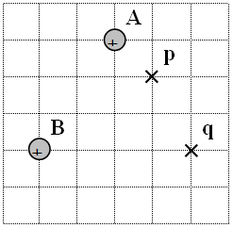  Vp: +1.48E+04 V, Vq: +8.46E+03 V, W: +0.884 J | B. Mass A is 5.40x10¹² kg, mass B is 1.90x10¹² kg  What work would it take to move a 1.70 kg mass from point q to point p?  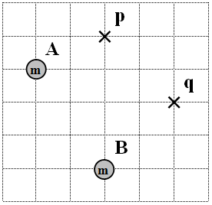  Vp: -193 J/kg, Vq: -132 J/kg, W = -103 J
C. Charge A is -6.30 µC, B is -1.10 µC  What work would it take to move a +520. µC charge from point q to point p?  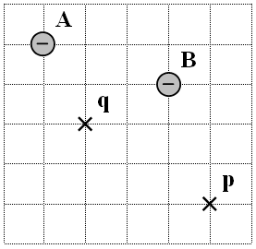  Vp: -1.31E+04 V, Vq: -2.98E+04 V, W: +8.64 J | D. Mass A is 5.10x10¹² kg, mass B is 1.80x10¹² kg  What work would it take to move a 2.90 kg mass from point p to point q?  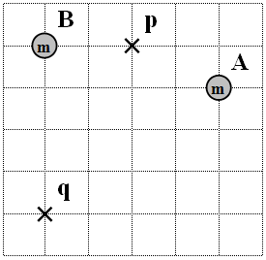  Vp: -212 J/kg, Vq: -98.0 J/kg, W: +331 J
E. Charge A is -3.20 µC, B is +2.50 µC  What work would it take to move a -640. µC charge from point q to point p?  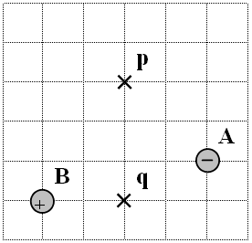  Vp: -3.94E+03 V, Vq: -1.63E+03 V, W: +1.48 J | F. Mass A is 8.90x10¹² kg, mass B is 2.70x10¹² kg  What work would it take to move a 4.20 kg mass from point q to point p?  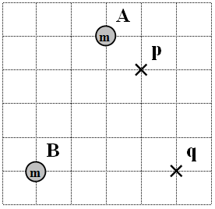  Vp: -462 J/kg, Vq: -178 J/kg, W: -1195 J

IB Physics
FA 17.2 - CRTs and Capacitors
Name

Favorite Documentary
Show your work, and circle your answers and use sig figs to receive full credit.
1. A parallel plate capacitor has plates that measure 34.0 cm x 34.0 cm, and an air gap of 1.10 mm. What is the charge on the capacitor if there if a potential difference of 48.0 V across it? (4.46x10⁻⁸ C)

2. To what voltage must you charge a 12,000 µF capacitor to store 13.0 J of energy? (46.5 V)

3. An RC circuit starts at 4.735 V, and is at 3.20 V 17.0 seconds later. What time will it take to reach 1.00 V?
(67.5 s)

4. These plates are separated by 10.0 cm and are 25.0 cm long. An electron traveling at 1.13x10⁶ m/s enters the left side parallel to the plates, and 5.00 cm from each plate, and exits 1.00 cm from the upper plate. What is the acceleration of the electron? What is the electric field between the plates? What voltage is across the plates?
(1.63x10¹² m/s/s, 9.29 N/C, 0.929 V)
+++++++++
+ + + + + + + + + + + + + + + + + + + +
+++++++++
- - - - - - - - - - - - - - - - - - - - - - - - - - - -
25.0 cm
10.0 cm

5. 150 keV protons (protons that have been accelerated through 150,000 V) going horizontally enter a steering device that is a couple of parallel plates 8.00 cm long, and 4.00 cm apart. They exit at an angle of 3.20º above horizontal. What is the velocity of the protons as they enter the plates? What must be the final upward velocity as they exit the plates so that it is traveling at this angle? What time is the proton between the plates? What is the vertical acceleration of the proton? What must be the voltage across the plates to achieve this?
(5.36x10⁶ m/s, 3.00x10⁵ m/s, 1.49x10⁻⁸ s, 2.01x10¹³ m/s/s, 8390 V)
+++++++++
+ + + + + + + + + + + + + + + + + + + +
+++++++++
- - - - - - - - - - - - - - - - - - - - - - - - - - - -
8.00 cm
4.00 cm

Electric Field Mapping Lab

You can map Electric fields two dimensionally by using a conductive medium, a power supply and a voltmeter. You actually will find lines of equal potential, but it is a short leap from there to E field lines. Every man, woman and child will need to do their own two field maps. I have several suggestions for what you can try to map, and you can also make up your own configuration. Try to do two different field maps. Branch out.

- You will need heavy paper, some electrodes, a pencil attached to a voltmeter, and a shallow tray filled with about 1-2” of water.
- Write your name in pencil on the top of your sheet op paper, slide the paper into the water from one end so that there are no bubbles under it, and place the electrodes on top of the paper to hold it down.
- Attach the leads from the power supply to the electrodes. (It is possible that some electrodes can be electrically unattached) Label the attached electrodes 0 and 6 V.
- Pick 5 voltages more or less evenly spaced from your maximum voltage to your minimum. Because of electrochemistry, we will read .8 V above, so for 0 to 6 V you would do 1.8, 2.8, 3.8, 4.8, 5.8 Set the voltmeter to 200 V, so that it shows the voltage with only one decimal point. (Otherwise you will go mad) Notice as you move the pencil around in the water (Don’t draw on the sheet yet) that the voltage changes, and that closer to the 6 V electrode, the voltage is closer to 6 V, and the 0 V electrode, 0V.
- First mark where all the electrodes are – so if you bump them you can put them back. Label them “0 V”, “6 V” or “N” for neutral
- Now mark gently on the paper (so as not to tear it) points separated by about a centimeter or so all the way across the page for every voltage. These lines are called equipotential lines.
- When you are done, carefully remove your paper, and place it to dry, and do another different map if you haven’t already.
- When your paper is dry, it should now have a bunch of dots on it that form neat patterns of equal potential. Connect the dots of equal potential with nice smooth lines in pencil, erasing if they aren't smooth. (i.e. all 1.8 volt dots, all 4.8 volt dots) Then trace over your equipotential lines with pen so they won't erase. Starting from the positive electrode, draw lines lightly at first in pencil that go to the negative electrode, and always cross the equipotential lines at right angles. (These lines are E-Field Lines) This will take some practice. Remember, the electrodes were conductors, and electric field lines are always perpendicular to conductors. (They will leave the electrodes at right angles)
- Answer these questions for each picture:
  - Where on your picture is the E-field the strongest? Circle that region, and calculate the E field there. E = ΔV/d. For ΔV you know the voltage of every equipotential line, so just subtract. For d, use a ruler. Remember to use meters. Show this calculation on the sheet itself.
  - Where on your picture is the E-Field the most uniform? Box that region and calculate the E-Field there.
  - Turn in both your pictures, with your calculations on them. That's it. (Each man, woman, and child must turn in their own two field maps)

RC Circuits

Ohm's Law states that the rate at which charge flows is proportional to the voltage making the charge flow. Here we are going to look at the voltage across a capacitor as it discharges through a resistor.
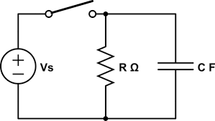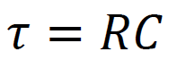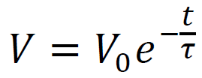

Gathering the data:
- Open the file "RC Circuit Lab" on the desktop. When a window pops up asking about a voltage sensor, click "Connect".
- From the "Experiment" menu choose "Data Collection"
- Click the "Collection" tab and have it collect one sample per second for about 3 time constants. (The resistor is a 1 MΩ, so 1.0x10⁶ ohms, and the capacitor has its value printed on it, read this, and multiply. τ = RC. Type this into the “Length” box) Record the values of your resistor and your capacitor so you have them later
- Click the "Triggering" tab and have the experiment automatically start as it decreases across 4.8 V. (Click "Triggering" and “On Sensor Value” and "Decreasing" and type in 4.8 for the value. 0 samples before triggering)
- Click OK to get rid of the Data Collection dialog box, and click on the last number on the time axis of the graph and change it to the length of the experiment you set in step 3 (If it doesn’t change for you)
- Hold the orange wire to the side of the capacitor that has the red connector attached to it. Notice that the voltage goes up to 5.00 V. Press the "Collect" button, and wait until you see that it is waiting to trigger.
- Disconnect the orange wire from the side of the capacitor. It will start to drain. The data collection should start automatically when the voltage falls across the threshold you set in step 4 (4.8 V?)
- When the data collection is finished, right click the upper left corner of the data table, choose "copy", and paste it into a Google Docs spreadsheet, so that you can free up the RC lab setup. You can now do the rest of the write up at home, or here on a laptop.
Writing up the lab:
- Make a nice labeled graph of your data. One time constant is when the voltage falls to e⁻¹ times the original voltage. (≈ 37% of the original voltage) Draw a horizontal line where this is on your graph printout so it intersects your data, and from the intersection of this line and your points of data, draw a line straight down to your x axis. Why does the voltage drop the way it does? Why is it steep at first, and less steep at the end?
- Look in your data and find at what time the voltage fell to 0.368 (e⁻¹) of the original voltage. (Multiply the first voltage recorded by 0.368, and find at what time it occurs in your data) How does it compare to the time constant you would calculate from the resistor? (Calculate RC, and compare it to the time you looked up)
- V_{o} is the first voltage you recorded. Pick 5 ordered pairs of (time, Voltage) throughout your data, and plug them into the formula 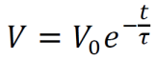 , and solve for the time constant τ. Do the values of the time constant remain, oh, I don't know.... constant???? Talk about this. Do they show any pattern, or do they just randomly differ?

Millikan Oil Drop Lab
Robert A. Millikan determined the charge on the electron by suspending tiny droplets of oil in an electric field, and letting them fall at terminal velocity in air. Here you will do the same except in a computer simulation.

Theory:
Suspension of Oil Drops:
When the drop is suspended, the electric force is equal to the force of gravity. So this means that:

mg = Eq m - mass
g - 9.80 N/kg
E - Electric Field
q - Charge

But since E is V/d, and m is ρV where ρ is the density of the drop, and V is its volume, substituting 4/3πr3 for volume you get:
Equation 1
ρ(4/3πr3)g = Vq/d ρ- Density (128 kg/m3)
r - Drop Radius
g - 9.8 N/kg
V - Potential across plates that create electric field
q - Charge on drop
d - Separation of plates

Which is great, but we know or can measure only V, d, ρ which means we don't know r and q. This is a bad situation with one equation.

Drops at Terminal Velocity:
Stokes Law states that for a small sphere, the viscous force on it as it moves through a fluid is given by
Equation 2:
F = 6πηrv

Where η is the viscosity of air (1.81 x 10-5 Nsm-2), r is the drop radius, and v is the velocity. At terminal velocity this force equals the weight of the drop so:
Equation 3:
mg = ρ(4/3πr3)g = 6πηrv ρ- Density (128 kg/m3)
r - Drop Radius
g - 9.8 N/kg
η - viscosity of air (1.81 x 10-5 Nsm-2)
v - terminal drop velocity

You can solve this for r, and then substitute this in for r in Equation 1. This is not pretty.
Procedure:
Drops at Terminal Velocity:
When you get a new drop, you will need to find its radius from their terminal velocity first. Get a charge suspended near the top of the viewing area, disconnect the voltage, and start the timer. Use the distance it falls in the measured time to determine the velocity of the drop. Reconnect the voltage to stop the drop from leaving the viewing area. Be sure to note what magnification you are using.
(77.5 μm/div is the best)

Suspension of Oil Drops:
This part is easy. Get a new drop, or keep working with your old one. Zap the drop with radiation, and adjust the voltage so that it quits moving up or down. Record the voltage. You may have to reverse the polarity to get the drop to suspend. Repeat the process of Zapping the drop, and suspending it for as many times as you can keep the drop in your field of view. If you lose your drop, you have to get a new drop and determine its radius again by letting it go into terminal velocity. Eventually you will find that the voltages for some reason repeat, and you will need to get a new drop.

In General:
I want you to collect 25 unique data points per person. The general procedure is:
- Get a new drop
- Determine its terminal velocity. (3 trials??)
- Zap the drop
- Suspend the drop/record the voltage
- Repeat steps 3 and 4 until you either lose the drop, or it repeats the same voltages over and over.
- If you don’t yet have 25 unique data points, go to 1
Take shifts at the computer. Each person in the group needs to collect their own data, but the group as a whole needs only turn in one report for the whole group with all names on it.

What you turn in:
Turn in the following:
Purpose
•What was the purpose of Millikan's investigation?
Procedure
•(A diagram of the set up Millikan used. There is one in your book)
Results
•Your raw data. (radii and suspension voltages)
•Your known values used for calculation (density, etc)
•Your calculated Charges. (Please use a spreadsheet)
•A histogram of your charges sorted by magnitude
•The general form of any calculation you made (your formulas for radius, velocity, charge)
Conculsion
Your answer to these questions:
•What did you determine the charge on the electron to be? (What is the size of your steps) - Show how you calculated your electron charge. (Explain with words)
•What would be your estimation of uncertainty of your results. How did you calculate it? (Explain with words)

IB2 Mock Field Theory Test

1. A moon (B) orbits a planet (A).
The following data are available:
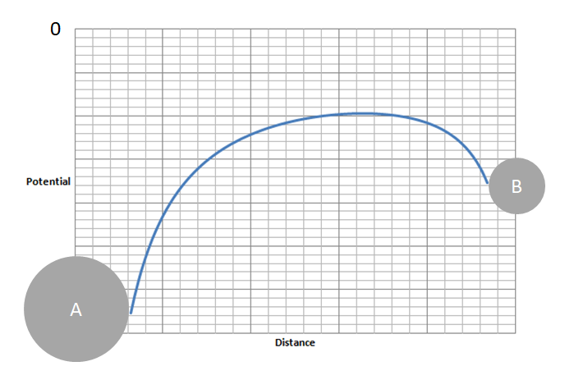
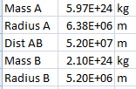

(Where Dist AB is the centre to
centre distance)

a. Label on the potential diagram above where there is no net gravitational field between the planet and the moon
b. Calculate the distance from the center of the planet to the point where there is no net gravitational field (3.26x10⁷ m)
c. Calculate the total gravitational potential at the surface of the moon due to the planet and the moon. (-3.54x10⁷ J kg⁻¹)

2. A satellite is in a circular orbit around a planet.
a. Outline why the gravitational force does not speed the satellite up.
b. Show that for all objects orbiting the planet, rv² = GM where r is the radius of orbit, v the velocity of orbit, and M is the planet's mass.

The following data are available:
Velocity of orbit of satellite A = 6470 ms⁻¹
Radius of orbit for satellite A = 8.40x10⁶ m
Radius orbit of satellite B = 7.20x10⁶ m

c. Calculate the velocity of satellite B (6,988 ms⁻¹)
d. Calculate the mass of the planet (5.27x10²⁴ kg)

3. An asteroid in deep space is going 2.30 km s⁻¹ when it is very far from Earth. It passes to within 4.10x10⁶ m of Earth's surface in its curving trajectory. The Earth has a mass of 5.97x10²⁴ kg, and a radius of 6.38x10⁶ m.
a. What is its velocity when it is closest to Earth? (9.016 km s⁻¹)
b. What distance is it from the surface of the Earth when its velocity is 4.60 km s⁻¹? (4.38x10⁷ m)

4. The electrical circuit shown is used to investigate the temperature change in a wire that is wrapped around a mercury-in-glass thermometer. A battery of emf (electromotive force) 46.0 V and of negligible internal resistance is connected to a capacitor and to a coil of resistance wire using an arrangement of two switches. Switch S1 is closed and, a few seconds later, opened. Then switch S2 is closed.
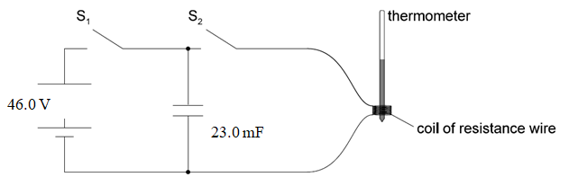
a. The capacitance of the capacitor is 23.0 mF. Calculate the energy stored in the capacitor when it is fully charged. (24.3 J)
b. The resistance of the wire is 15.0 Ω. Determine the time taken for the capacitor to discharge through the resistance wire. Assume that the capacitor is completely discharged when the potential difference across it has fallen to 1.00 V (1.32 s)
c. The mass of the resistance wire is 0.910 g and its observed temperature rise is 89.0 K. Estimate the specific heat capacity of the wire. Include an appropriate unit for your answer. (300. J kg⁻¹ ºC⁻¹)
d. Suggest one other energy loss in the experiment and the effect it will have on the value for the specific heat capacity of the wire.

