Noteguide for Simple Voltage - Videos 16H Name

Definition:
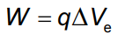  ΔV_{e} = Change in Voltage (Volts, V, J/C)  W = Work or PE (J)  q = Charge (C) | 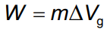  ΔV_{g} = Change in Grav. Potential (J/kg)  W = Work or PE (J)  m = Mass (kg)
Example 1: Hans Full does 0.012 J of work on 630 μC of charge. What is the change in voltage? | Example 2: How much work would you need to move 34.0 kg from a gravitational potential of 12.0 J/kg to 67.0 J/kg?

Whiteboards. (Note the order they are listed)
1. Sandy Deck does 125 J of work on a 12.5 C charge. Through what voltage did she move it? (10.0 V) | 3. Myles Togo lifts a 5.00 kg mass increasing its potential energy by 135 J. Through what gravitational potential did he move it? (27.0 J/kg)
2. Lila Karug moves a 120. μC charge through a voltage of 5000. V. How much work does she do? (0.600 J) | 4. Sally Forth moves a mass from 14.0 J/kg to 45.0 J/kg doing 267 J of work. What mass did she move? (8.61 kg)

Noteguide for Potential, Field and Displacement - Videos 16I Name

Definition:
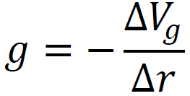  ΔV_{g} = Change in Grav. Potential (J/kg)  g = Grav. field strength (N/kg)  Δr = Displacement (m) | 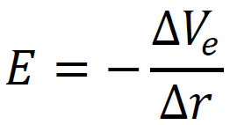  ΔV_{e} = Change in Voltage (Volts, V, J/C)  E = Elec. field strength (N/C)  Δr = Displacement (m)
Example 1: If you have a gravitational field strength of 9.81 N/kg, what is the change of gravitational potential in a vertical upward distance of 1.85 m? | Example 2: What is the electric field when you have 12.0 V across two || plates that are separated by 0.0150 m?

Whiteboards.
1. Lee DerHosen places a voltage of 25 V across two || plates separated by 5.0 cm of distance. What is the electric field generated? (5.0x10² V/m) | 2. Art Zenkraftz measures a 125 V/m electric field between some || plates separated by 3.1 mm. What must be the voltage across them? (0.39 V)
3. Helen A. Handbasket lifts a mass upwards (on earth) increasing its gravitational potential by 142 J/kg. What vertical distance did she lift it? (14.5 m)

(do the ones on the back too - they are like the assessment questions)

4. An electric field exerts a Southerly force of 3.30 N on a +450. µC charge. What is the change in potential if you displace yourself 7.30 m to the North? Is it an increase, or decrease in potential?  (+53,500 V, increase) | 5. A gravitational field exerts a force of 126. N on a 13.0 kg mass away from point B and toward point A that is vertically displaced from B a distance of 12.0 m. What is the field strength? In what direction? What is the change in gravitational potential if you go from B to A?  (9.69 N/kg, toward A, -116 J/kg)
6. A uniform electrical field changes electrical potential from 110. V to 370. V when you move down 6.10 m. What is the magnitude and direction of the electrical field, and what force does it exert on a -1.40 µC charge?  (42.6 V/m. up, 5.97x10⁻⁵ N down) | 7. If you move a mass vertically from point A to point B, the potential changes from -65.0 J/kg to -34.0 J/kg in a distance of 17.0 m. What is the gravitational field strength? Does the field point toward A or B? Which point is at a higher elevation, A or B?  (1.82 N/kg toward A, B is higher.)

Noteguide for Accelerated Ions - Videos 16J Name
Suppose we dropped a proton near the + 12 V side. What would be the proton’s velocity when it struck the right side?
q = +1.602x10⁻¹⁹ C, m = 1.673x10⁻²⁷ kg

1 electron volt is the energy of one electron charge moved through one volt.

An electron accelerated through 12 V has 12 eV of energy

1 eV = 1.602x10⁻¹⁹ J (ΔE_{p} = ΔVq)

An alpha particle (2p2n) accelerated through 12 V has 24 eV of energy (two electron charges)

Whiteboards.
1. Brennan Dondahaus accelerates an electron (m = 9.11x10⁻³¹ kg) through a voltage of 1.50 V. What is its final speed assuming it started from rest? (726,000 m/s) | 2. Brynn Iton notices a proton going 147,000 m/s. What is its kinetic energy in Joules, through what potential was it accelerated from rest, and what is its kinetic energy in electron volts? (1 eV = 1.602x10⁻¹⁹ J, mp = 1.673 x 10⁻²⁷ kg)  (1.81x10⁻¹⁷ J = 113 eV, it was accelerated through 113 V)
3. Mark Meiwerds notices that Fe ions (m = 9.287x10⁻²⁶ kg) are traveling 7193 m/s after accelerating from rest through 5.00 V. What is the charge on this ion, and is it Fe+1, +2, or +3? (4.805x10⁻¹⁹ C which is about 3e, so it is Fe⁺³)

Noteguide for Point Potentials - Videos 16K Name

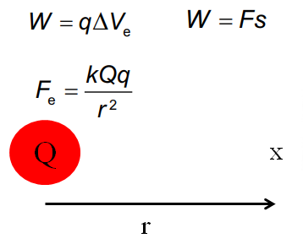
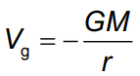  V_{g} = Potential at distance r  m = mass (kg)  r = distance (m) | 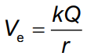  V_{e} = Potential at distance r  Q = charge (C)  r = distance (m)
Example 2: What is the gravitational potential on the surface of the moon? Mass = 7.35x10²² kg, radius = 1.74x10⁶m | Example 1: A van de Graaff generator has an 18 cm radius dome, and a charge of 0.83 μC. What is the voltage at the surface of the dome?

Whiteboards:
Lauren Order is 3.45 m from a -150. μC charge. What is the voltage at this point? (-3.91x10⁵V) | Alex Tudance measures a voltage of 25,000 volts near a Van de Graaff generator whose dome is 7.8 cm in radius. What is the charge on the dome? (0.22 μC)
What is the gravitational potential on the surface of the earth?  m = 5.97x10²⁴ kg, r = 6.38x10⁶ m (-6.24x10⁷ J/kg ) | At what distance from the center of the moon is the gravitational potential -1.00x10⁶ J/kg? Mass = 7.35x10²² kg  (4.90x10⁶ m )

Noteguide for Point Array Potentials - Videos 16L Name

The sum of the potentials due to an array of point charges or masses is the scalar sum of the individual potentials. (Scalar is like a number: 3+5=8)

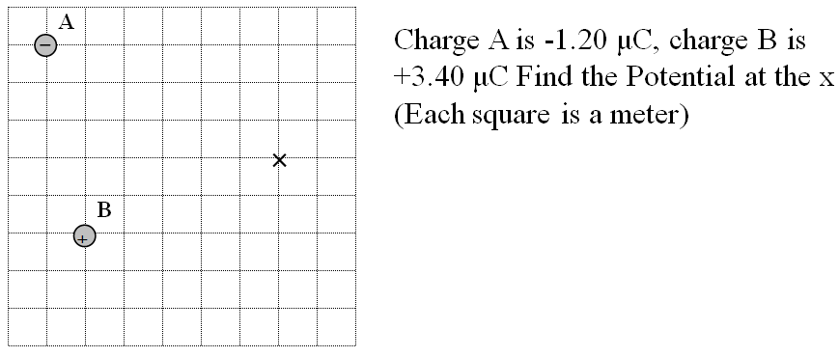

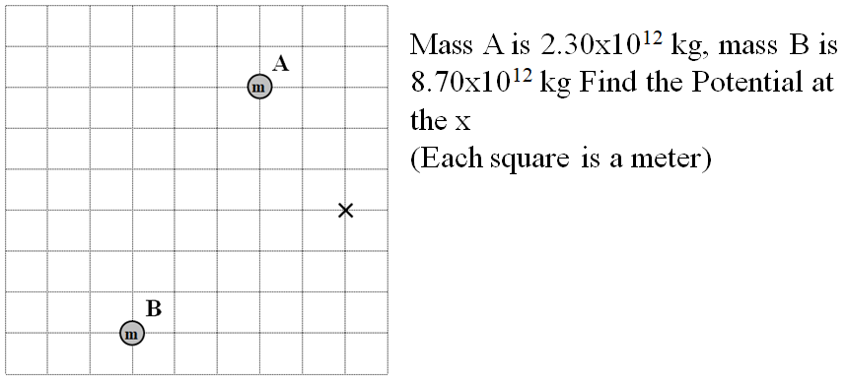

(I feel like if you watched those examples, you really don't need to do the whiteboards, but I put them on the back just in cases - so they are optional)

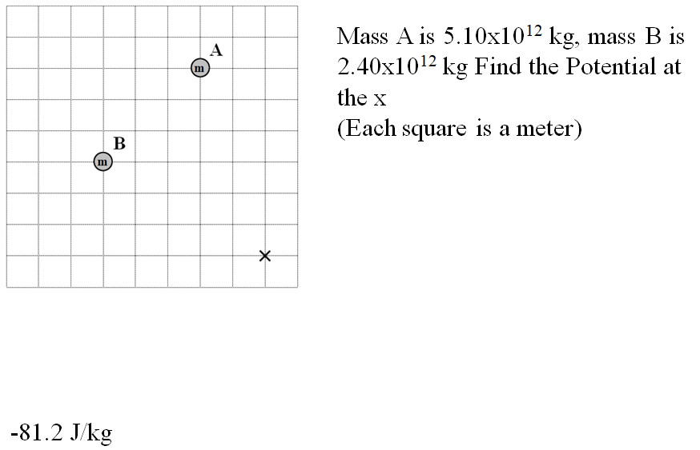

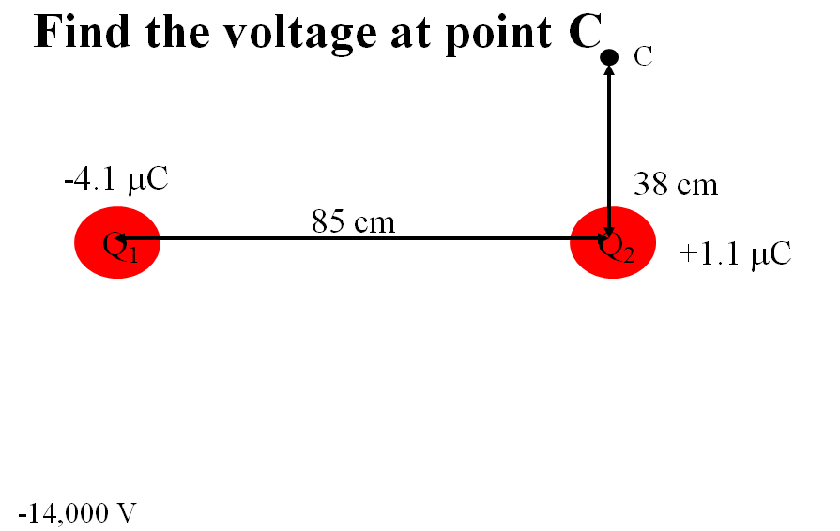

Noteguide for Movement in a field - Videos 16M Name

The work done to move a point charge is W = qΔVe, where ΔVe = Vf - Vi

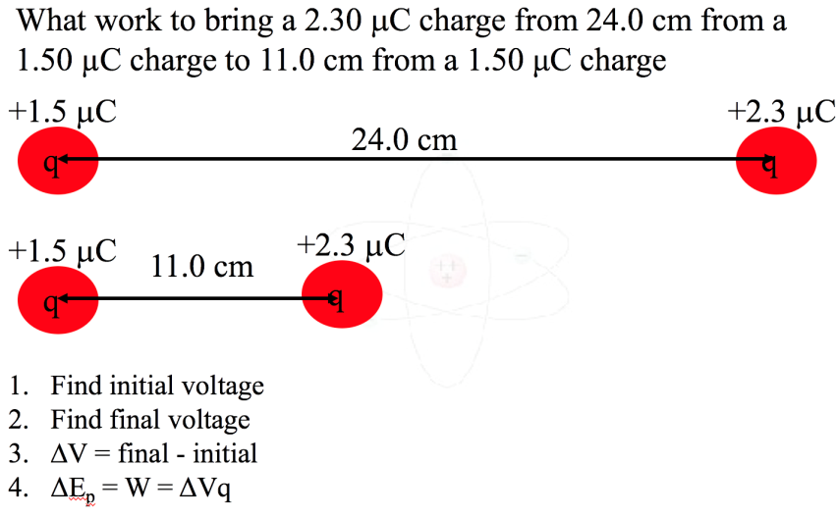

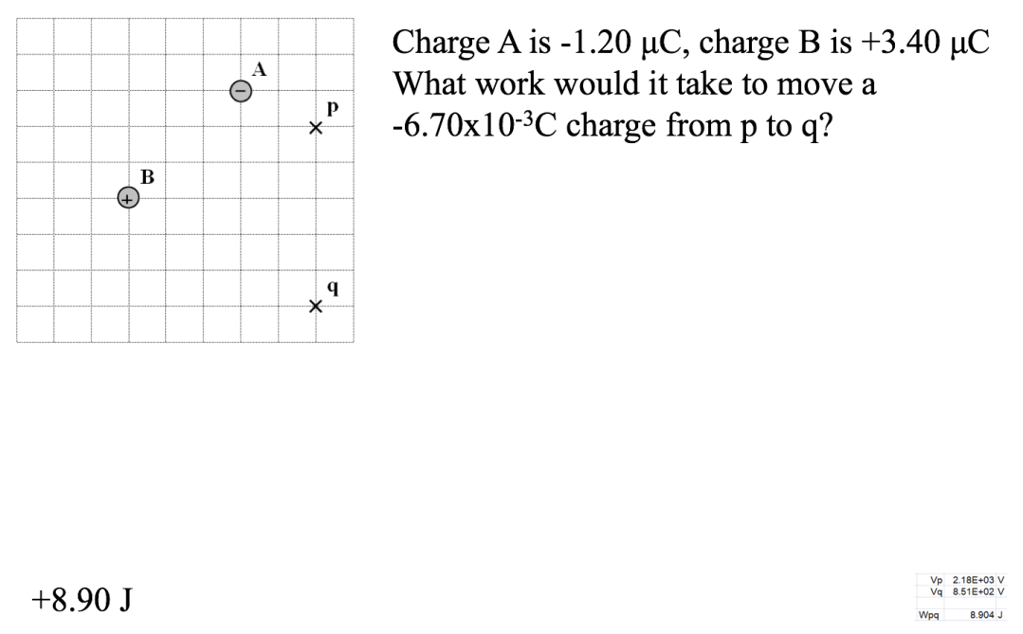

One More Example on the back with gravity

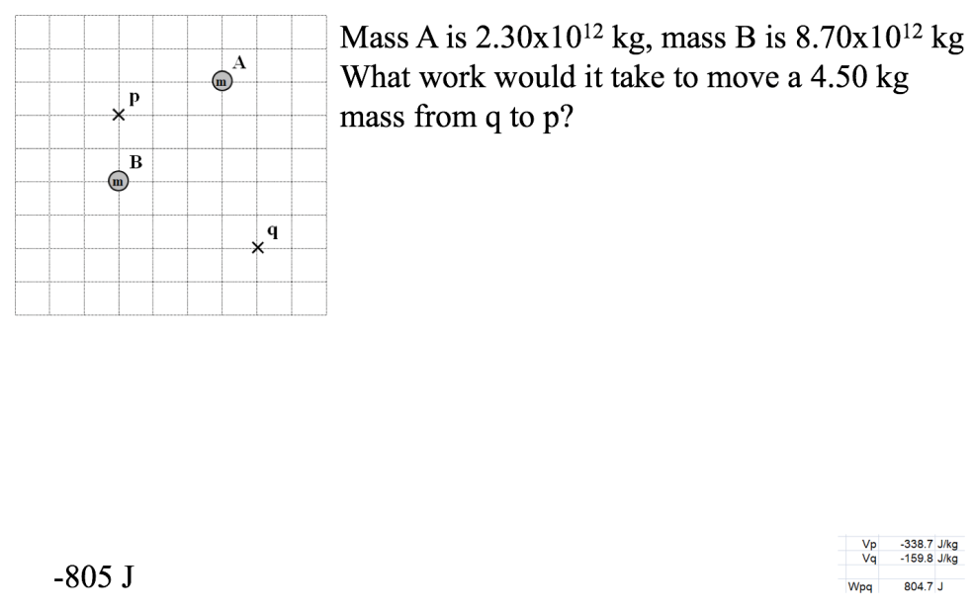

Noteguide for CRT Problems - Videos 16N Name

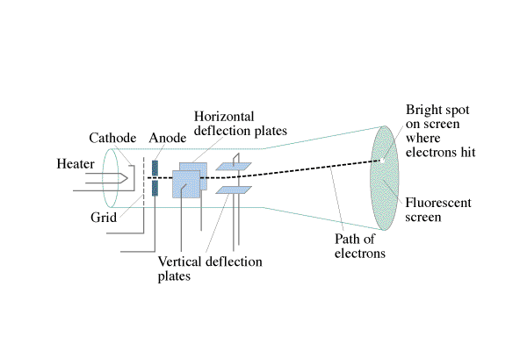

Part 1 - Acceleration toward the anode: Ve = ¹/₂mv²
Example - A CRT uses an accelerating potential of 5200. V. What velocity do the electrons have when they pass through the anode?

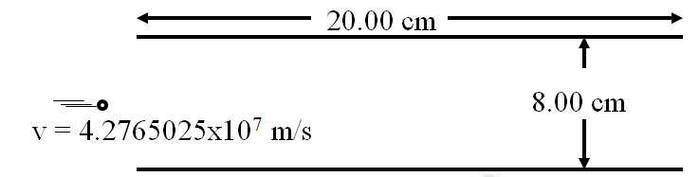

Part 2 - Steering the electron:
What voltage must be applied across the plates above to make the electron emerge from the other end 2.00 cm from the lower plate, assuming it starts parallel to the plates, and 4.00 cm from the lower plate? Which plate would be more positive?

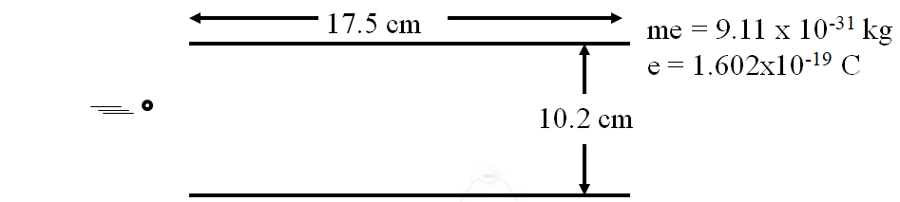

There is an electric field between these plates of 9420 V/m that makes the electrons that enter midway, nearly strike the bottom plate before they emerge from the plates.
What is the voltage across these plates?

What is the force on the electrons between the plates?

What is the downward acceleration of the electrons?

What time is the electron between the plates

What is the horizontal velocity of the electrons?

What voltage accelerated them to this speed before they got here?

Noteguide for Capacitors - Videos 16O Name
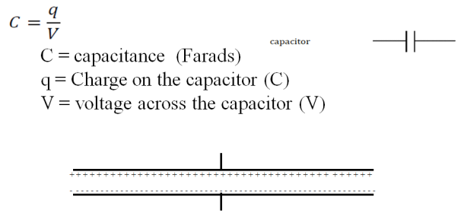
A CCD pixel has a capacitance of 1.7x10⁻¹² F. What is the voltage across it if it has been charged 6.0x10⁴ electron charges? (1 e = 1.602E-19)

Whiteboards:
1. What is the charge on a 250 microfarad capacitor if it has been charged to 12 V? (0.0030 C) | 2. What is the capacitance of a CCD pixel if it has 0.014 V across it when it has a charge of 2.13x10⁻¹⁵ C?  (1.5x10⁻¹³ F (or 0.15 pF))

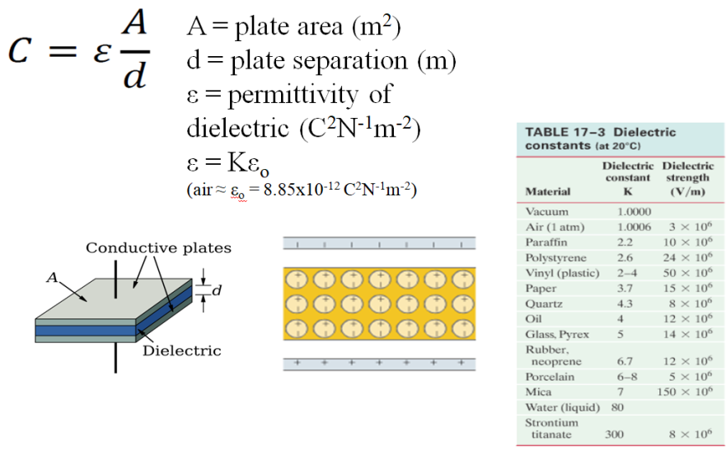
A 3.00 mm air gap capacitor has plates that measure 21.6 cm x 27.9 cm. (8.5”x11”) What is its capacitance?

Whiteboard: 1. A 47 µF electrolytic capacitor uses aluminum oxide as its dielectric (K = 9.1) If it has a plate area of 0.50 cm x 12.00 cm, what must be the thickness of the dielectric? (1.0 nm)

2. (Challenge for smart people only) You are designing a 1400 pF capacitor that must be able to have a peak voltage of 150 V. If you use neoprene as the dielectric,
A. What is the minimum gap you can use? (1.25x10⁻⁵ m)
B. What plate area must you have? (2.94x10⁻⁴ m²)

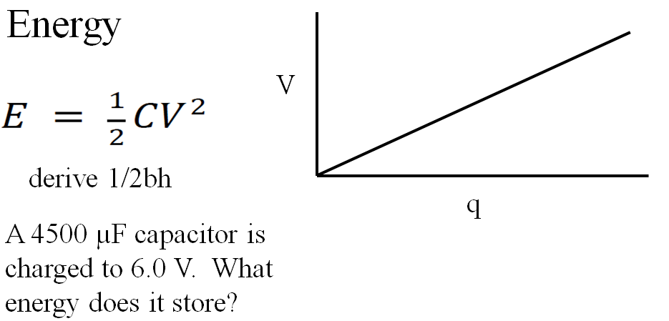

Whiteboards:
1. A camera flash requires a stored energy of 1.80 J. To what voltage must it charge a 4700 µF capacitor? (28 V)

2. What sized capacitor do you need to store 15 J of energy at a voltage of 12 V? (0.21 F)

3. What is the potential energy of 0.12 µC stored on an air gap capacitor with a plate area of 25 cm x 25 cm, and a plate separation of 1.0 mm? (Find C, then V, then E) (1.3x10⁻⁵ J)

What happens to the potential energy if the plates are moved so they are 3.0 mm apart? (Same charge) (3.9x10⁻⁵ J)

Noteguide for RC Circuits - Videos 16P Name
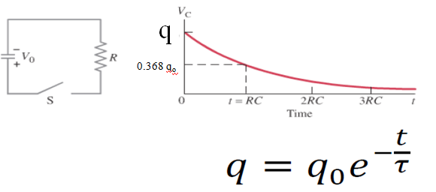
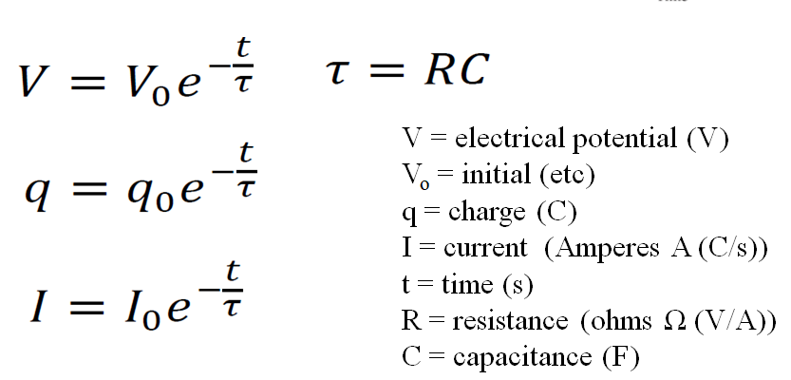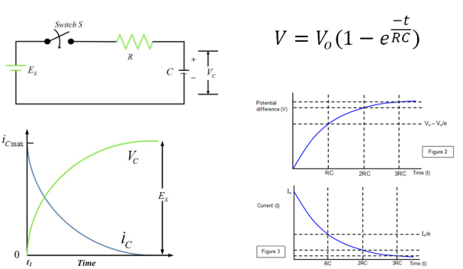

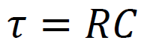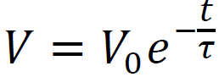
A 47.0 μF capacitor is charged to 12.0 V initially, and discharged through a 100. kΩ resistor.
What is its voltage at 13.0 s into the discharge? (0.755 V)

At what time does it reach 6.0 V? (3.26 s)

Whiteboards:
1. A 100. µF capacitor is attached in parallel with a 1.00 MΩ resistor. If it is initially charged to 5.00 V, what is the voltage 35.0 seconds after it starts to discharge? (3.52 V)

2. A 4.7 µF capacitor is attached to a 2.2 MΩ resistor in parallel. After 78 seconds of discharge there is 0.023 µC of charge on the capacitor. What was the original charge? (43 µC)

3. A discharging parallel RC circuit starts at 12.00 V, and after 312 s has reached 4.00 V. A. What is the time constant? B. What is the resistance if the capacitor has a value of 22.0 µF? (284 s, 12.9 MΩ)

4. A discharging parallel RC circuit has an initial discharge current of 195 mA, and is at a current of 162 mA at a time of 35.0 seconds into its discharge. What will be the current at 72.0 s? (133 mA)

Noteguide for Conservation of Energy - Videos 16Q Name

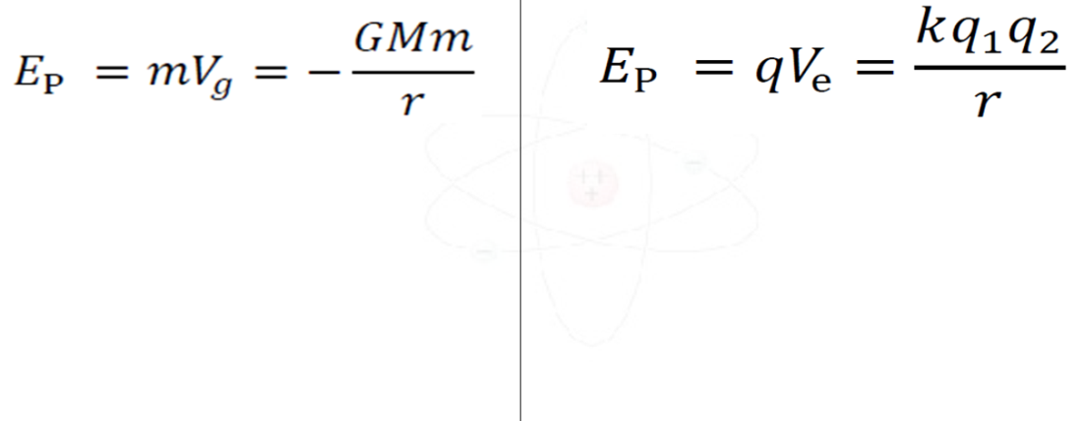

An 89.0 gram +2.30 µC charge is brought to 15.0 cm from a +1.10 μC charge. The 2.30 µC charge is released from rest, while the +1.10 μC is held fixed.

What is its speed when it is 37.0 cm away?

What is its speed when it is very far away?

(Do the gravity example on the back as well...)
Suppose you fired a 2.3 g rifle bullet at 1150 m/s straight up from the surface of the moon.
Mass = 7.35x10²² kg
Radius = 1.74x10⁶ m

A. What would be the greatest height it would reach?

B. What speed would it be going when it was 100. km above the surface?

D. What speed would it need to escape the moon’s gravity?

