Noteguide for Potential, Field and Displacement - Videos 16I Name

Definition:
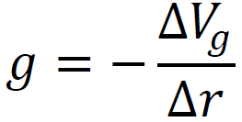  ΔV_{g} = Change in Grav. Potential (J/kg)  g = Grav. field strength (N/kg)  Δr = Displacement (m) | 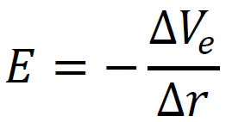  ΔV_{e} = Change in Voltage (Volts, V, J/C)  E = Elec. field strength (N/C)  Δr = Displacement (m)
Example 1: If you have a gravitational field strength of 9.81 N/kg, what is the change of gravitational potential in a vertical upward distance of 1.85 m? | Example 2: What is the electric field when you have 12.0 V across two || plates that are separated by 0.0150 m?

Whiteboards.
1. Lee DerHosen places a voltage of 25 V across two || plates separated by 5.0 cm of distance. What is the electric field generated? (5.0x10² V/m) | 2. Art Zenkraftz measures a 125 V/m electric field between some || plates separated by 3.1 mm. What must be the voltage across them? (0.39 V)
3. Helen A. Handbasket lifts a mass upwards (on earth) increasing its gravitational potential by 142 J/kg. What vertical distance did she lift it? (14.5 m)

(do the ones on the back too - they are like the assessment questions)

4. An electric field exerts a Southerly force of 3.30 N on a +450. µC charge. What is the change in potential if you displace yourself 7.30 m to the North? Is it an increase, or decrease in potential?  (+53,500 V, increase) | 5. A gravitational field exerts a force of 126. N on a 13.0 kg mass away from point B and toward point A that is vertically displaced from B a distance of 12.0 m. What is the field strength? In what direction? What is the change in gravitational potential if you go from B to A?  (9.69 N/kg, toward A, -116 J/kg)
6. A uniform electrical field changes electrical potential from 110. V to 370. V when you move down 6.10 m. What is the magnitude and direction of the electrical field, and what force does it exert on a -1.40 µC charge?  (42.6 V/m. up, 5.97x10⁻⁵ N down) | 7. If you move a mass vertically from point A to point B, the potential changes from -65.0 J/kg to -34.0 J/kg in a distance of 17.0 m. What is the gravitational field strength? Does the field point toward A or B? Which point is at a higher elevation, A or B?  (1.82 N/kg toward A, B is higher.)

