**Noteguide for Fields in Linear Arrays - Videos 16G1 Name**

|  |  |
| --- | --- |
| Field:  g - g near a point mass toward mass (N/kg)  G - 6.67x10-11 Nm2kg-2  M - the mass (kg)  r - distance from the point mass (m) | Field:  (not in data packet)  E - E near a point charge away from charge (N/C)  k - 8.99x109 Nm2C-2  q - the charge (C)  r - distance from the point charge (m) |

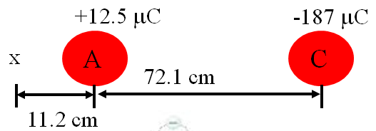

Example: What is the electric field at the x ?

Whiteboards - Work these out - if you don't get the right answer, watch the video to see how to do it.

|  |
| --- |
| 1. Find the gravitational field at p: (49.0 N/kg to the left)  2.70x1024 kg  8.20x1024 kg  m  m  1.80x106 m  (p)  9.10x106 m |
| 2. Find the electrical field at p: (51.6 N/C to the right)  21.0 m  (p)  13.0 m  +  -  +9.10 µC  -2.30 µC |