**Noteguide for Non-Linear Arrays - Videos 16D2 Name**

**Find the net force on A:**

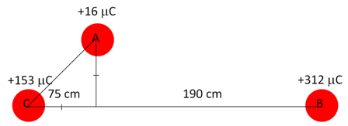

Write down the three steps:

Try this one:

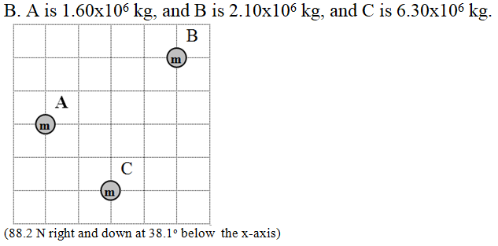Use the force of gravity formula - 

G = 6.67x10-11 N m2 kg-2