Noteguide for Coulomb's Law - Videos 16AB Name

- Charge is in Coulombs (C) (1C = 1 A·s)
  - Signed quantity (+/-)
  - e = 1.602x10⁻¹⁹ C
  - Protons are +, electrons are -
  - 1 C = 6.25x10¹⁸ electrons or protons
  - 1μC = 10⁻⁶ C
- Charge is conserved
- Likes repel, opposites attract

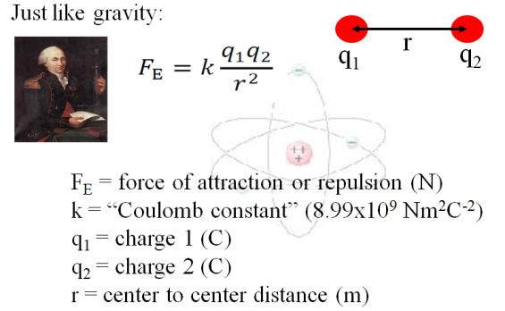
Example 1- What is the force of attraction between a helium electron and its nucleus if the electron is 1.7x10⁻¹⁰ m away? )

Example 2 – Two charged spheres have a force of repulsion of 5.40 N when their centers are 0.120 m apart. What is the force of repulsion when their centers are 0.360 m apart?

Whiteboards - Work these out - if you don't get the right answer, watch the video to see how to do it.
1. Jess Uwaite places a +3.0 µC charge 3.5 m from a +5.0 µC charge. What is the force of repulsion?  (1 µC = 10⁻⁶ C) (0.011N ) | 2. Noah Verkreinatlaad places a 5.0 C charge how far from a 3.0 C charge to make the force between them exactly 4.00 N? (1.8x10⁵ m or 180 km )
3. Cally Seniks measures a force of attraction of 4.50 N between two charges when their centers are separated by 1.20 m. What is the force of attraction when their centers are separated by 0.950 m?  (7.18 N ) | 4. Rita Book measures a force of attraction of 12.0 N between two charges when their centers are separated by 2.50 m. At what separation is the force of attraction 7.00 N?  (3.27 m )

