RC Circuits

Ohm's Law states that the rate at which charge flows is proportional to the voltage making the charge flow. Here we are going to look at the voltage across a capacitor as it discharges through a resistor.
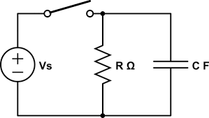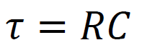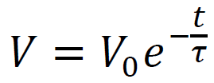

Gathering the data: (I will do this)
- Open the file "RC Circuit Lab" on the desktop. When a window pops up asking about a voltage sensor, click "Connect".
- From the "Experiment" menu choose "Data Collection"
- Click the "Collection" tab and have it collect one sample per second for about 3 time constants. (The resistor is a 1 MΩ, so 1.0x10⁶ ohms, and the capacitor has its value printed on it, read this, and multiply. τ = RC. Type this into the “Length” box) Record the values of your resistor and your capacitor so you have them later
- Click the "Triggering" tab and have the experiment automatically start as it decreases across 4.8 V. (Click "Triggering" and “On Sensor Value” and "Decreasing" and type in 4.8 for the value. 0 samples before triggering)
- Click OK to get rid of the Data Collection dialog box, and click on the last number on the time axis of the graph and change it to the length of the experiment you set in step 3 (If it doesn’t change for you)
- Hold the orange wire to the side of the capacitor that has the red connector attached to it. Notice that the voltage goes up to 5.00 V. Press the "Collect" button, and wait until you see that it is waiting to trigger.
- Disconnect the orange wire from the side of the capacitor. It will start to drain. The data collection should start automatically when the voltage falls across the threshold you set in step 4 (4.8 V?)
- When the data collection is finished, I will right click the upper left corner of the data table, choose "copy", and paste it into a Google Docs spreadsheet, so that you can free up the RC lab setup. You can now do the rest of the write up at home, or here on a laptop.
Writing up the lab:
- Make a nice labeled graph of your data. Put an exponential model on your data. (Series, trendline, exponential, label with equation) A. Why does the voltage drop the way it does? Why is it steep at first, and less steep at the end?
- Look in your data and find at what time the voltage fell to 0.368 (e⁻¹) of the original voltage. (Multiply the first voltage recorded by 0.368, and find at what time it occurs in your data) B. How does the time it took to drop to 0.368V_{o} compare to the time constant you would calculate from the resistor and the capacitor? How does it compare to the time constant derived from your model? (Calculate RC, and compare it to the time you looked up, and compare it to 1/k where k is the coefficient for time in the exponential)
- V_{o} is the first voltage you recorded. Pick 5 ordered pairs of (time, Voltage) throughout your data, and plug them into the formula , and solve for the time constant τ. Do the values of the time constant remain, oh, I don't know.... constant???? C. Does the value of the time constant change as time goes on? Do they show any pattern, or do they just randomly differ?

Your completed lab should have:
- A nice labeled graph with an exponential model with the equation displayed
- The answer to Question A
- The answer to Question B (Cite your data)
- Five calculations of the time constant from step 3 – a picture of your calculations on paper
- Your answer to question C

