Physics Millikan Prep Lab

1. All of these numbers are the product of a random integer and approximately the same non-integer.

40.9475 | 45.9661 | 16.2458 | 29.9228 | 27.2959
35.538 | 35.1581 | 18.9561 | 35.1041 | 32.482
27.3335 | 27.1694 | 29.9297 | 40.6765 | 24.413
27.2691 | 24.4337 | 38.0671 | 19.0247 | 21.6272
30.0691 | 24.411 | 10.9304 | 21.8267 | 29.7689
35.1612 | 27.028 | 24.4105 | 27.233 | 38.0465
29.7615 | 29.8704 | 40.6529 | 29.9329 | 35.0964
38.3087 | 29.8171 | 29.9978 | 19.1271 | 46.3732
37.9816 | 27.29 | 30.0056 | 35.4709 | 27.0478
38.0714 | 16.3893 | 32.7231 | 21.8214 | 24.3537

•On the reverse I have sorted them and made a histogram of them
•What is the step size? (The non-integer) (High step-low step divided by the # of upward transitions or steps)
•What is the uncertainty in your guess? (•The uncertainty will be the range/2 of the most populous step, divided by the number of steps you used to determine the step size.)

2. •Show the derivation of an equation for q - the charge on a sphere in terms of ρ - the density of the sphere, r - the radius of the sphere, d - the separation of the plates, V - the voltage applied to the plates, and g - the acceleration of gravity. •Use dimensional analysis (plug in the units to show they cancel) to check your answer. Show this

Useful formulas:
F = mg, F = Eq, V = Ed, Volume of a sphere = 4/3πr3, ρ = m/Volume
Units for Dimensional analysis: (ρ:kg/m³)(r:m)(g:N/kg)(V:Nm/C)(q:C)(d:m)

3. •Show the derivation of an equation for r - the radius of a sphere in terms of η - the viscosity of air, v - the terminal velocity of a sphere, g - the acceleration of gravity, and ρ - the density of a sphere. •Use dimensional analysis (plug in the units to show they cancel) to check your answer. Show this

Useful formulas:
F = mg, F = 6πηrv, Volume of a sphere = 4/3πr3, ρ = m/Volume
Units for Dimensional analysis: (ρ:kg/m³)(r:m)(g:N/kg)( η:Ns/m2)(v:m/s)

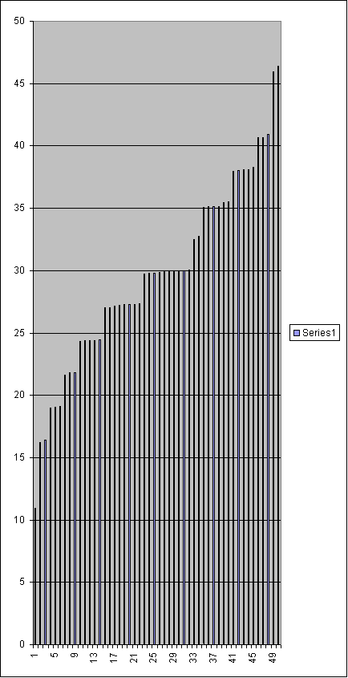 | Sorted
1 | 10.9304
2 | 16.2458
3 | 16.3893
4 | 18.9561
5 | 19.0247
6 | 19.1271
7 | 21.6272
8 | 21.8214
9 | 21.8267
10 | 24.3537
11 | 24.4105
12 | 24.411
13 | 24.413
14 | 24.4337
15 | 27.028
16 | 27.0478
17 | 27.1694
18 | 27.233
19 | 27.2691
20 | 27.29
21 | 27.2959
22 | 27.3335
23 | 29.7615
24 | 29.7689
25 | 29.8171
26 | 29.8704
27 | 29.9228
28 | 29.9297
29 | 29.9329
30 | 29.9978
31 | 30.0056
32 | 30.0691
33 | 32.482
34 | 32.7231
35 | 35.0964
36 | 35.1041
37 | 35.1581
38 | 35.1612
39 | 35.4709
40 | 35.538
41 | 37.9816
42 | 38.0465
43 | 38.0671
44 | 38.0714
45 | 38.3087
46 | 40.6529
47 | 40.6765
48 | 40.9475
49 | 45.9661
50 | 46.3732

