**IB Physics**

**16 A-D Group Quiz**

Name

**Show your work, and circle your answers and use sig figs to receive full credit.**

  - Inverse square force laws

1. What is the force of attraction between a -10.1 μC charge and a +34.1 μC charge if their centers are 67.0 cm apart? Is it a force of attraction or repulsion?

2. At what distance is the force of repulsion between a 2.00 C charge and a 3.00 C charge equal to 4.45 N

(1 pound of force, or 16 ounces of force)

3. What is the force of gravity between a 23.0 kg object on the surface of the moon. The moon has a mass of 7.35x1022 kg, and a radius of 1.738x106 m.

4. 450. Kg wrecking ball experiences a force of attraction of 6.30x10-10 N to a metal sphere that is 15.0 m away. What is the mass of the sphere?

5. Two point masses have a force of attraction of 2.30x10-12 N when they are separated by 56.0 cm. What is their separation if the force of attraction is 5.80x10-12 N?

6. Two point charges have a force of repulsion of 45.3 N when they are 2.30 m separated. What is the force of repulsion if they are separated by only 1.25 m?

7. Two point charges attract each other with a force of 1.40 N when they are 2.20 m apart. How far apart are they if the force of attraction is 5.60 N?

8. Find the net force and direction on masses A, B and C:

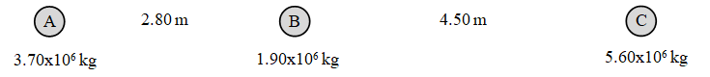

A =

B =

C =

9. Find the net force and direction on charges A, B and C:

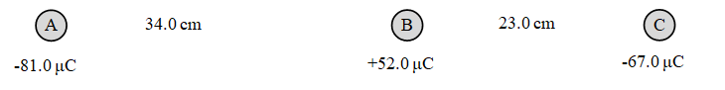

A =

B =

C =

10. Each grid line is a meter. Charge A is -430. µC, and charge B is +120. µC, and C is +780. µC. Calculate the force on charge C. Draw the force vector and label its magnitude and direction.

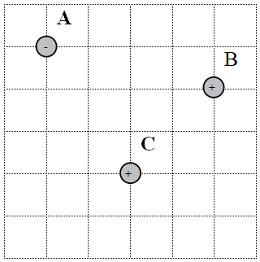

11. Each grid line is a meter. Mass A is 1.20x106 kg, and mass B is 3.10x106 kg, and C is 6.80x106 kg. Calculate the force on mass A. Draw the force vector and label its magnitude and direction.

