IB Physics
Heat group quiz
Name Did you watch Tiger King?

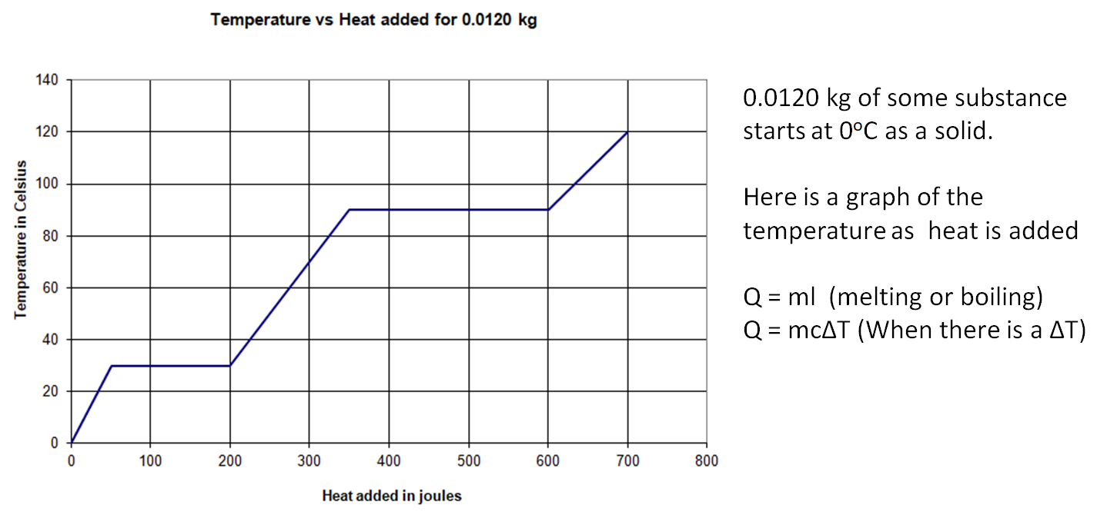
0. Label the solid, solid + liquid, liquid, liquid + gas, and gas regions
1. What is the melting and boiling temperature?

2. How much heat flows in to melt the substance? What is its latent heat of fusion?

3. What is its latent heat of vaporisation?

4. How much heat does the solid phase absorb? What is the temperature change of the solid phase? What is the specific heat of the solid phase?

5. What is the specific heat of the liquid phase?

6. What is the specific heat of the gas phase?

7. Eileen Dover takes 1.42 kg of water from 20.0 ºC to steam at 173 ºC. What TOTAL heat is needed?
(3,893,086.2 J or 3.89E6 J)
C_{ice} = 2100 J/kg ºC
C_{water} = 4186 J/ kg ºC
C_{steam} = 2010 J/kg ºC
Some latent heats
(in J kg⁻¹) Fusion Vaporisation
H₂O 3.33 x 10⁵ 22.6 x 10⁵

8. A piece of iron (C = 440 J/KgoC) at 86.0 oC is placed in 300. grams of water (C = 4186 J/KgoC) initially at 21.0 oC. The final temperature of the mixture is 29.0 oC. What is the mass of the piece of iron? (Assuming no heat was lost to the surroundings)
(401 g)

