**Worksheet 15A: Laws of thermodynamics, heat engines, and PV diagrams.**

Some specific heats

(in JoC-1kg-1)

Aluminium 900

Iron 450

Lead 130

**Objective A: Mechanical energy and heat**

**Problems:**

1. The Dryden drop tower at PSU uses inductive braking. If a 145 kg package is dropped 22.2 m, and 100% of the potential energy is absorbed as heat by the two 2.5 kg Aluminium brake fins on either side, what would be the temp. rise of the fins? (7.0 oC)
2. A biker and bike with a total mass of 87.2 kg stops, causing the 0.238 kg iron disc brake rotor to heat up from 23.0 oC to 85.1 oC. How fast was the bike going if 100% of the kinetic energy of the bike was absorbed as heat by the disc brakes? (12.4 m/s)
3. A 4.20 g lead bullet going 387 m/s strikes a block of wood. 75% of its kinetic energy is absorbed as heat. What amount of the lead would melt at its melting point of 327.5 oC if the original temperature is 23.0 oC, and the latent heat of fusion is 2.50x104 J/kg? (2.79 g)

**Objective B: Q = U + W**

**Questions:**

1. +Q means heat flows in or out of the gas?
2. How do you know if U changes? Can the temperature ever stay the same when U changes?
3. +W means the piston moves in or out? +W means work on the gas, or work on the world?

**Problems:**

1. How much heat must flow into a gas if the internal energy rises by 13 J, and it does 19 J of work pushing its piston out? (+32 J)
2. 43 J of heat flow out of a gas, and it does 72 J of work on the world. What is the change in internal energy of the gas? Did heat flow in or out? Did the piston move in or out? Did the temperature rise or fall? (-115 J, Heat flowed out, Piston moved out, Temperature fell)
3. If 67 J of heat flow into a gas, and its internal energy rises by 52 J, what is the work done? Did heat flow in or out? Did the piston move in or out? Did the temperature rise or fall? (+15 J, Heat flowed in, piston moved out, temperature rose)
4. Bob does 17 J of work on a gas, and 38 J of heat flow into the gas. What is the change in internal energy? Does the piston move in or out? Does the temperature rise or fall? (+55 J, piston moves in, temperature rises)
5. An ideal gas does 45 J of work, and the internal energy changes by -39 J. What is the heat flow? Did heat flow in or out? Did the piston move in or out? Did the temperature rise or fall? (+6 J, heat flowed in, piston moved out, and temperature fell)

**Objective C: W = PΔV**

**Questions:**

1. Why do the processes **bc**, and **da** below have zero work?
2. How could you make process **da** below happen? What would you have to do to the temperature?
3. Process **ab** below cut the volume in half, yet the pressure does not rise, and no gas leaks, so what must happen to the temperature to keep the pressure from rising?
4. Process **cd** below increases the volume by a factor of two, yet the pressure does not drop. What must happen to the temperature for this to happen?

**Problems:**

1. How much work to isobarically compress a gas at 105 kPa from 0.067 m3 to 0.045 m3? (2310 J)
2. A piston compresses isobarically from a volume of 0.035 m3 to 0.017 m3. If this requires 13,700 J of work, what was the pressure? (7.6x105 Pa)
3. (Challenge) When a gas is taken from a to c along the curved path in the figure below, the work done by the gas is W = -35 J and the heat added to the gas is Q = -63 J. Along the path abc, the work done is W = -48 J. (a) What is the Q for path abc? (b) If Pc = 1/2Pa, what is W for path cda? (c) What is Q for path cda? (d) What is Ua – Uc? (e) If Ud – Uc = 5 J, what is Q for path da? (from Giancoli) (-76 J, 24 J, 52 J, 28 J, 23 J) (Use Q = ΔU + W)
4. (Challenge) In the process of taking a gas from state a to state c along the curved path shown below, 80 J of heat leaves the system, and 55 J of work is done *on* the system. (a) Determine the change in internal energy Ua – Uc. (b) When the gas is taken along the path cda, the work done by the gas is W = 38 J. How much heat Q is added to the gas in the process cda? (c) If Pa = 2.5Pd, how much work is done by the gas in the process abc? (d) What is Q for path abc? (e) If Ua - Ub = 10 J, what is the Q for the process bc? (from Giancoli) (25 J, 63 J, -95 J, -120 J, -15 J) (Use Q = ΔU + W)

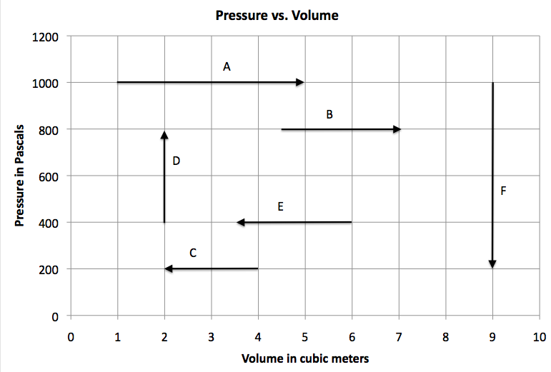

**For each process, calculate the work done, and say what happens to the pressure, volume and temperature.**

1. A Also – what is the temperature at the beginning and end of this process if this is for 2.407 mols of gas? (Use PV = nRT) (Work = 4000 J, pressure constant, volume increases, temperature rises, 50. K, 250 K)
2. B (Work = 2000 J, pressure constant, volume increases, temperature rises)
3. C (Work = -400 J, pressure constant, volume decreases, temperature falls)
4. D Also – what is the temperature at the beginning and end of this process if this is for 2.407 mols of gas? (Work = 0 J, pressure rises, volume constant, temperature rises, 40. K, 80. K)
5. E (Work = -1000 J, pressure constant, volume decreases, temperature falls)
6. F (Work = 0 J, pressure falls, volume constant, temperature falls)

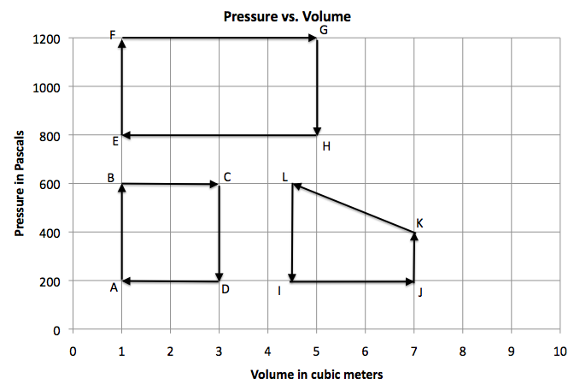

1. What is the net work done for cycle ABCD? If point A is at 60.0 K, how many mols of gas do you have, and what are the temperatures of the other vertices BCD, (+800 J, 0.401 mols, 180 K, 540 K, 180 K)
2. What is the net work done for cycle EFGH? (+1600 J)
3. What is the net work done for cycle IJKL? (-750 J)
4. Cycle MNOP is as follows: MN starts at 400 Pa and 8.0 m3 and 480 K and heats isochorically (Constant V) to 1100 Pa, NO is an isobaric (Constant P) expansion to 10.0 m3, OP is an isochoric cooling back to 400 Pa, and PM is an isobaric compression to 8.0 m3. Draw this cycle on the graph above, calculate the work done, the mols, and the temperature of the vertices NOP. (+1400 J, 0.802 mol, 1320 K, 1650 K, 600 K)

**Objective D: adiabatic, isothermal, isochoric, isobaric processes**

**Questions:**

1. In an adiabatic compression, physically how does the piston increase the temperature of the gas?
2. In an adiabatic expansion, physically how does a piston lower the temperature of the gas?