Videos 15J1 - Heat Flow in Engines Name
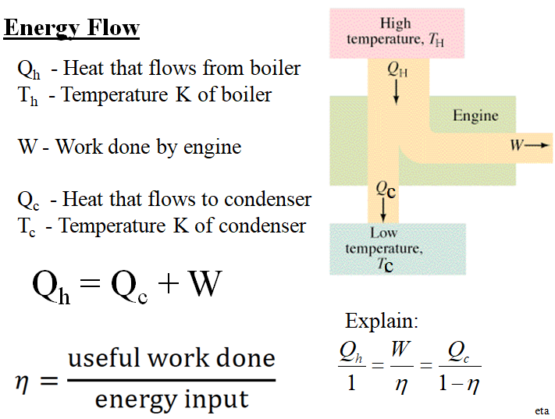
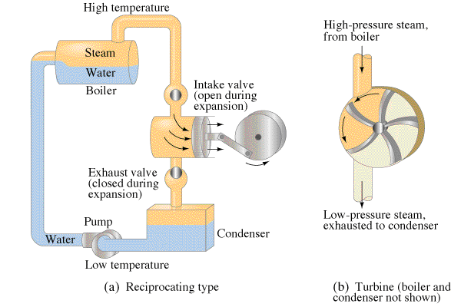

Example: A heat engine consumes 145 J of heat and wastes 97.0 J. What work does it do, and what is its efficiency?

Example: A heat engine is 22.4% efficient. If it wastes heat at a rate of 615 W,
A. At what (Watt?) rate does it do useful work?
B. At what rate does it consume heat from the boiler?

Whiteboards: (These are solved on the website in the videos linked after the main one)
1. Gotelit Andamantan has a heat engine that uses 85.0 J of heat from the boiler, and wastes 60.0 J of heat.  A. What amount of work does the engine do? (25.0 J)  B. What is the efficiency of the engine? (0.294 or 29.4%) | 2. Ms Ribble has a steam engine that puts out work at a rate of 742 W, and consumes heat from the boiler at a rate of 995 W.  A. At what (Watt) rate does heat flow to the condenser? (Wasted) (253 W)  B. What is the efficiency of the engine? (0.746 or 74.6%)
3. Miss Direction has a heat engine that wastes heat at a rate of 624 W, and does work at a rate of 225 W.  A. At what (Watt?) rate does it consume heat from the boiler? (849 W)  B. What is the efficiency of the engine? (0.265 or 26.5 %) | 4. Hugh Jass has a heat engine that is 53.0 % efficient, and consumes 512 J of heat from the boiler.  A. What work does it do? (271 J)  B. What heat does it waste? (241 J)
5. Mr. Fye’s heat engine is 5.54 % efficient. If it does work as a rate of 113 Watts  A. at what rate does it waste heat (1927 W)  B. at what rate does it consume heat from the boiler? (2040 W) | 6. Mr. Meaner’s heat engine is 34.7% efficient. If it wastes 12.0 J of heat,  A. what work does it do (6.38 J), and  B. what heat does it pull from the boiler? (18.4 J)

