**Videos 15D2 - IB Thermodynamics Name**

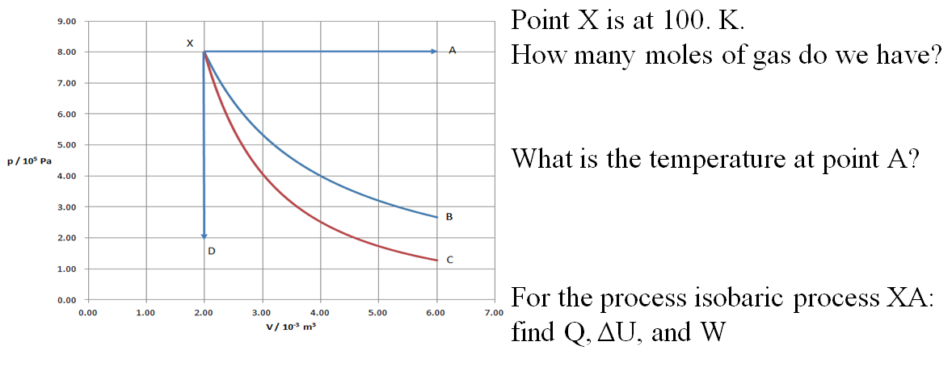

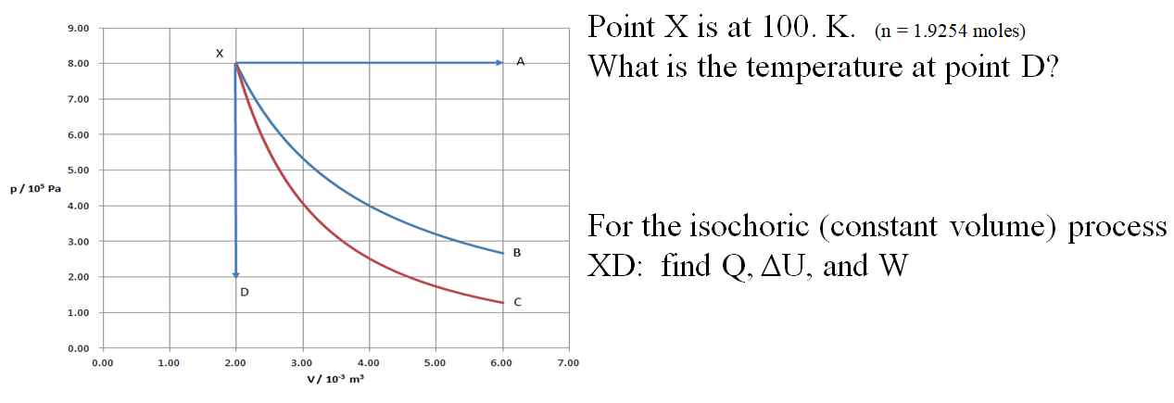

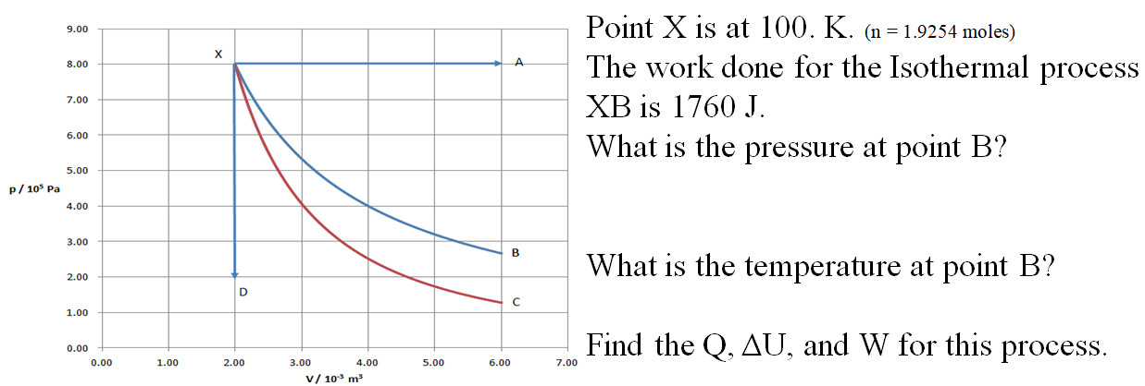

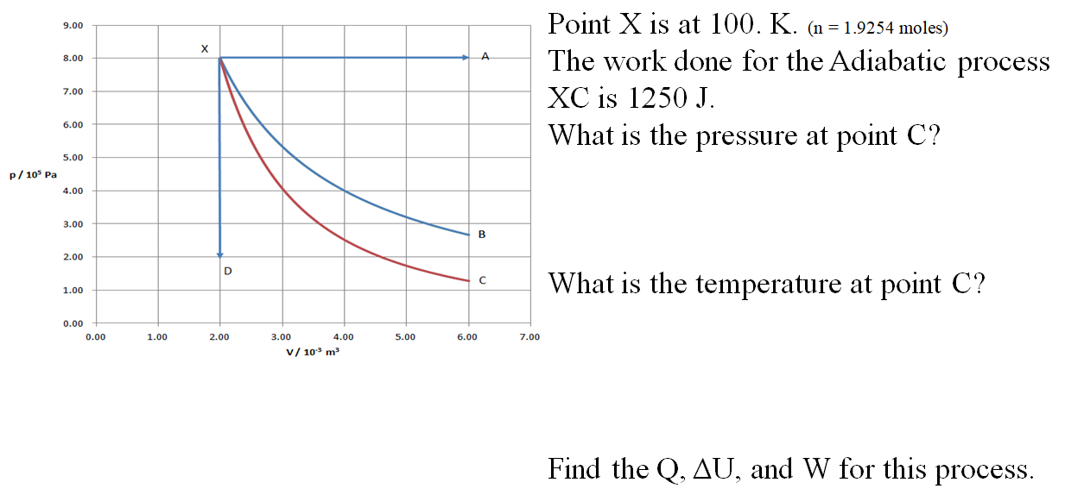

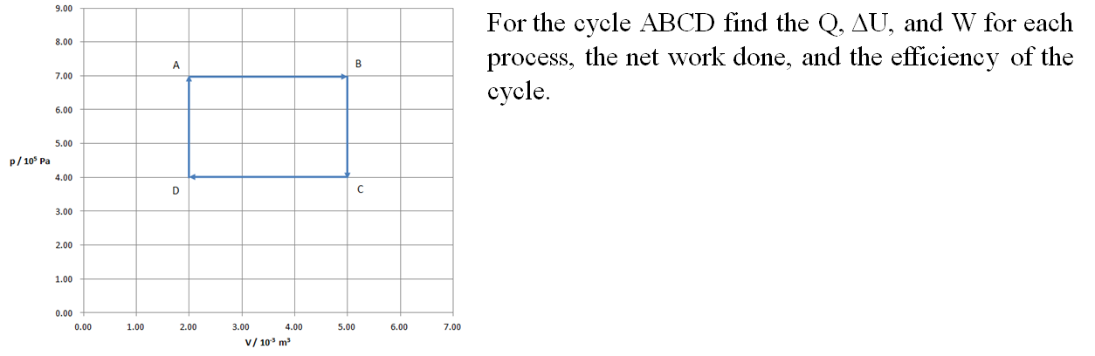

|  |  |  |  |
| --- | --- | --- | --- |
|  | **Q** | **ΔU** | **W** |
| **AB** |  |  |  |
| **BC** |  |  |  |
| **CD** |  |  |  |
| **DA** |  |  |  |
|  |  |  |  |