IB2 Mock Thermo Test

1. (a) 0.164 moles of an ideal monatomic gas is in a container of volume 1.30x10⁻³ m³,
with a pressure of 9.20x10⁵ Pa.

(i) Calculate the temperature of the gas [878 K]
(ii) Calculate in J the internal energy of the gas [1794 J]

(b) The gas is expanded very rapidly so that the pressure is 3.20x10⁵ Pa

(i) Explain why this process would be adiabatic [???]
(ii) Calculate the new volume of the gas [2.45x10⁻³ m³]
(iii) Calculate the new temperature of the gas [575 K]

2. The pressure volume (pV) diagram shows a cycle ABCA of a heat engine. The working substance is 0.850 moles of an ideal gas. At A the pressure of the gas is 12.0x10⁵ Pa, and the volume is 1.00x10⁻³ m³.
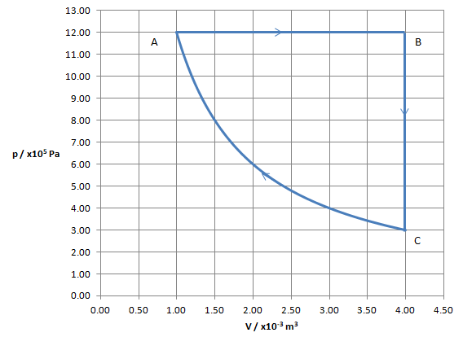

(a) For the isobaric expansion AB

(i) Calculate the temperature at A and B [170. K, 680. K]
(ii) Calculate the work by the gas [+3600 J]
(iii) Calculate the change in internal energy of the gas [+5400 J]
(iv) Calculate the thermal energy that flows into the gas [+9000 J]

(b) Calculate the thermal energy that leaves the gas for process BC [-5400]

(c) The work done on the gas during the isothermal compression CA is 1664 J

(i) Show using data from the graph that process CA is isothermal [pV = pV...]
(ii) Justify why the thermal energy lost during the compression CA is 1664 J [Q=ΔU+W]
(iii) Calculate the change in entropy of the gas for the isothermal compression CA [-9.79 J/K]

(d) Calculate the efficiency of the engine [0.215]

3. The P-V diagram of the Carnot cycle ABCDA for a monatomic ideal gas operating with a Carnot efficiency of 0.370

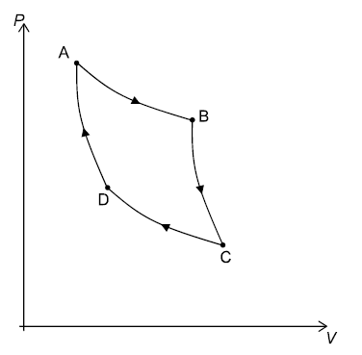

(a) On the diagram label each process either ("Isothermal" or Adiabatic") and either [???]
("Expansion" or "Compression")

(b) The low temperature is 345 K. Calculate the high temperature. Label these temperatures
on the graph above. Label also the processes where no heat flows, and those there heat either
flows into or out of the gas [548 K]

(c) During process CD, 1280 J of heat flow out of the gas.

(i) Calculate the useful work done by the entire cycle [752 J]
(ii) Calculate the heat that must flow into the gas in process AB [2032 J]

4. A planet with an atmosphere is 1.80x10¹¹ m from a star with a radius of 9.50x10⁸ m and a surface
temperature of 6250 K. The atmosphere of the planet has an albedo of 0.210.

(a) Show that the intensity of the radiation incident on the upper atmosphere is 2410 Wm⁻² [2409.9 Wm⁻²]
(b) Calculate the average intensity spread out over the entire surface of the planet [476 Wm⁻²]
(c) Calculate the radiative equilibrium temperature assuming that the atmosphere were
transparent to IR wavelengths of light [303 K]
(d) Calculate the peak black body wavelength radiated by the planet and the star. Also
state which part of the electromagnetic spectrum each wavelength belongs to. [9.58 μm, 464 nm]
(e) With reference to the wavelengths of the incident and radiated energy, explain how the [???]
surface of the planet could be warmer than the value you calculated in (c)

