15B - Heat engines – An ideal gas in a cylinder is our model for a simple heat engine. Assume no friction with the piston, and that the gas is ideal.

A heat engine:

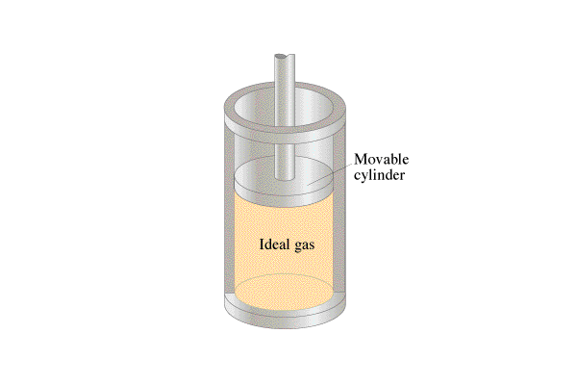Define:

Q – Heat flow into the cylinder.

ΔU – (Change of ) Internal energy of gas.

W – Work done by the gas.

Q = ΔU + W

|  |
| --- |
| Example 1: Doane Doodat lets a gas expand doing 17 J of work so rapidly that no heat flows into or out of the gas. What is the change in internal energy? Does the temperature rise or fall? Physically how does this happen?  (Temperature rises) (Piston moves out)  Q = ΔU + W  (Heat flows in) (Internal energy increases) (The gas does work) |
| Example 2: Unita Ryad does 45 J of work compressing a gas in a cylinder. 23 J of heat flow out of the gas. What is the change in internal energy of the gas???? What happens to the temperature?  (Temperature rises) (Piston moves out)  Q = ΔU + W  (Heat flows in) (Internal energy increases) (The gas does work) |

**Videos 15C1 - Work, Pressure and Volume: Name**

Write down the formula for work in terms of Pressure, and change in volume.

W =

**Example**: What work done by an isobaric compression at 500 Pa from 0.85 m3 to 0.52 m3?

PV Diagrams:

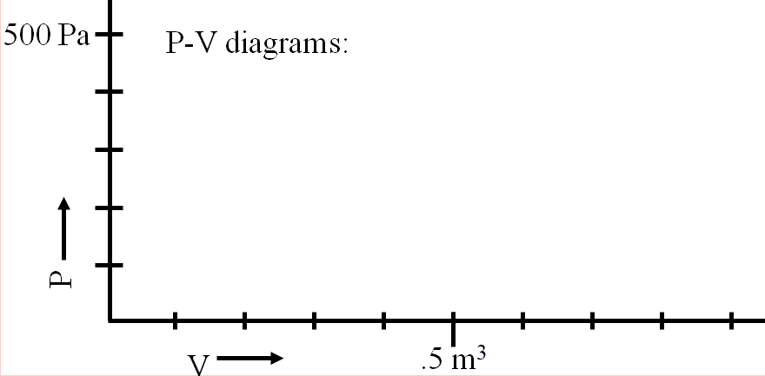

**Example**:

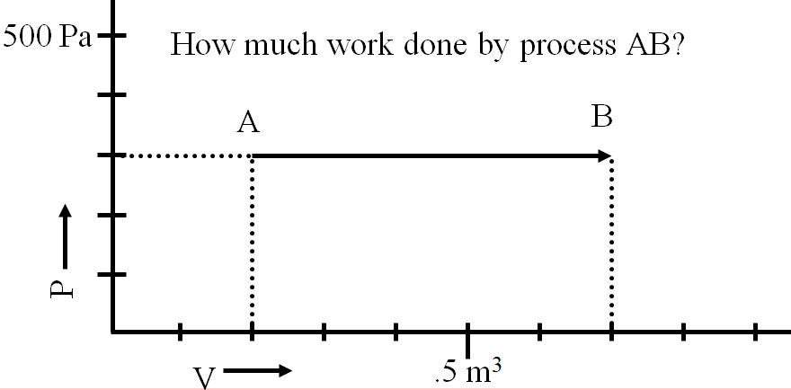

Whiteboards:

|  |  |
| --- | --- |
| Hugo First has a gas in a cylinder that expands from 200. liters to 500. liters at a pressure of 1200 Pa. What work did the gas do? (1000 liters = 1 m3) (360 J) | Mr. Fyde compresses a cylinder from 0.0350 m3 to 0.0210 m3, and does 875 J of work. What was the average pressure?  (62500 Pa) |

over

More Whiteboards

|  |  |
| --- | --- |
| (120 J) | (-90 J - work on the gas) |
| What is the work done by this process?    (210 J - Use an average pressure ) | (does the piston move at all? Is there any change in volume?) |

**Videos 15C2 - Work for Cycles Name**

**Method 1 - adding up all the processes:**

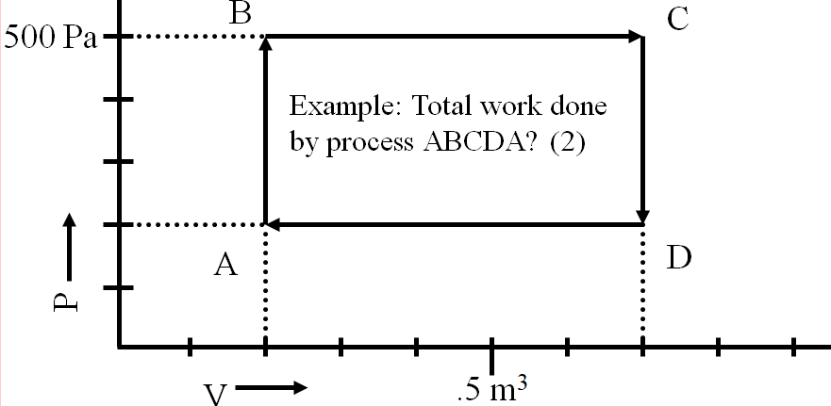

AB = BC = CD = DA =

Total Work =

**Method 2 - Area inside the process:**

The rule about Clockwise vs. Anti-Clockwise:

**Heat engines and heat flow:**

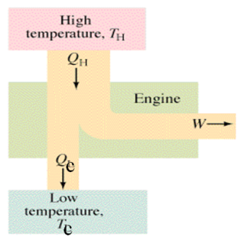 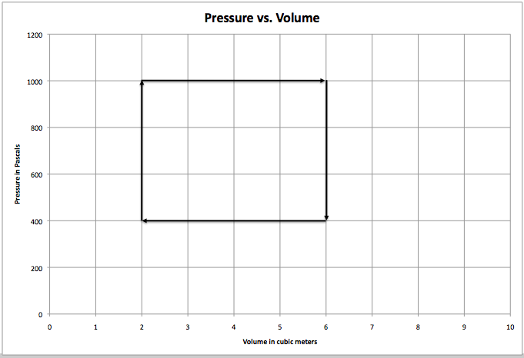

over

Whiteboards

|  |  |
| --- | --- |
| (+30 J) | What is the work done by this cycle?    (-120 J - work on the engine) |
| What is the work done by this cycle?    (+45 J - Use the area) | What is the work done by this cycle?    (-180 J) |

15D1 - PV Diagrams and Processes

|  |  |
| --- | --- |
| **Isobaric:** Constant Pressure  Expansion: Q = ΔU + W  Compression: Q = ΔU + W | **Isochoric: W = 0.** (Constant Volume)  Heating: Q = ΔU + W  Cooling: Q = ΔU + W |
| **Adiabatic:** Q = 0. (No heat flows)  Expansion: Q = ΔU + W  Compression: Q = ΔU + W | **Isothermal:** ΔU = 0. (Constant Temperature?)  Expansion: Q = ΔU + W  Compression: Q = ΔU + W |

**Videos 15D2 - IB Thermodynamics Name**

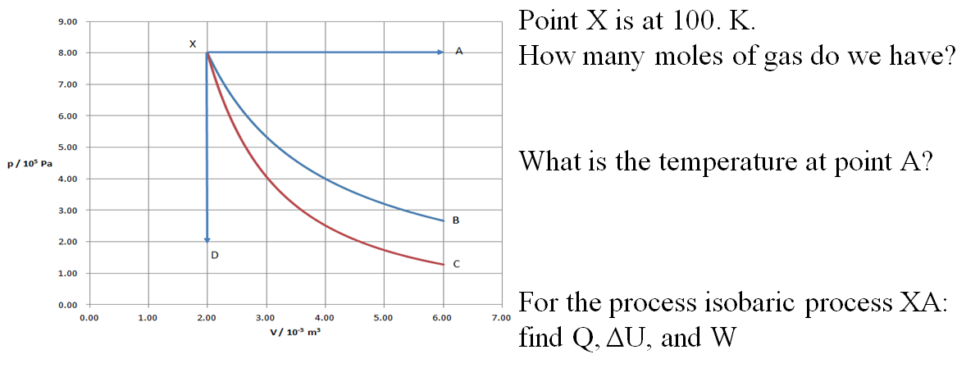

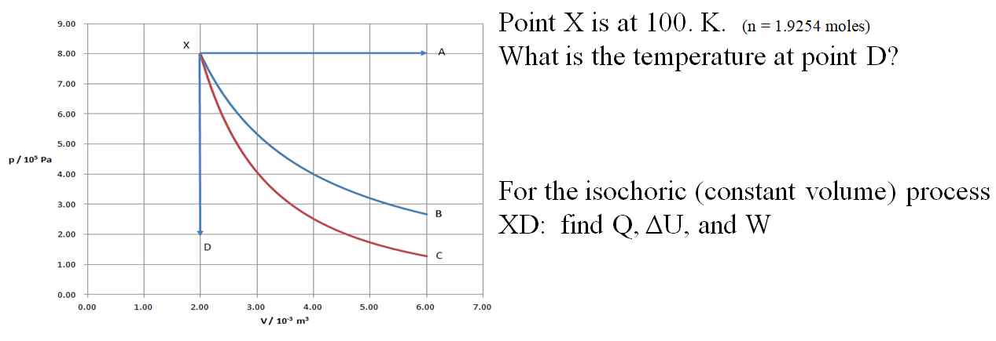

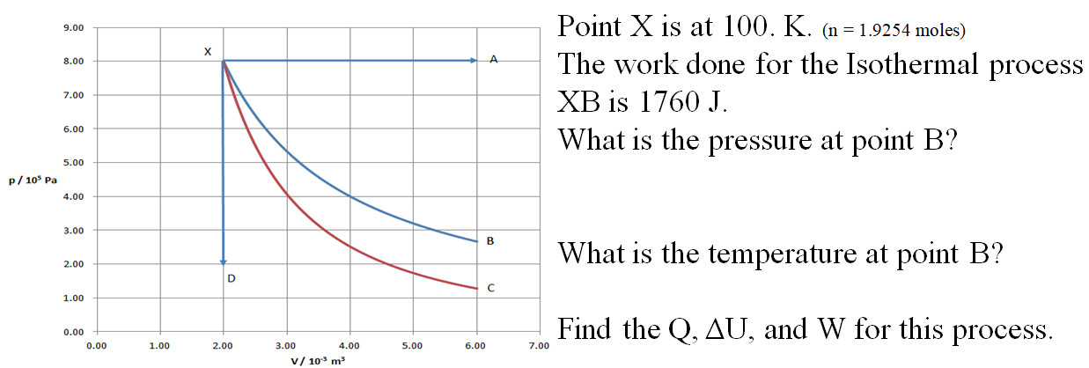

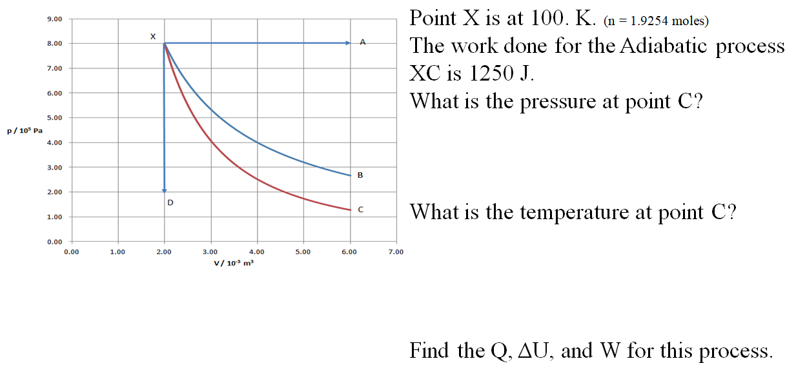

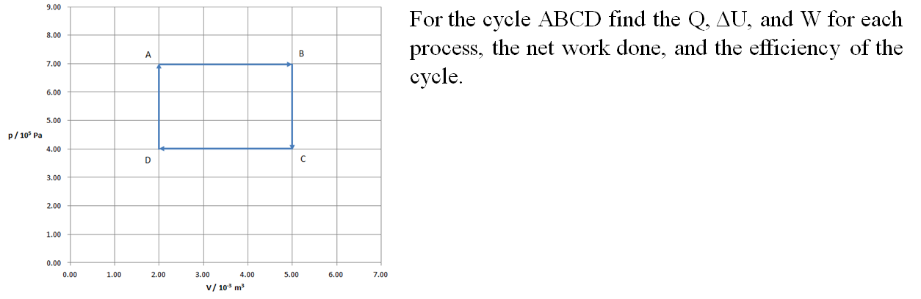

|  |  |  |  |
| --- | --- | --- | --- |
|  | **Q** | **ΔU** | **W** |
| **AB** |  |  |  |
| **BC** |  |  |  |
| **CD** |  |  |  |
| **DA** |  |  |  |
|  |  |  |  |

**Videos 15G - Internal Energy Name**

Write down what these things are:

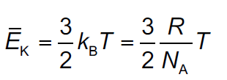 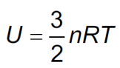

Example #1 – What is the total internal energy of a balloon full of Helium gas at STP. Assume the balloon is a 12.0 cm radius sphere.

Whiteboards: (These are solved on the website in the videos linked after the main one)

|  |  |
| --- | --- |
| 1. At what temperature does 0.450 mols of Neon gas have a total internal energy of 1250 J? (223 K or - 50.3 oC) | 2. A Helium has an internal energy of 5610 J at a temperature of 45.0 oC. How many mols do you have? How many grams? (m = 4.003 g/mol) (1.41 mols, 5.66 grams) |
| 3. You have 12.0 grams of Neon gas at 20.0 oC. What is its internal energy? (m = 20.1797 g/mol) (2170 J) | |

**Videos 15H - Adiabatic PV Name**

For an adiabatic process (Q = 0, so compression raises temperature, expansion lowers temperature)



**Example: Gas in a piston has a volume of 1.200 liters and a pressure of 1.00x105 Pa.**

a. If it is compressed isothermally (constant temperature) to a volume of 0.800 liters, what is the new pressure? (1.50x105 Pa)

b. If it is compressed adiabatically (no heat flow – Quickly?) to 0.800 liters, what is the new pressure? (1.97x105 Pa)

Why does the adiabatic process result in a higher pressure?

Whiteboards: (These are solved on the website in the videos linked after the main one)

|  |  |
| --- | --- |
| 1. Gas in a cylinder at a pressure of 1.013x105 Pa and a volume of 0.150 m3 is expanded quickly (adiabatically) to a volume of 0.810 m3. What is the new pressure? (6090 Pa) | 2. Gas in a cylinder at a pressure of 9820 Pa and a volume of 0.0450 m3 is expanded quickly (adiabatically) so the pressure drops to 7510 Pa. What is the new volume? (0.0529 m3 ) |
| 3. Gas in a cylinder is at 12.0 psi when the piston is 10.00 cm from the bottom. If it is quickly (adiabatically) compressed to a height of 5.00 cm, what is the new pressure? (38.1 psi) | 4. Gas in a cylinder is at 760. Torr when the piston is 8.00 inches from the bottom. If you quickly move the piston out to make the pressure 380. Torr, how high is the piston? (Cut the pressure in half) (12.1 inches) |

**Videos 15I - Entropy Name**

2nd Law of Thermodynamics:

Write down what these things are:

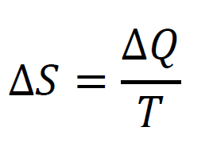

**Example** – A 35.0 gram piece of iron (C = 450. J/kg/oC) initially at 35.0 oC is placed in a cup of water at 30.0 oC and they come to equilibrium at 31.0 oC.

* Estimate the change in entropy of the iron. (-0.206 J/K)
* Estimate the change in entropy of the water. (+0.207 J/K)
* What is the net change in entropy? (+0.00169 J/K)

(net increase when from hot to cold, why this is an estimate, how temperature is defined)

**Example** – A 68.0 gram ice cube (L = 3.33x105 J/kg) at 0 oC is thrown in a swimming pool that is at 18.0 oC.

* What is the change in entropy of the ice cube? (+82.9 J/K)
* What is the change in entropy of the pool? (-77.8 J/K)

(solid to liquid is an increase of entropy….)

Whiteboards: (These are solved on the website in the videos linked after the main one)

|  |  |
| --- | --- |
| 1. What is the change in entropy when 34.0 grams of water at 0 oC freezes? (L = 3.33x105 J/kg)  (-41.4 J/K ) | 2. A 150 gram piece of copper (c = 390. Jkg-1oC-1) heats from 40.0 oC to 42.0 oC. Estimate the change in entropy.  (+0.37 J/K ) |
| 3. A 164.0 gram piece of copper (c = 390. Jkg-1oC-1) at 32.0 oC is placed into water at 20.0 oC. If they come into equilibrium at 24.0 oC  a. Estimate the change in entropy of the copper.  b. Estimate the change in entropy of the water.  c. What is the net entropy change?  (-1.70 J/K, +1.73 J/K, +0.0345 J/K) | |

**Videos 15J1 - Heat Flow in Engines Name**

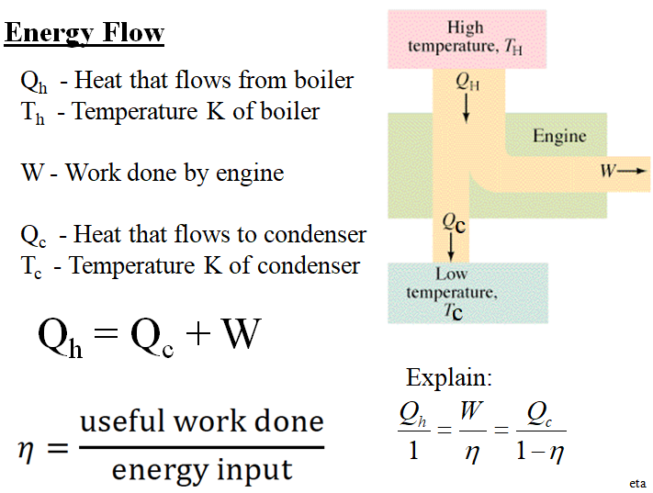

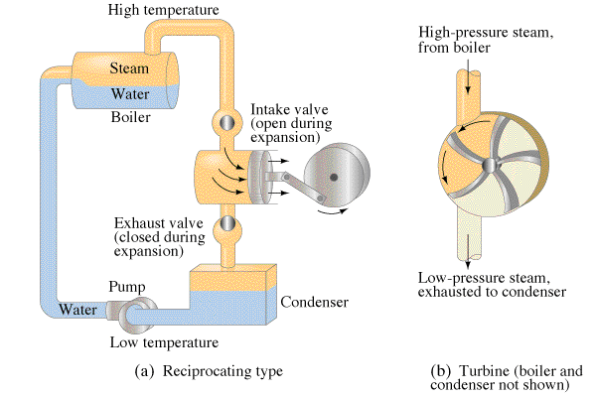

Example: A heat engine consumes 145 J of heat and wastes 97.0 J. What work does it do, and what is its efficiency?

Example: A heat engine is 22.4% efficient. If it wastes heat at a rate of 615 W,

A. At what (Watt?) rate does it do useful work?

B. At what rate does it consume heat from the boiler?

Whiteboards: (These are solved on the website in the videos linked after the main one)

|  |  |
| --- | --- |
| 1. Gotelit Andamantan has a heat engine that uses 85.0 J of heat from the boiler, and wastes 60.0 J of heat.  A. What amount of work does the engine do? (25.0 J)  B. What is the efficiency of the engine? (0.294 or 29.4%) | 2. Ms Ribble has a steam engine that puts out work at a rate of 742 W, and consumes heat from the boiler at a rate of 995 W.  A. At what (Watt) rate does heat flow to the condenser? (Wasted) (253 W)  B. What is the efficiency of the engine? (0.746 or 74.6%) |
| 3. Miss Direction has a heat engine that wastes heat at a rate of 624 W, and does work at a rate of 225 W.  A. At what (Watt?) rate does it consume heat from the boiler? (849 W)  B. What is the efficiency of the engine? (0.265 or 26.5 %) | 4. Hugh Jass has a heat engine that is 53.0 % efficient, and consumes 512 J of heat from the boiler.  A. What work does it do? (271 J)  B. What heat does it waste? (241 J) |
| 5. Mr. Fye’s heat engine is 5.54 % efficient. If it does work as a rate of 113 Watts  A. at what rate does it waste heat (1927 W)  B. at what rate does it consume heat from the boiler? (2040 W) | 6. Mr. Meaner’s heat engine is 34.7% efficient. If it wastes 12.0 J of heat,  A. what work does it do (6.38 J), and  B. what heat does it pull from the boiler? (18.4 J) |

**Videos 15J2 - Carnot Cycle Name**

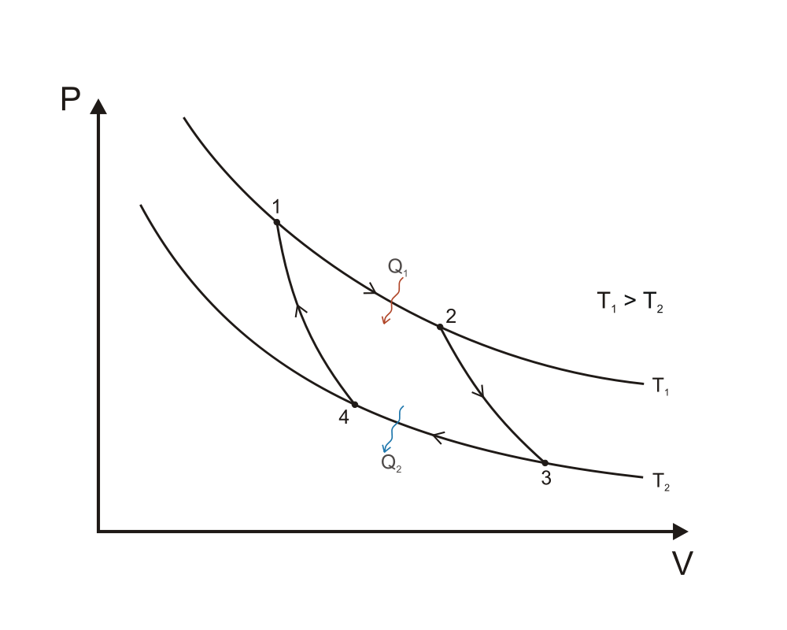

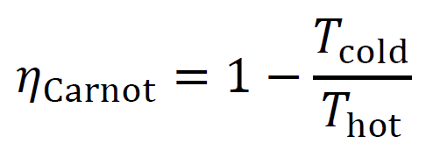 (Temps in K of course)

Processes: Q = ΔU + W

1-2: Isothermal Expansion:

2-3: Adiabatic Expansion

3-4: Isothermal Compression

4-1: Adiabatic Compression

Whiteboards: (These are solved on the website in the videos linked after the main one) 

|  |  |
| --- | --- |
| 1. Amanda Huggenkiss operates a Sterling engine between the temperatures of 35.0 oC and 13.0 oC. What is the maximum theoretical efficiency she can achieve? (Carnot efficiency)  (.0714 or 7.14%) | 2. Amanda Huggenkis operates a Sterling engine between the temperatures of 35.0 oC and 13.0 oC. If the engine is to do 134 J of work, what heat must flow from the high temperature, and what heat is wasted?  Hint - we already know that efficiency = 0.071429  (1876 J, and 1742 is wasted ) |
| 3. Kahn and Stan Tinople have a heat engine with a Carnot efficiency of 0.35, if the low temperature is 285 K, what must be the high temperature? (Assume Carnot efficiency) (440 K) | 4. Olive Hughe has a heat engine that does 25.0 J of work, and wastes 41.0 J of heat during a cycle. If the low temperature is 20.0 oC, what must be the high temperature in Celsius?  (Assume Carnot efficiency)  (472 K or 199 oC ) |