IB Physics
FA 15.3 - Thermodynamics
Name

Favorite Celebrity (Besides Matt Damon)
Show your work, and circle your answers and use sig figs to receive full credit.
When you have finished this, go to the website and check your answers. If you got a problem wrong, cross it off on the front, and do it correctly on the back.
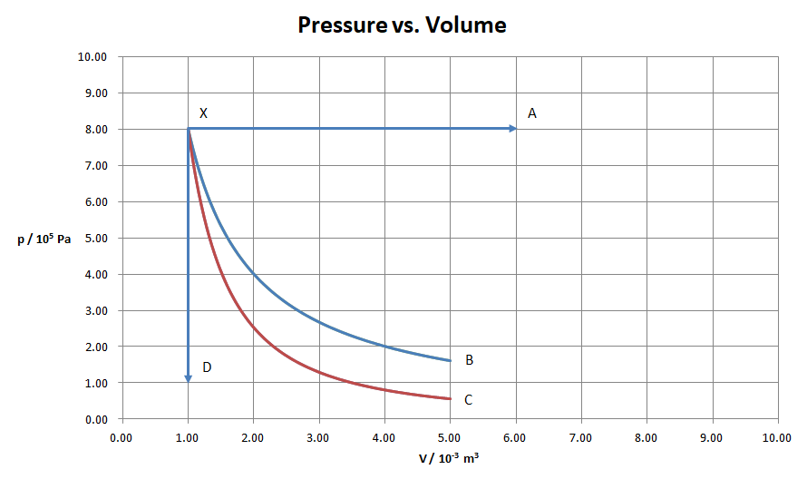
Process XB is isothermal, XC adiabatic. The temperature at X is 430. K
A. For process XA, find the temperature at A, and the W, ΔU, and Q. [3]

B. For process XC find the W, ΔU, and Q. [3]

C. For process XD find the temperature at D, and the W, ΔU, and Q. [2]

D. For process XB the work done is 1288 J. Find the pressure at B, and the W, ΔU, and Q. [2]

