Esteemed IB Physics 2 students!!!

I am going to flip a heat and ideal gas law review (stuff you already learned in Chemistry) for the Summer, so that we can spend more time on Thermodynamics (Which is hard) when we get back in the September. I have created a Google Classroom for all of us to communicate, post videos, etc.

The Google class code is ivby962

Sign in to Google, click Google Apps, Choose Google Classroom, click the + to join a class, and type in this code

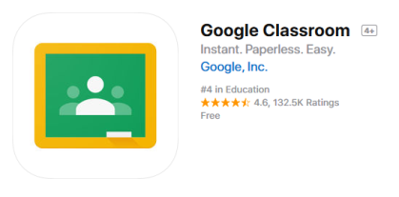If you get the Google Classroom App you can get notifications

Esteemed IB Physics 2 students!!!

I am going to flip a heat and ideal gas law review (stuff you already learned in Chemistry) for the Summer, so that we can spend more time on Thermodynamics (Which is hard) when we get back in the September. I have created a Google Classroom for all of us to communicate, post videos, etc.

The Google class code is ivby962

Sign in to Google, click Google Apps, Choose Google Classroom, click the + to join a class, and type in this code

If you get the Google Classroom App you can get notifications

