Videos 15K - Wind Turbines Name
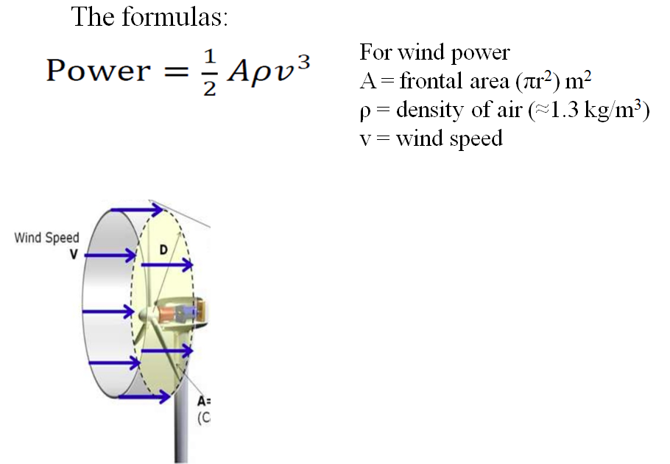

Ex1 – What max power can you get from a wind turbine with 8.2 m long blades when the wind speed is about 5.4 m/s on the average? Use the density of air to be 1.2 kg/m³

Ex2 – What max power can you get from a wind turbine with 8.5 m long blades when the wind speed is about 7.3 m/s incident on the front of the blades, and is slowed to 6.5 m/s after the blades. Use the density of air to be 1.3 kg/m³

Try this one:
Your wind turbines have a radius of 9.70 m. They operate where the wind speed is 8.50 m/s, and they slow the wind to 7.60 m/s on their downwind side. Use the density of air to be 1.3 kgm⁻³
- What is the power output per turbine?
- How many turbines do you need to generate a megawatt of power? (1.00x10⁶ W)
33652.26963 W ≈ 3.37x10⁴ W, 30 turbines

